RIP

Brenda Warton, Barbara Anderson

Lord God, Let us find in your Son comfort in our sadness, certainty in our doubt and courage to live. Make our faith strong through Christ our Lord. AMEN.

BAPTISMS

Father and loving God, bless these children and those who care for them. Grant them your gifts of love, wisdom and faith. Fill them with the light of your presence and establish them in the joy of your kingdom, through Jesus Christ our Lord. AMEN.

ABSENT FRIENDS

We remember church members who are not able to be with us Sunday by Sunday.

Heavenly Father, be with us in all our weakness and frailty, and strengthen us by your Spirit; through Jesus Christ our Lord. AMEN.

Sunday 5th (Easter Sunday), 10.00 am Holy Communion
Sunday 12th (Easter 2), 10 am All-age & Parade Service of the Word (Non-Eucharistic)
Sunday 19th (Easter 3), 10 am Holy Communion, 12 noon Baptisms
Sunday 26th (Easter 4), 10 am Holy Communion followed by APCM

No mid-week services the week after Easter
Tuesdays and Thursdays and Fridays as usual after that.

14th 10-12 noon – Coffee Morning, 1.30 pm NO BIBLE STUDY
21st at 7 pm - Baptism Preparation Class

Notice of Annual Meeting

The Annual Parochial Church Meeting (APCM) will be held on Sunday 26th April 2015 following the morning service at approximately 11.30 am in church. At this meeting, various reports will be presented and elections will be held for the office of Church Warden, Deputy Warden, PCC members and sidespeople. In preparation, the written annual report and nomination forms for the various positions will be available from Sunday 5th April. Please remember to pick up your copy of the report and take time to read it thoroughly before the meeting.

Please pray that the right people will be found for all the important roles. Could God be calling you to something new? If you need any further information please speak to Carol.

HOLY WEEK EVENTS 2015

MONDAY IN HOLY WEEK
7.00 pm Stations of the Cross at St. John’s

TUESDAY IN HOLY WEEK
1.30 pm Lent Course, Session 6 Reliability at St. John’s
7.00 pm Compline at St Stephen’s Kearsley

WEDNESDAY IN HOLY WEEK
7.00 pm Lent Course, Session 6 Reliability concluding
with Compline at Holy Trinity, Prestolee

MAUNDY THURSDAY
10.00 am Holy Communion BCP at St. John’s
7.00 pm Holy Communion with Agape Meal at St Stephen’s
7.00 pm Holy Communion with stripping of the altar
at St. Saviour

GOOD FRIDAY
9.30 am Children’s Workshop at St. John’s
11.00 am All-Age Service at St. John’s
12 noon Walk of Witness - set off from Holy Trinity Prestolee leading to
2.00 pm Last Hour at the Cross at St. Saviour Ringley
7.30 pm Reflections before the Cross, a service of readings,
music and reflection at St. John’s

EASTER SUNDAY

10.00 am Hallelujah! Christ is Risen!
Holy Communion at St John’s

Announcing the appointment of a new Team Vicar.

It was announced in March that the Revd Kim Lafferty, currently Team Curate in the Horwich and Rivington Team, has been appointed as Team Vicar in the Farnworth, Kearsley and Stoneclough Team Ministry (Bolton Deanery).

Kim, originally from the Highlands of Scotland, is a gifted and lovely person and comes with a great deal of experience in all areas of ministry. Her role in the Team will be predominantly based at St Stephens but she will have other responsibilities around the Team, especially at Stoneclough at the Thursday evening service.

Carol is absolutely delighted by the appointment and is looking forward to working with Kim. Carol would like to thank the parish representatives and PCCs for all the hard work in the run up to this appointment.

Kim will be licensed in the Team sometime in the summer. Please pray for Kim, the people of Horwich and Rivington and, of course, our own Team Ministry as we look forward to this next phase in our life together.

 Fairtrade

St John’s is a ‘Fair Trade’ church. This means that whenever and wherever we meet, whether in church or school, we use fairtrade products especially tea, coffee and sugar. Thank you to all those who donate tea and coffee for use. Please can we ask, if you want to do this, that you only buy fairtrade products. We cannot accept tea and coffee which isn’t fairtrade. The quality of fairtrade has improved dramatically over the last few years and there are plenty of other products – cakes, biscuits, chocolate, nuts and sweets available. Why not give them a try and, if you feeling in a generous mood, bring some to share with us at church. Carol

INTRODUCING Revd. Kim Lafferty

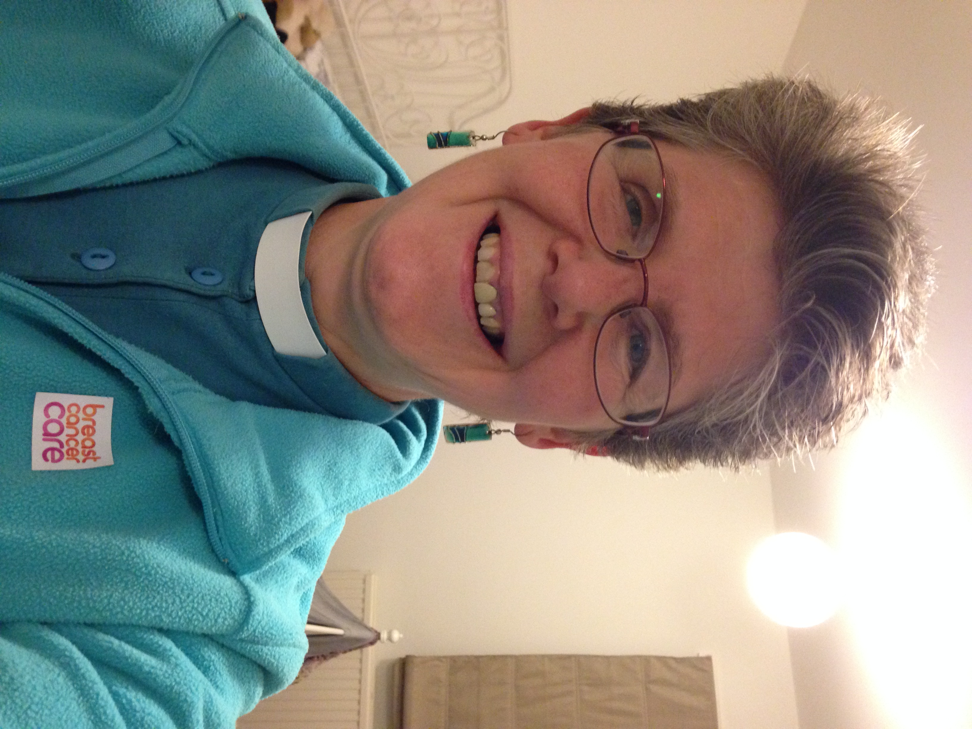

Just tell us a bit about yourself, they said – where to begin, I thought......

Beginning of calling - I am originally from Fort William in the Highlands of Scotland but have lived here in the Greater Manchester Area since 1999. God called me into full-time Christian ministry at the age of 14 and I’ve been on that journey ever since! I was a registered nurse and worked in various areas, latterly in the community as a rapid response nurse.

Calling continued - On arriving in Manchester I joined a local Anglican church and quickly became involved in different aspects of church life. I had wondered if God’s call on my life so many years ago would ever find fruition but enjoyed serving God as much as I could while working full-time. It was on a visit to Israel that I finally realised God was calling me into the Anglican ministry. And the rest is history!

Moving on - I studied at Wycliffe Hall in Oxford for the 2 years. The teaching was enjoyable, the essays less so! Through it all, I have been so grateful to God for the opportunity to be set apart for study and have done my best to make the most of it. After this I have had the immense joy of serving my curacy within the Horwich & Rivington Team and our mission partnership with St Katharine’s, Blackrod. This has been a time of such learning, stretching and growing in my knowledge and understanding of God, His love and purposes for His people.

About me personally – I love books, in fact words of any kind and if I run out of reading material you will find me reading the cereal packets! I am looking forward to being a dog owner once more. I am leader of my pack – consisting of myself and Alfie, a 7 year old yellow loony lab!! He gives me a ready excuse for long walks (another favourite activity). I also play the guitar (not very well) and like cross-stitch.

I am looking forward to joining you all and seeing all that God has in store for us.

Jeremiah 29:11- For surely I know the plans I have for you, says the Lord, plans for your welfare and not for harm, to give you a future with hope.

