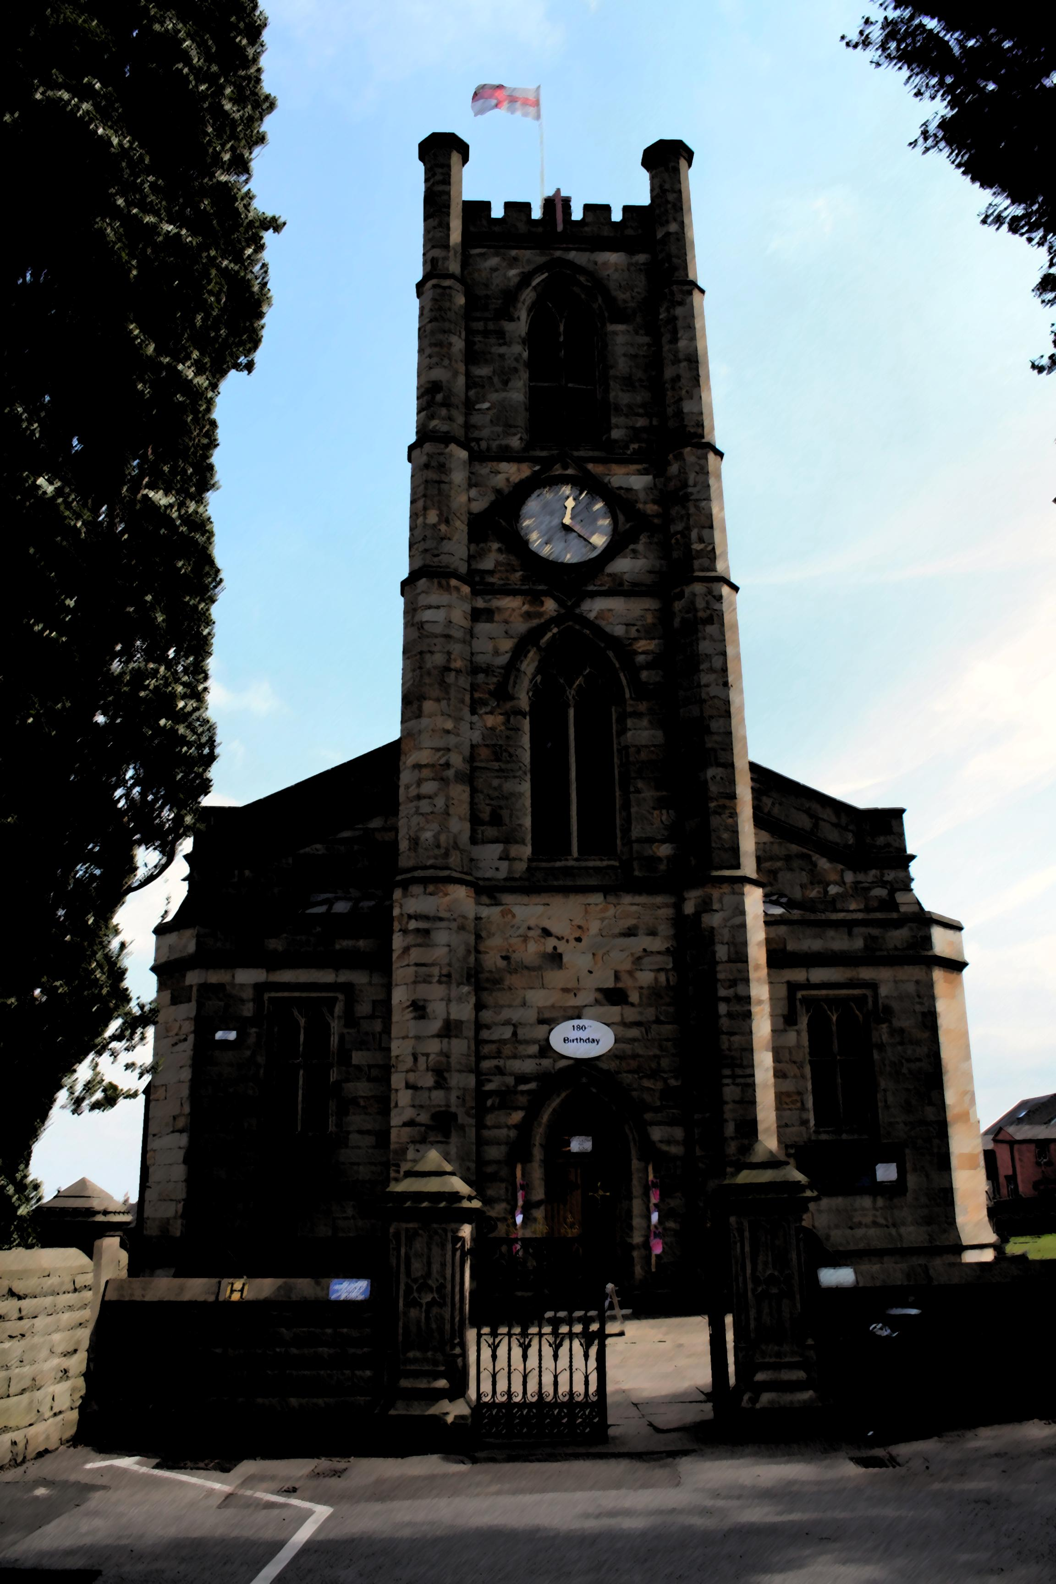
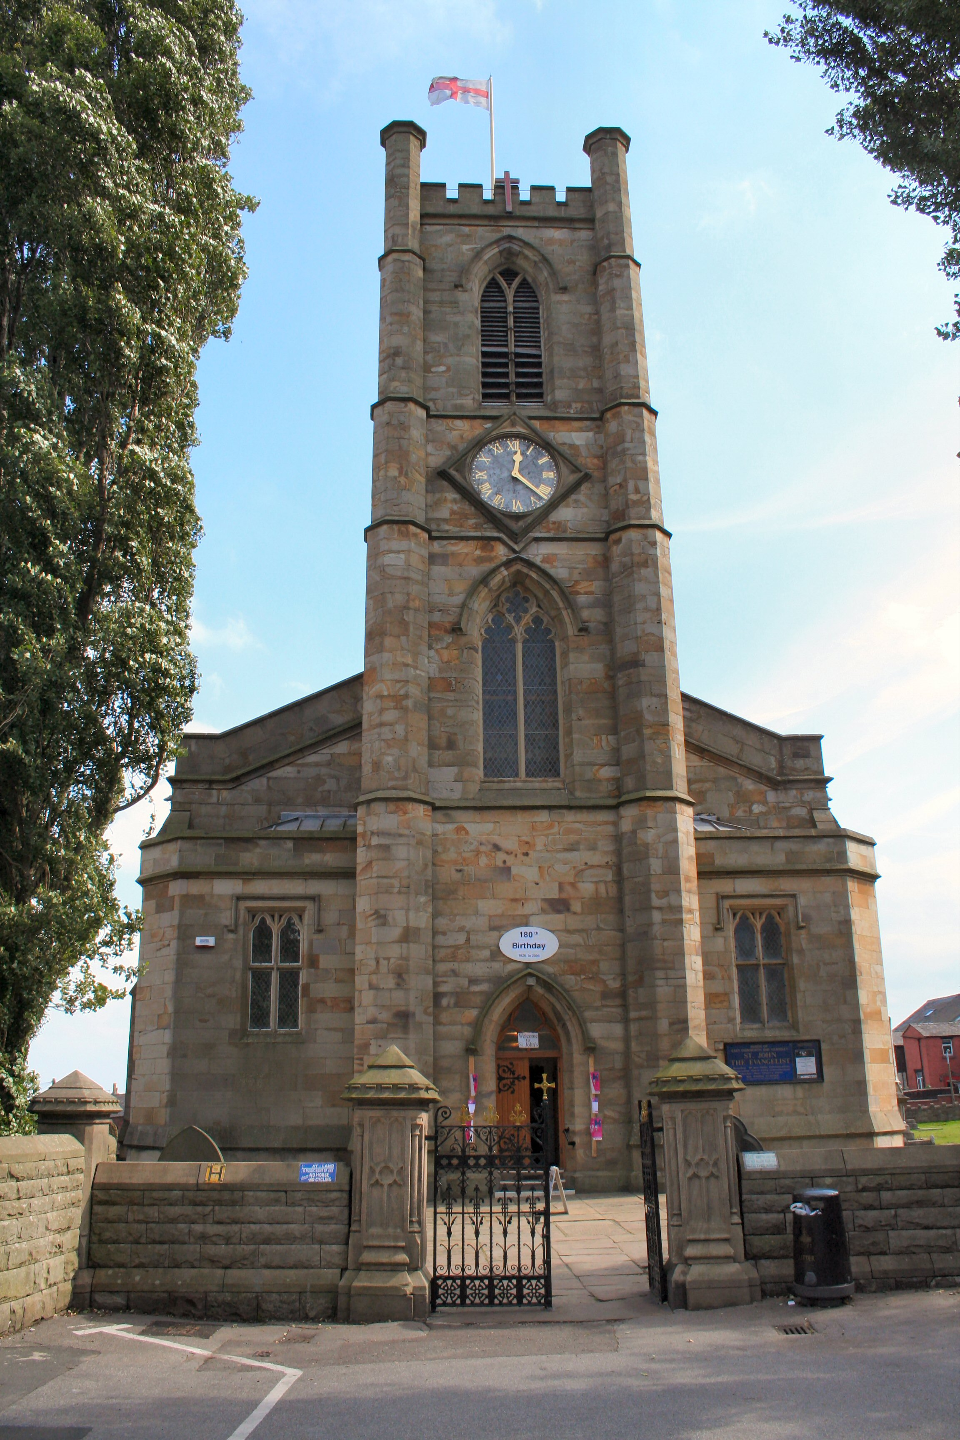
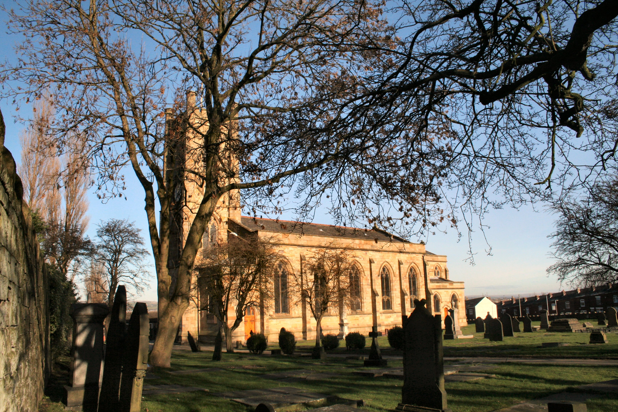

Diocese of Manchester
Parish of Farnworth & Kearsley
Annual Report for 2016

23 April 2017
Index of Report

Chair …………………………………………………………… Page 3
Secretary …………………………………………………………… Page 6
Treasurer …………………………………………………………... Page 8
Planned Giving and Gift Aid ………………………………………… Page 9
Wardens …………………………………………………………… Page 9
Curate ………………………………………………….............. Page 10
Deanery Synod ………………………………………………….. Page 10
Evangelism Project Officer ………………………………………….. Page 11
Authorised Lay Ministry ………………………………………….. Page 11
Electoral Role Officer ………………………………………….. Page 12
Child Protection …………………………………………….…….. Page 12
Sunday School ...………………………………………………... Page 12
Men’s Group ………………………………………………….. . Page 13
Church Website ……………………………………………..……. Page 13
School Project Worker ……………………………………..…… Page 14
Messy Church …………………………………………………… Page 16
All Saints CE Primary School Head teacher ….…………….. Page 17
St John’s CE Primary School Head teacher …….………..… Page 18
St Peter’s CE Primary School Head teacher ………….......... Page 21
3rd Farnworth St John’s Rainbows ………………………… Page 23
3rd Farnworth St John’s Brownies ………………………… Page 24
3rd Farnworth St John’s Guides ………………………… Page 25
14th Farnworth St John’s Scout Group ………………………… Page 27
Statement of Accounts ………………………………………….. Pages 28 - 31
Minutes of the Annual Vestry & Annual Parochial Church Meeting Page 32
PCC Attendance Record ………………………………………….. Page 34
Agenda of the Annual Vestry & Annual Parochial Church Meeting Page 35

CHAIR’S REPORT
Walls and vines
building and planting
planning and tending
measuring and pruning
protecting and nurturing
waiting and watching –
God is at work.
You might know that I enjoy a glass (or 2!) of wine occasionally. In John’s gospel Jesus says I am the true vine and my Father is the vine-grower’ (John15: 1) and a few verses later, ‘I am the vine and you are the branches’ (John 15: 5). Thinking about vines, recently I discovered the little poem above and thought how well the words relate to the life and worship of the church. This year I’m using them as a base for this report.
Building and planting
As always, much of our work through 2016 built on the legacy we have from past years. We continue to worship together, to learn together and to serve our community together in many different ways. Many of us have belonged to St John’s for a number of years but it is always refreshing to see new faces in our midst and different people getting involved in our various activities. One example of this would be in our work with local schools. We have had good relationships with schools for decades but year on year we build on this relationship. In 2016 we developed a new event for schools called ‘Experience Creation’. Paul, our School Project Worker, was the key person in delivering this. We continue to have a programme of many and varied opportunities for our schools to visit church. Elaine Walker in her role as ALM (Authorised Lay Minister) in children’s work plays a major part in welcoming classes and looking after visits. Over the year new people came part of our Schools Support Team that carries out this vital work.
Every week we try our very best to offer to God worship which is of a high quality, well planned and edifying. In 2016 we introduced a new service for the Advent Season which was put together by our curate Malcolm. We also continue to seek ways to make the worship at our monthly All-Age service an even better experience. This can be challenging but we are keen that children and families should learn by participation in this service. With this in mind we have tried to engage different people in reading and leading intercessions. We continue to involve our church schools and unformed organisation groups when they want to be involved. Alison Mole in her role as ALM in children’s work coordinates those who read and lead intercessions at this particular service. We also hold services with the particular needs of families in mind at special times of year such as our Good Friday Service and our Crib & Christingle Service on Christmas Eve. It is really refreshing to see how the number of people attending these services, and the workshops before them, continue to grow.
In terms of ‘planting’, as ever we are also keen to develop new ideas in our work. In 2016 we established a Team Communications Group to look at how we might better aid communications between the parishes in our team. The group is led by Vicar Kim and Steve Mann. Whilst this group is very much still in its infancy we are hopeful that new and innovative ways will be found to help us all feel more connected. In terms of our Team Ministry I feel that we are getting to know each other better and our Team services are always a highlight of my year. It is always good to look around a room of people at the various social events and see a good mix of folk from all the parishes. The poem talks about ‘walls and vines’. As we all know walls can protect but also separate. Whilst we are a team of three distinct parishes we are all connected and we need to ask God’s help to demolish all that separates us and hinders our ability to worship and work together for the glory of God in our area.
Thank you to all who have built and planted this year. Thank you to PCC members, the Social Committee and leaders of all groups. Thank you to our ALMS and Dorothy our PCC secretary. Thank you to our magazine editor, our pew sheet editor, our website manager and all those who have administrative duties. God is at work.
Planning and tending
As a parish our thinking regarding our long term plans continued in 2016. The PCC remain convinced that our beautiful building could be a better resource for the local community if it was adapted. Plans have been drawn up in recent years to enhance toilet facilities and make better use of the largely disused space in the balcony area. In 2016 a small group began preparation work to apply to the Heritage Lottery Fund for a grant to realise these plans. There will be an update on this later this year.
In terms of tending, the work carried out to keep our building and grounds in good order is never ending. We have a dedicated team of helpers who continue this good work. Of course we also tend and care in other ways too. For example, around fifteen people from our congregation are involved in school governance. (One of those, Jean Smith, retired from this role in 2016 after many years of dedicated service.) This role can be a very demanding one but is crucial in the ‘tending’ of our church schools.
Thank you to all who have planned and tended this year. Thank you to our Church Wardens Graham and Keith, our Deputy Wardens Jackie and Shaun, the Tuesday gang, the Saturday gang, our grant application team, school governors, vergers, organists, many others who help prepare our church building for worship and all those who care for our building and people. God is at work.
Measuring and pruning
Measuring or reviewing are essential components as we seek to move forward. In 2016 at the time of the attendance survey in October covering Sunday and weekday services, our average weekly attendance was counted at 158 (110 adults and 48 children.) Of those 110 (74 adults and 36 children) were considered regular attenders, coming to church at least 12 times a year. Of particular significance in these statistics is the number of children. We are very privileged to have such a good number of young people as part of our family. It may also interest you to know that in 2016 a total of 126 people attended our Easter Sunday Service and 250 people attended worship on Christmas Eve or Christmas Day. Throughout the year ministers conducted 31 baptisms, 8 weddings, 17 funerals in the church and 16 funerals at local crematoriums.
A big part of the work of the PCC is to continually review our finances. As you will see and read elsewhere in this report the parish once again occurred a deficit. The PCC has discussed this matter in detail and tried to introduce ways in which to encourage all to think about and to give realistically of their finances to God and the work of his church. The topic of stewardship is always an important one which means that we are all asked to review regularly how we give generously of our time and talents and money. In January we carried out a ‘time and talents’ survey and, as a result of this project, quite a few people took up new roles.
We all know how pruning is so important for the health of most plants. When we relate this term to our church life it is always a difficult subject. In 2016 we engaged on a very serious amount of physical pruning, or rather cutting down completely, the 12 poplar trees which have stood proudly in our grave yard since they were planted for the Queen’s Coronation. Whilst many in our church and community were not happy to see them go, the PCC made a good decision in having them felled before the trees caused all kinds of damage and problems and expense in the future. Replanting something more appropriate in their place is still something that the PCC is considering.
The metaphor of pruning could be continued into other areas of our church life. It’s worth reminding ourselves that when Jesus used the illustration of the vine, the original readers of John’s Gospel saw vines growing and grapes ripening and would know about pruning and fruitfulness. If we put this in the context of the time where a small group of Christians were struggling to survive in a hostile environment, they could not afford to have members who were half-hearted, or who denied their allegiance as soon as persecution threatened. Only those who were really committed would remain — and as the early Christians saw some of their number renounce their faith in fear, or turn back to previous beliefs, the image of pruning, with its promise of growth, would be one of hope.
Whilst as a church today we do not suffer persecution, our churches can seem threatened by indifference, or the growing burden of maintaining buildings and structures. Perhaps we too need pruning — of structures and committees, or traditions and expectations that hold us back. It’s a good question for 2017. What do we need to prune in order to be more fruitful?
Thank you to all who have measured and pruned this year. Thank you to our new treasurer Rob, our assistant treasurer Sandra and our planned giving officer Tony for their continued work. Thank you to those who are involved in sometimes having to make decisions which are not popular but are essential in order that our life and worship can flourish. God is at work.
Protecting and nurturing
Year on year we have as a parish a responsibility to protect. This could relate to our role in caring for our building and heritage again, but in this section I want us to think about how we have a part to play in protecting people. We have, for example safeguarding policies for children, young people and vulnerable adults. We endeavour at all times to look out to the needs of the more senior people within our congregation. One of the ways we do this is by the provision of a service of Holy Communion (Book of Common Prayer) on a Thursday morning. Whilst this is not a service just for the elderly members of our congregation, it is a service which this generation love and grew up with. It is a little oasis of calm in the week and appreciated by 10-20 people each week.
We also in recent years have been blessed and challenged to look to the needs of asylum seekers and refuges who come to find a home with us. This gives us a great opportunity to consider how we welcome all and also an opportunity to learn from different people of different backgrounds. This will become a bigger and more important aspect of our life as the years roll on I’m sure. Our sidespeople are at the frontline of this work as they make sure people feel welcome and at ease when they enter our building.
We nurture so many different people in so many different ways. We have regular study groups, lent groups and advent groups. Our curate Malcolm in his role takes a lead on this and is also developing an itinerary of day pilgrimages and retreats.
With the privilege of having a growing number of children in our church family comes the enormous responsibility of nurturing them in the faith. A large part of this work is undertaken by our Sunday School leaders who are to be congratulated for their creativity, resourcefulness and patience in dealing with so many children in such a cramped area. We are also fortunate to have a number of uniformed groups for children and young people attached to our church.
We have a dedicated team of people who look after those who approach us seeking baptism. In 2016 the PCC started looking again at our baptism policy and how we might better help families to engage in our life and worship following a baptism of a child. This work is on-going and is being looked at by a small group from the PCC. We also are fortunate that we have couples who come to us wanting to get married in our church building. It is such a privilege as someone who is ordained to be able to part of this area of ministry at such an important milestone in a couple’s relationship. Our Curate Malcolm became part of our wedding ministry this year and I am especially grateful that our associate minister Phillip also continues to be part of this ministry. Our annual wedding evening is always a lovely occasion to meet couples and start the process of planning their special day.
We are so fortunate to have St Peter’s Family Church who meet each month at St Peter’s School. This is an informal service were families, mainly from the St Peter’s School Community, can worship and learn together. Sister Dorothy heads this up with a great deal of skill and sensitivity, especially with those who have never had any experience of belonging to a church before.

Sadly this year a number of our church family died. Whilst we rejoice that they are now with God in heaven we do miss them. It is always lovely to witness how well the church family comes together to support those who are grieving the most.
Thank you to all who have protected and nurtured this year. Thank you to Sunday School leaders and Uniformed Group leaders. Thank you to the Sidespeople. Thank you to all who are involved in teaching, baptisms, weddings, funerals and supporting the bereaved. Especially a big thank you to my colleagues who are amazing, generous and kind hearted people. God is at work.
Waiting and watching
The purpose of a vine is to be fruitful. The same applies to the church. Vines can flourish or fail. Grapes can be sweet or sour. The PCC is involved in a process called ‘Mission Action Planning’. In essence this process is all to do with how we can be more fruitful. All of us have a role in being responsible stewards of all that God gives to us and wants to achieve through us. Jesus says I am the true vine and my Father is the vine-grower. I am the vine and you are the branches’. Later Jesus says, ‘Remain in my love’.
In the bible fruitfulness is not measured by how good our worship is or, necessarily, how many new people come to our church, as important as these things are. Fruitfulness is shown by the love we have one for another and those in our community. We might fail but we must continue to work at being branches that bear much fruit. Thank you for being a branch. We wait and watch together as we continue the next step of our adventure in God’s love.
St John the Evangelist Church, Farnworth & Kearsley
God is at work.
Farnworth, Kearsley & Stoneclough Team
God is at work.
Thank you.
Carol Pharaoh
Team Rector and Chair of St John the Evangelist Church PCC

PCC Secretary’s Report
Once again, I would like to take this opportunity to thank the Church Wardens, Treasurer and members of the PCC for their support throughout the year.
The PCC met on 9 occasions, in church, during the period January – to December 2016, with an average member attendance of 15 (72%). Meetings are chaired alternatively by our chair, Revd Carol Pharaoh, and the lay chair Rob McIntyre. Our meetings open with prayer, led by either the Chair or Lay Chair, which is followed by a bible reading selected and read by a different member each meeting.
Our Advent and Christmas Services were reviewed at our meeting in January. It was noted that the number of people attending Midnight Mass was higher than the previous year, as was the Christingle Workshop and Christingle and Crib Service. The Christmas Day Service was slightly down, as was the Carol Service.
In February, the Lay Chair presented a summary of the Quinquennial Report. He reminded members, under items which should be completed within the next 18 months, that consideration should be given to the complete renewal of the south pitch of the slated nave roof. Further discussion took place on the re-modelling of our Church Building. It was agreed that we go forward with the lottery bid and as part of that bid we embark on phase one, subject to our final accounts and monies being available. A bulletin was produced to inform the congregation about the re-modelling and that the plans would be displayed in church.
On the 7th March the felling of our Lombardy Poplar Trees, (or 12 Disciples as they were known locally) which were planted in 1953 to celebrate the Coronation of Queen Elizabeth II, began and took just over a week to complete.
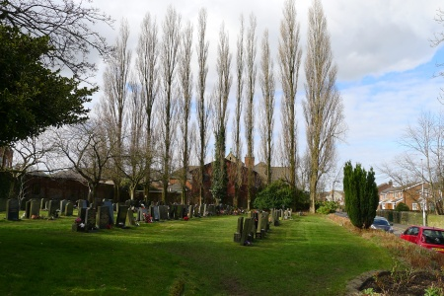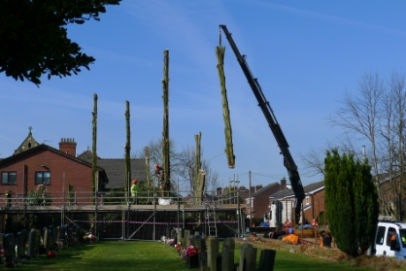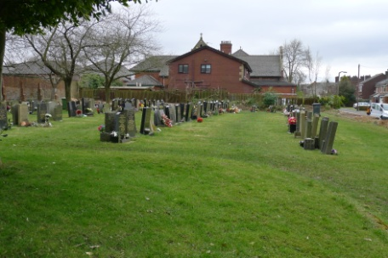
At our March meeting the annual accounts were approved and we reviewed the Child Protection Policy.
The Rector, Revd Carol Pharaoh, chaired the Annual Vestry and Annual Church Meeting on Sunday 26th April 2016, following the morning service. At this time there were 146 persons on the Electoral Roll.
At the first meeting of the newly elected Parochial Church Council on 5th May 2016, the following Church Officers were elected – Lay Vice Chair, Rob McIntyre; Secretary, Dorothy McGlynn and Treasurer, Rob McIntyre. The Chairperson (Revd Carol Pharaoh), Lay Vice Chair, Church Wardens, Treasurer and Secretary are members of the Standing Committee with powers to make decisions when required. Members received feedback from the ‘Congregation Consultation’ on the building plans and discussed the next steps; the meeting agreed to accept the Diocese of Manchester ‘A Safe Church Policy’ as our own policy; the PCC agreed to purchase ‘It is Your Move’ books for those children due to leave our 3 Church Primary Schools to go to Secondary School; a working party was set up at this meeting to establish a Junior PCC.
Tania Lewychyi, the head teacher at St James’s CE High School, attended this meeting. She gave an overview of the proposal for a Multi Academy Trust, linking St James’s CE High School in Farnworth with Canon Slade School in Bradshaw. She explained that as part of the original Foundation of the school we would need to vote to allow St James’s to look at academisation. Members voted unanimously to give consent to the Governing Board of St James’s CE High School to enable them to apply for an Academy Order under the provisions of the Academies Act.
In June, ‘Stewardship and the Changing Patterns of Giving’ was the main topic for discussion. This resulted in Offertory/Gift Aid leaflets being produced and made available in the pews. In addition, posters were displayed in church promoting ‘text giving’ and laminated tokens were provided for those people who give to church by direct debit.
A letter had been received in July from the Commonwealth War Graves Commission, offering, as part of the centenary of the First World War, to erect a sign near the entrance to the church yard reminding the public that it was a war grave site. The PCC agreed to the placing of a War Grave Sign on the masonry near the front gate. Church and Graveyard security was discussed following the theft of some of our York Flagstones.
In September, we reviewed our Mission Action Plan and attempted to measure its impact. Following on from the success of our Waterloo Open Weekend, we agreed to put all our resources into the planned Flower Festival to celebrate 190 years of worship at St John’s Church. A new action was to research the necessary procedures for the provision of a new notice board and it’s positioning in the Church Yard.
Our Lay Chair and Treasurer, Rob McIntyre, told members at the October meeting about the thought provoking conference he had attended regarding poverty in Bolton. He identified where it was located across the borough, with Farnworth being one of the most deprived areas. In response, members agreed to a ‘Reverse Advent Calendar,’ encouraging people to bring a different food item each week for the Food Bank during Advent. Steve Mann reported that the notice board working party had met to discuss various options and Diocesan recommendations. The next step was to obtain quotations.
Our last meeting of the year was in November when a decision was made to order new Mission Praise Hymn books in memory of Nessie Martin, Jack Longworth, Colin Fielding and Sydney Wray, all lifelong members of our choir. In addition it was agreed to hold a Special Songs of Praise Service for members of their families, once the books have arrived. The Junior PCC steering committee reported that they had agreed that the Junior PCC should meet 3 or 4 times a year. Those who become members should be a minimum of 10 years old and will meet after Sunday Morning Service.
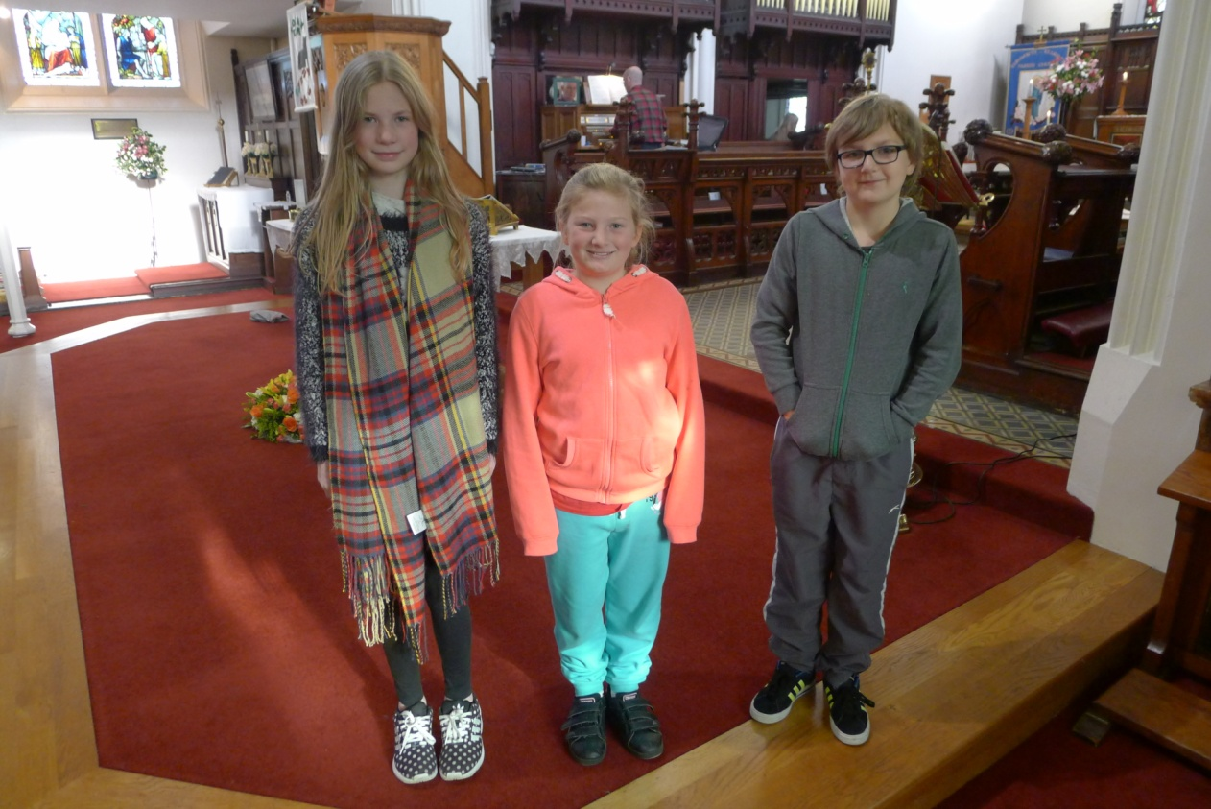
PCC Members watched the Baptism DVD and started the process of reviewing and developing our Baptism Strategy, one of our Mission Action Plan areas for review.
We once again rounded off the year with all three of our church primary schools - All Saints, St John’s and St Peter’s, holding their Carol Services in church.
Dorothy McGlynn
Treasurer’s Report
2016 has been financially challenging for our church with a reported deficit for the year of £2,095, however this was after income received from maturing CBF investments of £7,423. This is compared to a deficit in 2015 of £5,388.
Our regular giving and loose cash reduced in year by £2,542 and we have seen this steadily reduce over the last couple of years. We know and appreciate how difficult it is for us all financially in these times but we need to pray and encourage our congregation to increase their weekly giving. On a brighter note donations increased by £3,036.
We received donations towards the cost of tree felling and churchyard maintenance of £2039. It is important that the PCC continue to remind users of the maintenance cost.
Income from fairs and events increased by £421 to £2,959 and the social committee are to be thanked for their continuing efforts to raise income. The only disappointing note would be the lack of support from members of the congregation for some of these events.
We did however continue to pay our Quota at £39,212 in full which represented an increase of £4,280 on 2015. It is important we continue to pay this as it will allow us to apply for any future grants from the Diocese, especially now as we have some plans for the improvements to our church.
Gas, electric and insurance costs decreased to £11,385 but are constantly subject to inflationary pressures. We have fixed our energy prices for a further two years to mitigate against this inflation risk.
Churchyard expenses were £12,958 in 2016 which is an increase of £10,433 on the previous year, however within this figure was the cost of felling the Poplar trees at £10,000
My job as Treasurer would be a great deal more difficult if it wasn’t for the help and support I have received from Sandra, Betty, Carol, Malcolm & Shaun – Thank you.
Rob McIntyre
Planned Giving and Gift Aid
There has been a steady decrease in membership of the Planned Giving Scheme over the past ten years with the loss of many of our congregation.
In 2016 there were 60 contributors (giving either via an envelope or through a bank standing order) compared with 63 in 2015, 77 in 2014 and 93 in 2007.
There are presently 40 members who have signed up to the Gift Aid Scheme and the tax reclaimed on their donations, with the addition of those who have signed One-Off Donation envelopes, amounted to £4,533.44 in 2016. This is a little down on previous years but still a significant amount.
Due to HMRC’s Gift Aid Small Donations Scheme (or GASDS for short) which was introduced in April 2013, we have also been able to claim ‘top-up’ payments on amounts of up to £5,000 on none Gift Aided cash donations of £20 or less. This has provided an additional £1,250 over the last two years but was down to £1,227.65 in 2016. This is a bit frustrating because from April 2016 the limit on the amount we can claim against was raised to £8,000 giving a potential additional income of £2000.
I would like to thank all who have contributed through Planned Giving and Gift Aid in the past year. It is appreciated.
Tony Hemming
Churchwarden’s Report.
Here we are again, doesn’t seem five minutes since the last AGM.
We have paid our quota in full and have a certificate to prove it. We would like to thank the music group for their continued support at our All Age Sunday Service and to Shaun for allowing the children to play on the drums. Well done to the Social Committee for organising many events throughout the year, raising much needed money to help to keep our church running. These events have brought new people into our church, some have stayed some have not, and have brought us together enjoying each other’s company and fellowship.
We would like to thank the work of the Saturday group which runs alongside the Tuesday gang, which we thank for all their hard work over the past year. Paul continues to work in our schools, the children enjoy his work with them and we think Paul enjoys it just as much as the children. Keep up the good work, thank you Paul. We would like to thank all the Clergy that have kept us in worship of God’s word throughout the year. It is a pleasure to welcome Sister Dorothy back into the flock. We would like to thank Malcolm for organising our trips to York and Chester, let’s not forget the retreat coming up in 2017. Looking forward to Liverpool and Durham trips and a successful flower festival in May 2017.
During the year we said goodbye to the 12 poplar trees which stood at the boundary of the new churchyard, which were planted to commemorate the coronation, but had started to become unsafe. We also lost some York stone slabs from outside the church entrance in the summer, which had to be replaced through an insurance claim, and caused some disruption whilst they were missing. A repair to the vestry roof was also undertaken. There is nothing major in need of repair, things are looking good about the Church itself, the boundary wall in the new graveyard is being monitored for movement at regular intervals, and seems to be stable at the moment. Our team has grown in strength during the last twelve months.
We would like to thank everyone involved in St John’s Church for your support in making our job that little bit easier.
Here ends the report for 2016
God bless you all.
Keith, Graham, Jackie & Shaun
Curate’s Report
Settling in
It is now over 18 months since I was ordained Priest, and I do now feel that I am starting to settle into what my ministry in this team may look like going forward. The training hasn’t quite finished, but the formal bits are reducing, and so it is now just a matter of filling in the missing bits of experience (For example attending a service after the new Mayor’s inauguration at Bolton Parish Church to see something of civic work of the C of E). I have also been on some away fixtures in the Seven Saints Team to broaden my experience of other worship styles. Hopefully by the summer of next year, I will have been able to hand all the paperwork in, have had it assessed, and be officially your OLM rather than a curate in training.
But important as this all this may be, a positive thing this year has been the increasing time I have been able to devote to my ministry focus, which is in developing discipleship and activities focussed on the working age members of our churches. In addition to the now regular team study group (it’s not scary come and join us!), we have had visits to York and Chester and a Team quiet day, all of which were well attended, and seem to have been well received. We have a good number signed up for our first team retreat for a number of years, which will take place in late April at the Foxhill centre in Cheshire.
It would be lovely to be able to do more, but there is a limit to what you can fit in alongside a full time job. It is now around 7 years since I first went to have a chat to Carol about this nudge I seemed to be feeling. Do I regret putting myself forward? Not at all. Is it sometimes very hard work? Yes it can be. Would I encourage anyone else to do the same? Without a doubt. It is a privilege to serve in this Team, and although it can be hard work at times, it is tremendously fulfilling.
Malcolm Wearing
Deanery Synod
The past year has seen the Deanery Synod meetings being held in a variety of venues across the Bolton Deanery. From the Parish Hall at Bolton Parish church, to The Bridge Church, to the Third Space Coffee Shop on Deansgate, Bolton.
Third Space is a non-profit, volunteer run charity, funding youth workers in Bolton High Schools. Well worth a visit.
Topics discussed have been varied, including the resettling of refugees and asylum seekers, a topic which we here at St. John’s are very much supportive of, and mission and mission statements for our own churches.
At the meetings we also find out about services and activities that are up and coming in the Bolton area.
Being a Deanery Synod Rep gives us the opportunity to meet other people from across the Bolton area and feed back to our PCC what is being discussed and going on in the wider area of Farnworth.
Alison Mole
Evangelism Project Officer’s Report
Writing my annual report reminds me what a strange year 2016 was for me. It began with high hopes and renewed energy after I had taken a sabbatical in the autumn of 2015. However, treatment for cancer, diagnosed just after Easter, meant I was largely out of action until the end of January this year. In the periods between treatment I kept as active as possible, so I didn’t lose touch with St Peter’s School, and I was able to do some Sundays too. The main problem was the risk of infection while my immunity was very low.
I was blessed by the love, prayers and support of so many people during those months, and I certainly felt God had me safely held in the palm of his hand throughout. I now feel fully well again, full of energy and enthusiasm and raring to go!
St Peter’s School monthly Sunday Family Service has had a good year, and is a joy to lead. There are now a number of families who attend very regularly, and there is a real sense that we are now an established church family whose members care about the time together, and contribute to its smooth running in a number of ways. I am supported in leading the services by Vicar Carol and Elaine Walker, and there is always a member of the school’s leadership team there too.
I have continued to lead a weekly assembly followed by time with a class as often as possible, and it has been good to get back on to a regular pattern again since January. Similarly I am glad to be able to play an active part again in our programme of school visits from around the parish.
I enjoy meeting with other members of the staff team, and Vicar Carol is a great support and encouragement to me with her wisdom, patience and good humour.
Other areas of my work in the Seven Saints Team, Walkden and Little Hulton Team and with Church Army have also suffered during 2016, but this has been a great time to review what I do, to refocus my priorities for the next few years. This is still a work in progress.
Sister Dorothy Needham
Authorised Lay Ministry
In the past year I have continued to maintain and build on the links between St. John’s Brownies and our church. The Brownies like to be involved in the service either by reading or writing their own prayers and reading them out. It remains a challenge to obtain a good attendance at family service.
I have been working with 5 of the girls who were interested in doing the Discovering Faith Badge. They have to regularly attend church, write prayers, talk to somebody whose faith plays an important role in their lives (the girls are looking forward to interviewing Vicar Carol), learn about 2 religious festivals and research into a religious based organisation-such as Christian Aid.
I led the Christingle service on Christmas Eve with help of the children. It was very well attended.
In September I am due to be recommissioned in my Children’s ministry, which I look forward to. I enjoy working with our children, they are so amazing and enthusiastic. They learn from us but we also learn a lot from them. I am also studying towards an ALM in Worship this year.
Alison Mole
September 2017 will hopefully see me attend Manchester Cathedral on the 10th September to be re-commissioned for another 3 years as an ALM in Children’s Ministry.
With regards to this role, I feel that I have only begun to scratch the surface with my participation in school visits to church, leading the Key Stage One assemblies at St Peter’s once a month, attending the monthly family church which is held in the studio at St Peter’s School. Until recently I was a Sunday School leader which I enjoyed very much, but which sadly I have had cause to resign from.
In the future I hope to expand the role and take on more responsibility and participation in events which would come under the umbrella of Children’s Worship. In May 2017 I will commence a new ALM course, this time in Community and I am excited to start this new journey for what I hope will be a fulfilling 3 years.
I would hope that this new ministry will combine in some way with my current role and I look forward to commencing my training on the 3rd May 2017. I am not sure what route the future will take me on, but I approach it with excitement and a renewed sense of hope that my ALM ministry will take me on an enjoyable and fulfilling journey.
Elaine Walker
Electoral Roll Officer’s report. 2017
The electoral roll started last year at 146 members. Unfortunately, I have to report a decrease in the roll for this year. After the loss of some of the older congregation and people moving away the roll stands at 142.
With the amount of new families attending church regularly it might be advantageous for us to promote the electoral roll at family services, and explain that it doesn’t cost anything and in fact works to their advantage, and then perhaps we could look forward to an increase in 2017/18.
Kim McIntyre
Child Protection
Fortunately there is very little to report for 2016. No incidents have been recorded, I put this down to the fantastic people we have that work with our children. I feel confident in the knowledge that our children can come to our Church and feel safe and comfortable.
We have been fortunate to have had new Volunteers for Sunday School this year and would like to thank them for sticking with the process, all now have their DBS. I have also been working with existing volunteers on renewing their DBS certification and to make sure we have all the relevant documentation required.
We continue to offer our children a safe and caring environment and would like to thank all who currently work with children for their continuing work mentoring, teaching and protecting our parish’s young minds.
Please come and see me if you have any interest in working with our parish’s children and I will talk you through our process.
God bless
Shaun Croston (Child Protection Officer)
Sunday School
Sunday School has grown over the last twelve months and at times there have been over 25 children attending. You all will appreciate that this is great for our growth but challenging for the Sunday School teachers. We have had a few changes to staff this last twelve months and thank them for all they have done for the children. It is not easy standing at the back of church trying your best to deliver a lesson and make learning interesting, as well as keeping noise levels down.
We are lucky to have some new recruits to our Sunday School teacher team and we will all be going on some training soon to help us enrich the children and keep them safe.
It is lovely for the children to share what they have done each week and they enjoy talking to the congregation.

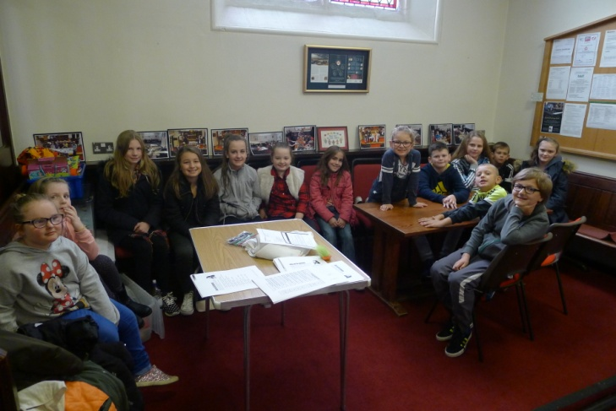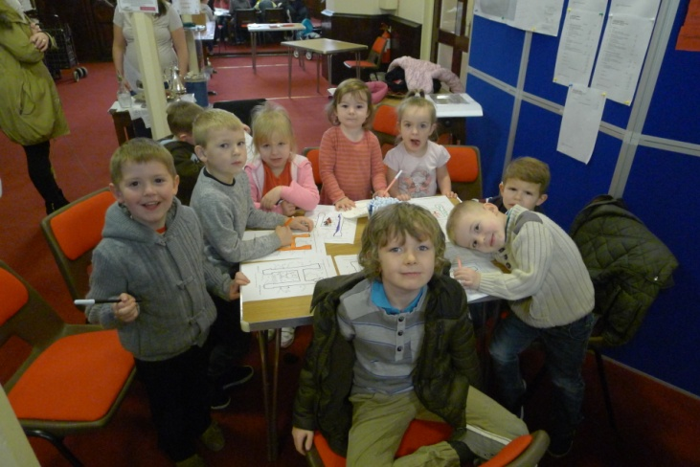
We are looking towards changing the name of the Sunday School so will be asking the children what they would like, watch this space.
Please keep us in your prayers.
Sandra Martin, Sunday School Teacher

Men’s Group
It is sad to report (Again)that the Men's Group is struggling to some extent due to the loss of some members and ill health with others. However, we do not despair and intend to resume activities very shortly after Easter 2017.
As usual we are on the lookout for new members of our group so if you would like to join in and help us have some fun and make some attempt at being a musician (In the loosest sense of the word) please get in touch with me or any member of the group.
Phillip Castle
Church Website
Last year I reported that the website numbers were looking good. This year the ‘headline’ figure of total page views is down a little on 2015, but at 16,206 pages viewed, is still the 2nd highest on record. The good news is, the trend over the last 7 years is upwards.
I believe the most important figure is the ‘returning visits’ figure. This shows how many people are deliberately returning to the site, rather than just coming across it by accident, so this is a measure of how much the site is being used. Last year this number more than doubled from the previous year and has continued to increase, albeit slightly, this year (1146 returning visitors).
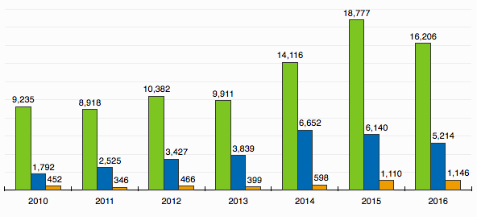
With the help of Nigel McFarlane we have increased our use of twitter and Facebook. Our FB post promoting the Family Fun Day reached 974 individuals and has been our most successful post to date.
Thank you to all that have contributed to the website, Facebook or Twitter. Please keep up the good work, and remember, use it or lose it! Comments, observations and suggestions are always welcome.
Steve Mann
School Project Worker
As I was reading back through the previous year’s report for Schools outreach work, at the time, there were a lot of things that were changing at Zac’s, people moving on, job funding uncertainties, all of which felt quite unsettling, as well as in my own personal life, moving house, joining St Peter’s Church, Halliwell my wife starting quite a demanding role as youth minister there. But preparing this past year’s report for year ending 2016, it feels like writing from a different place all together.
There is a lot to give thanks to God for, his provision and timing, opening doors for schools outreach to continue, new young people met, new schools to work with, new ideas and financial provision, the support of Revd. Carol and the school support team in putting on school events. There is a lot to give thanks for. Thank you to St John’s for all the on going support including hosting the Zac’s celebration Evening each Christmas in church, the young people really gain a lot from that experience. Below is a report of the key projects I have been involved in over the past year, and looking ahead to the next year.
Hate Crime Awareness CD: Zac’s received funding last year from Bolton CVS to record a hate crime awareness CD. Part of the project was engaging pupils in schools in the theme, so I ended up working for 6 weeks with 20 pupils from Kearsley Academy and 10 pupils from St James’s in addition to the regular sessions we ran. As I was leading this project, the children thought about subjects such as stereotypes, treating people fairly, caring for others who are different from yourself, “not judging a book by its cover.” The children then wrote songs and worked with a professional music producer to record the songs and then a CD was produced and released at an event that was held in The Vaults in Bolton Market Place. It was great as I got to work in Kearsley Academy for the first time and get to know pupils there and recognised many faces from schools work we have done in the past in Primary schools. Hopefully there might be more scope in future to work in that school.
St James’s Impact: Towards the end of summer term 2016, the previous chaplain at St James’s (Miriam) moved on from the school, and Andy Hunter became chaplain. He was keen to continue with Impact if I was willing. We relaunched it again, this time in a different classroom, and it has proved really popular with between 20 and 40 pupils each week in attendance for much of the past term. The session is proving to be a safe space for teenagers to come and hang out with their friends, and then many staying around at the end as we discuss and think about different things each week in relation to the Christian faith such as “Is God real?” “Sacrifice” “Christmas” “Justice”. It is the largest session I run as schools worker numerically, which is a nice dynamic as it is quite hectic and not as focused as the smaller groups, but is really lively and we are obviously providing a service the young people really benefit from, even if it is just somewhere to hang out and talk for a few minutes to staff and friends.
Engage @ The Ferns: the “Engage” session has continued as previously, with no major changes, the session is still really popular with having to turn children away each week due to the amount that are coming.
The Ferns school has the Engage session running once a week during lunch time and this is a really popular club for young people to attend. We set the number at 15 so that we can have as impacting a session as possible, but each week there are around 20 that want to come but as it is first come first served, we have to turn people away and ask them to come back next week. This session has really grown in popularity and it is great to see so many attending week in week out. We look at different subjects such as “how to be a good friend”, “dealing with disappointments” “Being a good role model” as well as more RE based subjects such as “why do Christians celebrate Easter” This is a great session for those who struggle making friends or knowing what to do with themselves at lunchtime and provides a safe place to make friends for the children.
Through the activities we run, playing games and then giving children space to reflect upon their own lives, we have had really interesting questions asked, and children open up to staff about the struggles in their lives such as the loss of parents, bullying etc. It is a great way of communicating with teachers about what the children have said to us in order to get them the support they need more.
Mentoring: I have been going in on Friday afternoons to The Ferns for an hour over the past year to mentor 2 children. One was a girl that had moved over from Afghanistan and couldn’t speak English. Each week I sit with her and read a book and play games and colour in with her. In the time I’ve been working with the girl she has turned from being really shy to happy and smiley, and her English is improving lots. Obviously, there are lots of people helping the child in school, I can’t take much credit for the change, but it has been great seeing her consistently each week and letting her have fun for that time and choose what she would like to do. I have introduced her to table tennis, Jenga and other games whilst reading and drawing pictures of her home country.
Energize @ St John’s.
Energize continues with around 10-15 children each week, thinking about different Bible stories and faith based subjects and character development.
We have looked at subjects such as “what is prayer” “the persecuted church” “The fruit of the Spirit” “loving my enemy” “Caring for others”
Mentoring: I have been mentoring several pupils over the past year in St John’s, most recently with one year 5 boy each Friday before lunch with teachers commenting “they have really improved lots over the past few months.”
Friday After School At All Saints
Moving forward from the previous in school session, the school were struggling to accommodate the group during school time due to lack of space, so the group has changed to after school on a Friday, and we have between 7 and ten mainly year 4’s attending. It has been good to see this little community develop and have fun together whilst thinking about similar subjects to the other groups such as listening well, caring for others etc. and also encouraging the children to grow as people in their character through positive reinforcement of their attitudes when they are good.
Kearsley West:
My work at Kearsley West is growing from strength to strength, I now go in once a week to speak to pupils who have been identified by school as needing some extra support. So I have worked with 3 different children now on a regular basis including children who have suffered bereavements and who have low attendance in school. I make worksheets for the children to fill in whilst we talk about aspirations for the future, hopes and dreams etc.
Assemblies:
The assemblies have been continuing to go well, I have been continuing delivering collective worship in St John’s, The Ferns, All Saints and St Saviour, Ringley and Kearsley West. Although I haven’t taken assembly for the past while in The Ferns or All Saints.
Events:
The Experience Events have continued to prove popular. We added another event to the program called “Experience Creation” which I wrote in addition to the Footprints event we have been working on over the past few years. Experience Creation is about helping children to appreciate their environment and to think about how their life choices might affect other people as well as trying to give them an appreciation for the creation all around them in the hope that it might point them to God. Kearsley West have begun attending these events.
Collective Worship CD:
In the summer term 2016, I applied for some funding for myself to develop creative project ideas, one being to record a children worship CD of songs I had written, the bid was successful and the work on the CD began, Andy and Wendy Green, music producers based in Radcliffe and part of Bury Christian Fellowship agreed to be involved in the project and 7 groups from 6 primary schools signed up to be involved. The CD will be released in July 2017 and focus on the theme of “The Wonder World” and will have songs based on being made in God’s image, have a purpose in life, heaven, John 3:16 etc. and will engage with around 200 children in the schools, with a launch event taking place at St John’s church in July.
Finland 2016-I was invited by Susie Mapledoram to go on a confirmation camp in Tampere, Finland in July 2016 after being involved leading the musical worship at a youth night at St Mary’s Church, Prestwich. The trip takes up to ten young people from the Manchester Diocese for a week to a residential retreat centre in Finland to spend time thinking about the Christian faith, as well as having an unforgettable experience in another country getting to know other English children and make some Finnish friends too. The week was amazing, helping the young people consider their beliefs and commitment to Jesus, two of the young people we took from Manchester loved it so much that they signed up to the following years’ program called “Isonen on the Road” which is a young leadership program, which I was invited to be part of again. I mention the trip as it was a real privilege to be part of, but also in the hope that maybe some of the young people from this parish might get involved in a life changing week…the trip was good for me to experience youth work in a different context and also to meet other youth workers from Finland, but I hope that some of the young people from St John’s might get the chance to experience a week away thinking about their life and where they are heading, and to make new friendships and experience a different culture.
Please continue to pray for the work of Zac’s, my work in schools to grow and become stronger and more influential and the lives of the young people we meet to be impacted in a positive way.
I’m praying that as well as having fun and making friends, these session and events and assemblies we do would really impact lives and cause them to examine where they are going, the choices they make and the beliefs they choose for their lives. Please pray that young people would be impacted by the love of Christ in their lives and follow the One who has plans to give them a hope and a future. Also, for the ongoing reach of the “Looking For The Wonder World” CD to bear fruit in the lives of the people that hear the songs, that they might experience God’s love for them through the songs.
Thank You
Paul Saxon
Messy Church
One of the casualties of my being off work ill was Messy Church, and we have not had a session since last May. The team has seen a few changes since we began, and there have been issues we need to address, such as how we engage all members of the family in the activities, not just the children.
As we seek to pick things up again, it is a good chance to review, reflect and pray about the best way forward, including recruiting new helpers to be part of the craft, catering, or welcoming. Anyone who feels they would like to be part of this can speak to Vicar Carol, the wardens, or me.
We have inevitably lost momentum, but I think all of us involved in Messy Church felt that it was worthwhile and a useful vehicle for outreach to families on the fringe of church life, helping them to learn more about Jesus and his love for them in a relaxed and friendly setting. I hope 2017 will see us relaunch, with new ideas and revived enthusiasm, confident that God will use our efforts to bless others.
Sister Dorothy Needham
All Saints’ CE Primary School
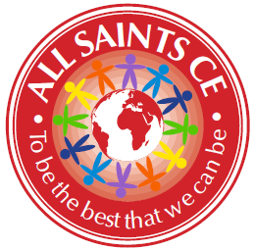
We have had a great year at All Saints, with lots of exciting events both in and out of school. Although our SATs results fell this year, this was in line with the national picture as a result of the new tests being introduced. Our progress was good, as several of our children are below national average lower down school. We were especially pleased with our Maths progress which was in the top 30 in Bolton.
Enrichment

And God saw everything that he had made, and behold, it was very good. Genesis 1:31
A big part of our mission is to provide our children with the opportunity to experience our wonderful world. This includes regular visits to art galleries and museums – we are very blessed in being so close to a train station so Manchester is a regular haunt of ours! Each class also go on trips related to the topics that they are learning, which last year included Skipton Castle, Tatton Park, Cadbury World and Smithills Farm.
The highlight though was our whole school trip to Thornton Cleveleys. About 18 months ago, we discovered that the vast majority of our children had never seen the sea. We applied for a grant to help with the travel costs and set off last June. I wish I could have bottled the look on the children’s faces! They all had a paddle, made sandcastles and had fish and chips and ice cream. It was one of those days that make you glad to be alive.
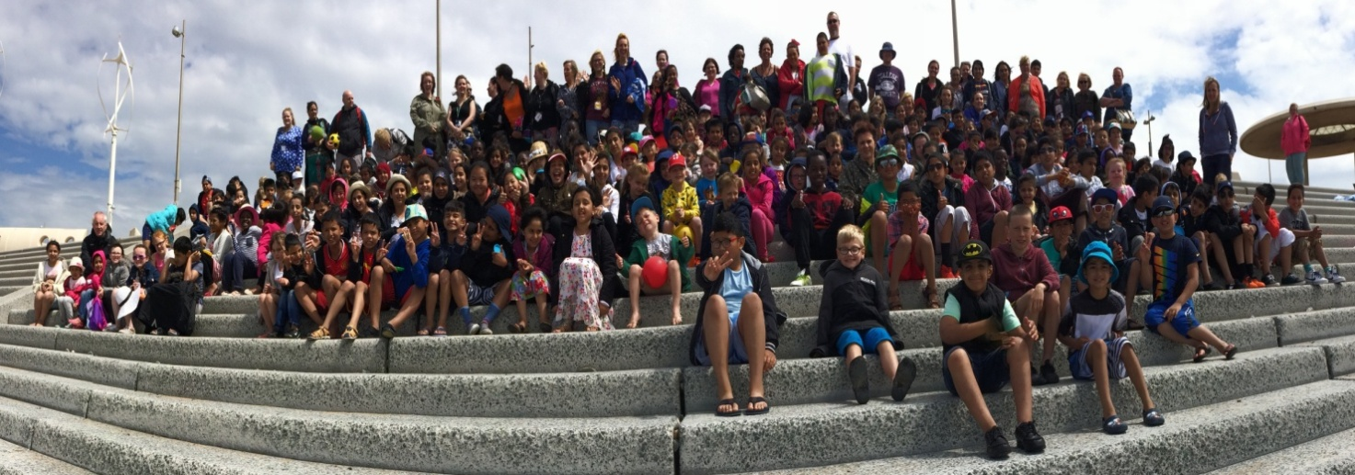
Church and Community
So then you are no longer strangers and aliens, but you are fellow citizens with the saints and members of the household of God, Ephesians 2:19
We have continued to strengthen our links with the church and wider community. Several of our classes have benefitted from the ‘Experience…’ events at St John’s church and always come back full of enthusiasm. We held our carol service in church again and had a few more parents attend. Our school council wrote and read the nativity readings in their own words this time, which added a special touch. Paul has been running a weekly club supporting children with their spiritual wellbeing. Vicar Carol and Paul have also continued to deliver collective worship sessions in school.
Last June, we had the honour of welcoming a Headteacher from Lahore to the school. Meeting a Christian from Pakistan was a revelation to lots of the children and they learned a lot about the work of the Church in other parts of the world.
The schools in Farnworth continue to forge a strong partnership with collaboration at all levels. This includes our continued teacher training programme which supports us in recruiting high quality teachers. On a personal note, the support from other Headteachers is invaluable.
Governors
This service that you perform is not only supplying the needs of the Lord’s people but is also overflowing in many expressions of thanks to God. 2 Corinthians 9:11-12
Our governors have continued to develop their role in school improvement. They have been involved with learning walks, book scrutinies and more training which is helping them to know school better as well as them becoming familiar faces for the children. We also have a number of governors who join us on trips or for our theme weeks. We are currently working on updating our long term vision for the school. We need to say a special thank you to Jackie Powell, whose latest term of office expired this year. Jackie has given generously of her time over her years as a foundation governor and we are very grateful to her.
Conclusion
I continue to be grateful and proud of the work that we do in school. Our children are blessed to have a nurturing team of staff who give of their time and their talents to support their progress, both academically and spiritually.
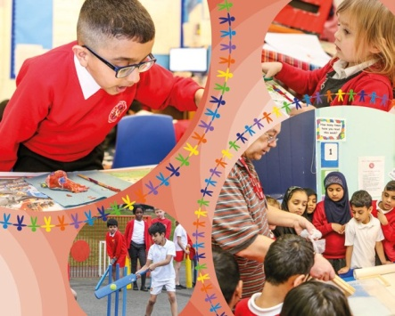 | 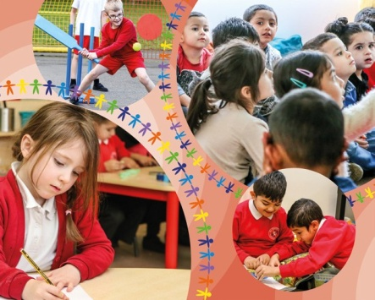

Katie Hague
Headteacher

St John’s CE Primary School
Spring term 2016
We again combined Comic Relief celebrations with our non-uniform day towards the Easter Bingo – which sells out every year and we couldn’t do without Keith Entwistle and a team of volunteers from St John’s Church. As usual we thoroughly enjoyed our Easter Experience in church and thank the team behind it.
Summer term 2016
This term the school held its first ‘What Makes Britain Great Week’ and we were visited by a range of services and enjoyed ‘tea- parties’ and other wonderful events.

All of our Year 6 children received St John’s Ambulance training and our Year 5 and 6 enjoyed an ‘Anti-Discrimination Workshop’.

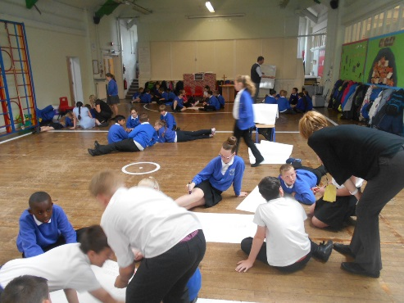

Our children helped to plant flowers and shrubs as part of ‘Kearsley in Bloom’ to help improve the appearance of the front of the school.
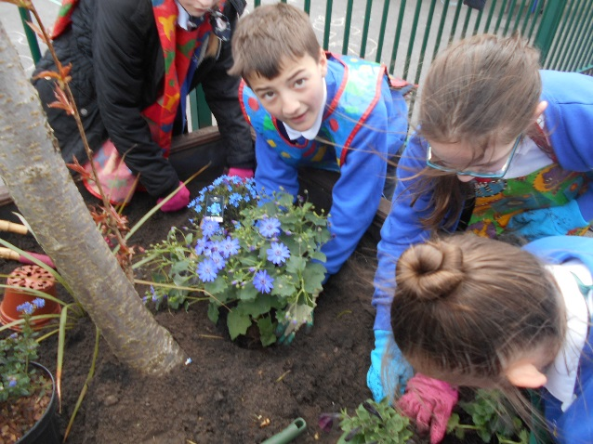

Autumn term 2016
We held our annual Harvest Festival where we gave thanks for God’s good gifts.
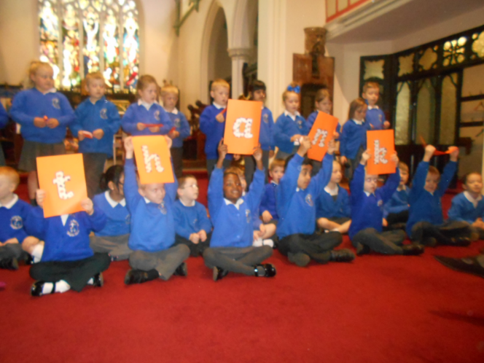
The whole school took part in the ‘Race for Life’ around the school field raising money and awareness for cancer research.
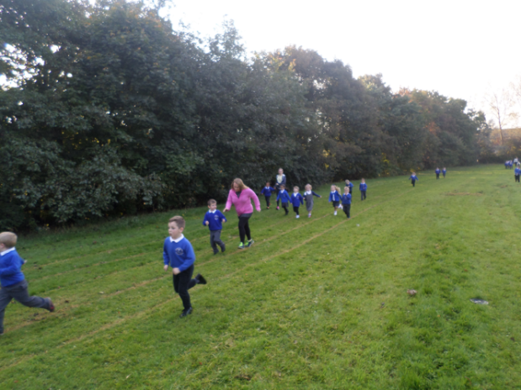
The school was rewarded with another ‘Good’ rating at the SIAMS Inspection in November where it was recognised the strong links with the church and community St John’s Kearsley has.
The children had the opportunity to take part in an Inter Faith Day at the Well where they had hands on experience of other faiths and beliefs.
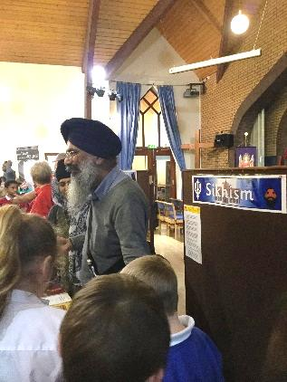
We welcomed Paul Saxon and his Energize Club into school to run sessions for the children.
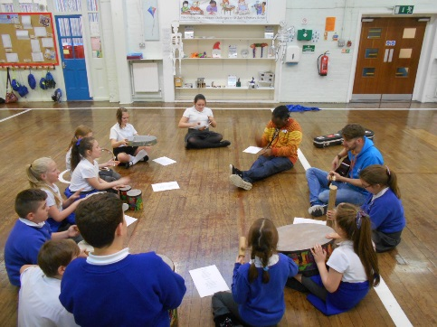

Mrs Coucill one of our Foundation Governors visited Year 6 to teach them about the Eucharist.
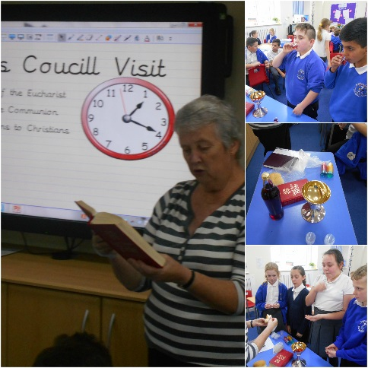
We held our ever popular ‘Christmas Tree Dressing Ceremony’, the infants performed their Nativity plays to a packed house.
Suzanne Howard
Head teacher (from January 2017)

St.Peter’s C.E.Primary School

Head teachers Report for the Parish – March 2017

“ Learn, Sparkle & Shine…”

2016 was an exceptional year for all at St. Peter’s with a number of noteworthy events taking place.
The year began with a visit from OFSTED on February 2nd 2016, exactly five years since their previous visit.
We were delighted to be informed that the HMI judged our school to be OUTSTANDING and this was further enhanced when in June 2016 the school was rated OUTSTANDING by Manchester Diocese Board of Education in our SIAMS inspection.
The overriding Christian Value that permeates all our work is that of hope – hope for our future and that of all our children.
As children walk through the school entrance doors and step in to St. Peter’s they are asked to imagine themselves taking daily steps down Progress Avenue.
Displayed on our walls are the words; “Where you enter St. Peter’s neither impresses nor depresses us; we just expect that you know you come to school to learn and make progress as you take daily steps down Progress Avenue with us.”
This philosophy led to us being awarded Bolton News Primary School of the Year 2016 and also being shortlisted for the Times Educational Supplement (TES) primary school of the year.
As OFSTED said;
“Each corridor is labelled to reinforce a value or an ambition and emphasises the aspirational ethos which pervades the school. Pupils regularly walk up Progress Avenue, Cooperation Alley or Achievement Road on their way to lessons, assembly or out to play.”
The vision continually reinforced is that Progress Avenue is endless;
- it does not seek to limit someone to a predetermined potential
- it does not assume a natural talent or predisposition.
- It recognises that hard work and effort will lead to greater outcomes and achievement.
- It starts with you and takes you as far as you want to go.
This philosophy has helped our staff to open their minds to the meaning of inclusion and avoid limiting beliefs, both for themselves and the pupils.
By building a belief that anything is possible, you just have to take the first step towards achieving it, the children have been given the power to determine their own destiny.
We believe that acquiring basic literacy and numeracy skills is fundamental for pupils’ future success. Through the implementation of rigorous phonics, reading and mathematics programmes we have ensured that the attainment gap between disadvantaged pupils and their peers is narrowed.
Our exceptional provision in reading was recently validated through being awarded “reading recovery school of the year – 2016,” by the Institute of Education at University College London (UCL).
Our simple mission when entering school is to ensure that each day we are further on our journey than the day before. This philosophy was reflected in our whole school worship theme for the Spring Term.

‘Success won’t just come to you; you have to make it happen! It’s your future and it starts now’

Proverbs 3:6
‘Let God direct your steps!’

Beyond the pupils of St. Peter’s, 2016 allowed us to reach out to other schools and pupils in our role as a National Support School designated by NCTL June 2016. Our team of SLE’s, led by the Head teacher who is an NLE, were given the humbling opportunity to contribute to school improvement work across Bolton and indeed in to Manchester .
Our staffroom wall displays the following words, which epitomise the soul of the school. We are the servants of the next generation and we aspire to give them the best future possible.
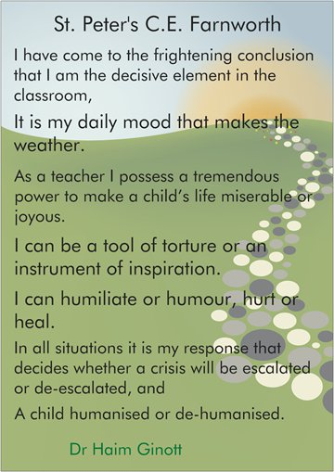
Our links with the church and community are very much valued by the school.
Our entries in to the Kearsley in Bloom Festival and Kearsley Scarecrow festival brought great joy to the children and certainly added an extra layer of colour to our local area.

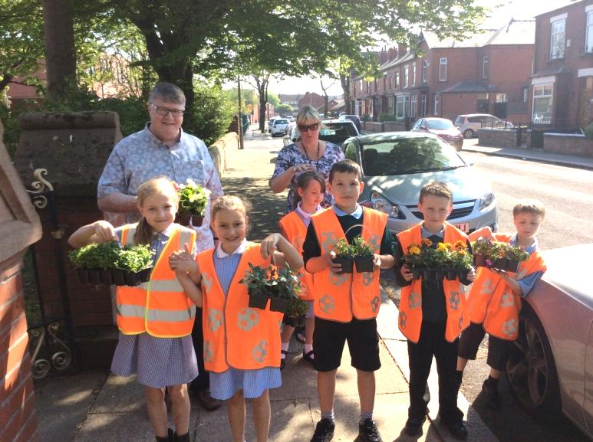

We are reassured by the support and encouragement we receive from our school Governors and from all members of the parish. It would be difficult to imagine leading a school, without such key people! Our thanks go to each one of them and to Vicar Carol for their continuing involvement and blessing.
The future of collaboration in Farnworth is looking exceptionally strong and we look forward to being part of that future, working alongside the church community to build a great future for our children.
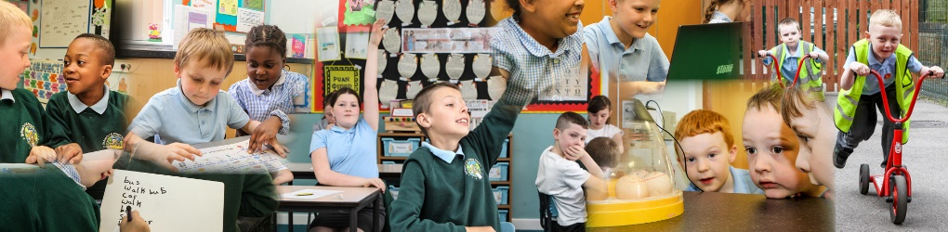

Thank you
Lynn Williams
Head teacher

3rd Farnworth St John's Rainbows
St John’s Rainbows is a very happy and busy group. We meet on a Wednesday evening in School. We are always full and have a waiting list, which is a good sign.
We do lots of crafts and gain confidence in our abilities. We have shared activities with the Guides and Brownies. There is myself and Heather, Group Leaders, and we have two young leaders in training from Guides, Catlin and Keely. They delivered our Christmas programme and did a good job. We have shared party nights with the Brownies and trips out.
In October we went on a sleep over with Brownies to the Lego Land and Sea Life Centre, it was an amazing experience even for the leaders and we managed to get some sleep whilst watching the sharks swim by.
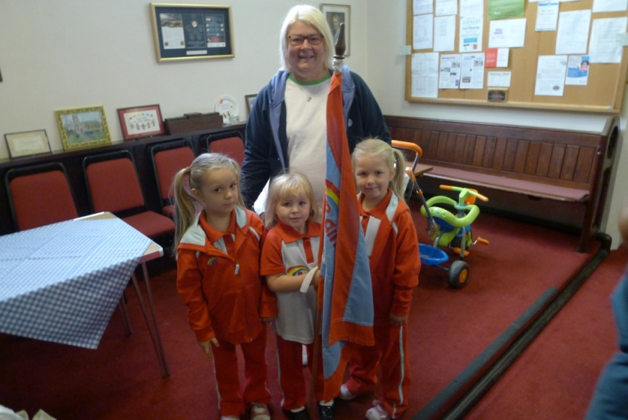

We have had some success in getting girls to join the Family Service and they love carrying the flag with pride. Due to our success, I have had to recently recruit another adult helper as I am at my limited permitted number of 18 for a group.
We love working with the girls and also have close relationship as a whole Guiding Group. St John’s is very healthy in its Guiding Units.
Yours in Guiding,
Sandra Martin Unit Leader
3rd Farnworth St John's Brownies
The past twelve months have continued to be busy and enjoyable at Brownies. We have seen a number of our Brownies leave because they have reached the magical age of 11, meaning that they can longer be with us. A few have joined our guide unit, whilst others are thinking about it. We have, on the other hand, had new girls joining our pack. Some have come up from Rainbows, whilst others are new to the guiding movement.
We, as leaders continue to face new challenges to keep the girls interested in coming each week. There are so many other things that they can do these days.
We have actively encouraged the girls to work towards interest badges. Badges achieved include, writer, cyclist, speaker, sports, artist and the swimmer badge. Currently five brownies are working towards their discovering Faith badge.
At our meeting we enjoy playing games, treasure hunts, colouring therapy, quizzes, craft work, baking, going for walks (weather permitting) and learning about ourselves, our community and our World. The Brownies have been very keen to take part in our family services and enjoy writing their own prayers and doing the reading during the service.
Last October we had a joint trip with our rainbows and their leaders to Legoland and Sealife at the Trafford Centre. We slept overnight by the side of the fishes. Or shall I say –some slept! A good time was had by all.We had a joint Christmas party with the Rainbow where we played games, won prizes and for a change, had pizza for our tea.
Rachel –our young leader in training, has almost completed her training. She continues to be a valuable member of our team. We would all like to wish Rachel well as she will be leaving us later this year to embark on the great adventure of University life. This coming year we hope to do more day trips and maybe a weekend. We look forward to new girls joining. The most important thing for all of us, girls and leaders, is to have fun!
Alison, Jackie, Dot and Rachel – our young leader in training.

3rd Farnworth St John's Guides
2016 has been a hectic year for 3Rd Farnworth Guides filled with fun, excitement and laughter. We have been doing lots of different badges as well as lots of fun residential experiences. Here is just a rundown of some of the things we have done over the past year. Our Guide unit has on average 16-20 girls.
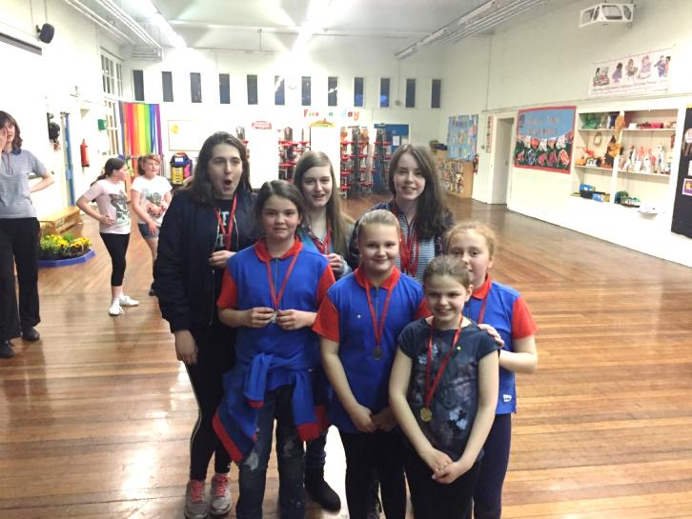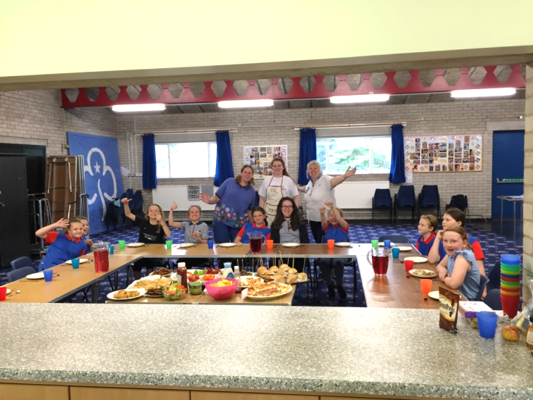

Backwoods Cooking at Bibby’s Farm and Ready Steady Cook. (May)
In May, our Guides did their cook and outdoor cook badge. We learnt about health and safety in the kitchen and how to plan a healthy meal on a budget, which meant a trip to the supermarket comparing brands. On our Ready Steady Cook day, we created a feast for our entire unit which included homemade pizza (including the dough!), fish goujons, homemade bread, and other delights.
We also took part in a backwoods cooking day at Bibby’s Farm. We learnt how to light a fire safely, what to do if any accidents happen and lots of outdoor cooking techniques. We skinned rabbits, descaled and deboned fish and even had squirrel!!!!! As you can imagine not all of the Guides liked that!!!
Target Sports at Bibby’s Farm
This year our unit has had lots of new girls which meant lots of firsts! So when we took part in the target sports competition at Bibby’s Farm, it was first time many of them had slept under canvas! We took part in lots of target activities which included, rifle shooting, pistol shooting, archery and crossbow. On the Saturday we had several sessions to practice and develop our skills in the target sports and then on the Sunday we began the competition against other Scout groups! Our Guides were amazing. We came 3rd in Archery and 2nd in Crossbow!
GOLD Rwanda 2016 (August)
In summer, our Guide Leader Jenny was selected to represent Girl Guiding UK on a GOLD project (Guiding Overseas Linked with Development) to Rwanda. GOLD projects provide sustainable community or guiding based development projects, from leadership skills training to delivering advocacy programmes to young women.
In Rwanda, the project was to provide leadership skills workshops for Leaders and Young Leaders, to run workshops with girls on new programme resources and to provide first aid training to Troop Leaders. Jenny travelled around the rural areas of Rwanda providing training which was sustainable so leaders out there could re-use ideas, games and activities with the limited resources they had yet develop young women out there. It was a fantastic experience which showed the importance of world Guiding and women’s rights. After the project the GOLD Rwanda team travelled on and went trekking to see the Gorillas! A once in a lifetime experience!
Waddow- A taste of Adventure 2016 (December)
Before Christmas we had a little getaway to Waddow Hall. For one of our Guides it was the first time she had slept away from home (She enjoyed it that much she has already booked on to camping this summer). We were very fortunate with the weather, a very sunny weekend which was brilliant as we were doing lots of outdoor activities! We did caving, crate challenge, nightline and grass sledging. At night time we made Christmas gifts for our friends and family.
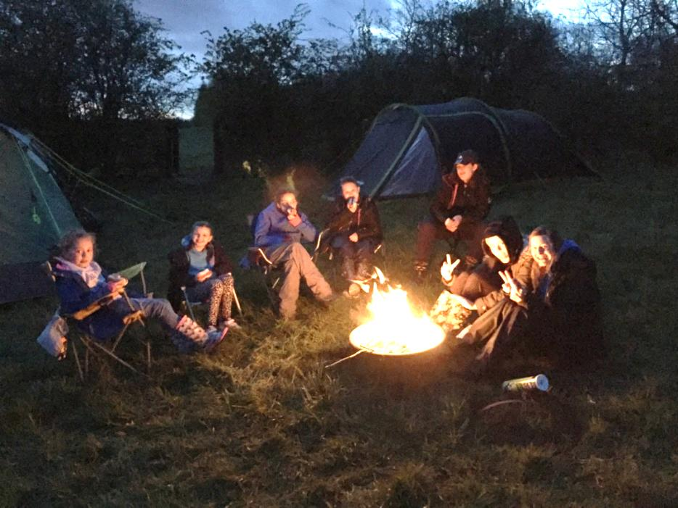
The next year will see us going further afield with our unit, we are going to Switzerland and Disneyland Paris in 2018. Also, our Senior Section leader Dot and senior section member Hannah are going to Canada this summer (2017) as part of a county trip. Finally, all of this is not possible without the support of both the church and school.
Jenny Jones

14th Farnworth (St. John’s) Scout Group
The Scout Group was very active during the year with eight Beavers, eight Cubs and five Scouts. We also had five leaders/helpers.
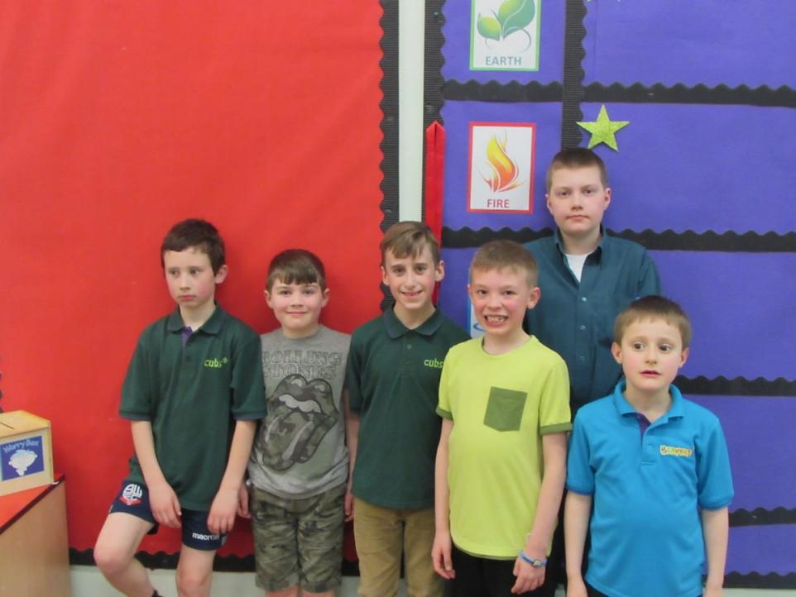
They were involved in a variety of activities such as map reading, knot work, cooking, crafts, first aid and a hike. However, as the year went on, numbers began to decrease and we lost leaders and helpers as well. We contacted several people who had expressed interest in joining the group but unfortunately this did not materialise.
After Christmas we were down to FIVE members with 1 leader and 1 helper. The District Commissioner was aware of our situation and came to discuss our plight. He reluctantly concluded that we would have to close the group, particularly as there was no ‘back-up’ committee in place.
It was with great sadness, that after so many years, 14th Farnworth (St John’s) Scout Group would close and for the first time since 1954, there will be no scout group associated with St John’s church.
Yours in Scouting,
Graham and Heather

Year End Statement of Accounts 2016
Income |  |  |  |  |  |  |  |  |  |  |  |  |  |  |  | 2016 |  |  |  | 2015
101 & 103 |  |  |  | Parish regular giving |  |  |  |  |  |  |  |  |  |  |  | 19454.24 |  |  |  | 21817.75
104 |  |  |  | Parish loose cash |  |  |  |  |  |  |  |  |  |  |  | 1927.59 |  |  |  | 2105.43
102 |  |  |  | Reclaimed Tax |  |  |  |  |  |  |  |  |  |  |  | 6171.28 |  |  |  | 6300.88
105 |  |  |  | Donations |  |  |  |  |  |  |  |  |  |  |  | 4128.06 |  |  |  | 1092.27
105 |  |  |  | Bells |  |  |  |  |  |  |  |  |  |  |  | 271.00 |  |  |  | 296.70
203a |  |  |  | Fairs and events |  |  |  |  |  |  |  |  |  |  |  | 2959.83 |  |  |  | 2538.19
203b |  |  |  | Charity ** |  |  |  |  |  |  |  |  |  |  |  | 0.00 |  |  |  | 112.67
402 |  |  |  | Building rental (+Mast) |  |  |  |  |  |  |  |  |  |  |  | 7873.56 |  |  |  | 7373.93
403 |  |  |  | Magazine |  |  |  |  |  |  |  |  |  |  |  | 533.70 |  |  |  | 648.72
404 |  |  |  | Weddings |  |  |  |  |  |  |  |  |  |  |  | 3362.00 |  |  |  | 4593.00
404 |  |  |  | Funerals |  |  |  |  |  |  |  |  |  |  |  | 11607.04 |  |  |  | 11858.92
404 |  |  |  | Baptisms |  |  |  |  |  |  |  |  |  |  |  | 251.00 |  |  |  | 1437.00
 |  |  |  | monies for churchyard |  |  |  |  |  |  |  |  |  |  |  | 2039.20
 |  |  |  | internal transfer |  |  |  |  |  |  |  |  |  |  |  | 8800.00
 |  |  |  | Register Fees |  |  |  |  |  |  |  |  |  |  |  | 136.00 |  |  |  | 76.00
 |  |  |  | insurance claim |  |  |  |  |  |  |  |  |  |  |  | 3596.00
 |  |  |  | CBF investment fund |  |  |  |  |  |  |  |  |  |  |  | 7423.96
 |  |  |  | Sundry |  |  |  |  |  |  |  |  |  |  |  | 2476.40 |  |  |  | 1866.78
 |  |  |  | Youth worker |  |  |  |  |  |  |  |  |  |  |  | 10338.00 |  |  |  | 14271.55
 |  |  |  | Clergy Expences |  |  |  |  |  |  |  |  |  |  |  | 3542.36 |  |  |  | 2957.13
 |  |  |  | Total Income |  |  |  |  |  |  |  |  |  |  |  | 96891.22 |  |  |  | 79346.92
Expenditure
2001 |  |  |  | Quota |  |  |  |  |  |  |  |  |  |  |  | 39212.04 |  |  |  | 34932.28
2002 |  |  |  | Clergy Stationary and Post |  |  |  |  |  |  |  |  |  |  |  | 481.51 |  |  |  | 159.96
2002 |  |  |  | Travel Expenses |  |  |  |  |  |  |  |  |  |  |  | 1207.94 |  |  |  | 1196.00
2002 |  |  |  | Telephones |  |  |  |  |  |  |  |  |  |  |  | 220.47 |  |  |  | 636.03
2003 |  |  |  | Parsonages |  |  |  | General |  |  |  |  |  |  |  | 0.00 |  |  |  | 0.00
2003 |  |  |  |  |  |  |  | Council Tax |  |  |  |  |  |  |  | 2959.44 |  |  |  | 2364.67
2005 |  |  |  | Heat & light & Ins St Johns |  |  |  |  |  |  |  |  |  |  |  | 11385.36 |  |  |  | 13599.13
2006 |  |  |  | Maintenance |  |  |  |  |  |  |  |  |  |  |  | 6335.65 |  |  |  | 1413.69
2007 |  |  |  | Service Requisites |  |  |  |  |  |  |  |  |  |  |  | 635.93 |  |  |  | 441.92
2008 |  |  |  | Churchyard |  |  |  |  |  |  |  |  |  |  |  | 12958.00 |  |  |  | 2525.00
2016 |  |  |  | Organists |  |  |  |  |  |  |  |  |  |  |  | 1650.00 |  |  |  | 1145.00
2016 |  |  |  | Vergers |  |  |  |  |  |  |  |  |  |  |  | 600.00 |  |  |  | 729.99
4000 |  |  |  | Printer Stationary |  |  |  |  |  |  |  |  |  |  |  | 874.56 |  |  |  | 897.76
 |  |  |  | Parochial fees |  |  |  |  |  |  |  |  |  |  |  | 5637.00 |  |  |  | 8049.00
1004 |  |  |  | Charity |  |  |  |  |  |  |  |  |  |  |  | 644.55 |  |  |  | 262.00
 |  |  |  | Evangelist Expences |  |  |  |  |  |  |  |  |  |  |  | 329.63 |  |  |  | 900.53
 |  |  |  | Youth Worker |  |  |  |  |  |  |  |  |  |  |  | 13058.96 |  |  |  | 13058.96
 |  |  |  | Holiday Club |  |  |  |  |  |  |  |  |  |  |  | 0.00 |  |  |  | 50.00
 |  |  |  | sundry |  |  |  |  |  |  |  |  |  |  |  | 795.96 |  |  |  | 2373.25
 |  |  |  | Total Expenditure |  |  |  |  |  |  |  |  |  |  |  | 98987.00 |  |  |  | 84735.17
 |  |  |  | Surplus/Deficit |  |  |  |  |  |  |  |  |  |  |  | -2095.78
Bank Reconciliation
 |  |  |  |  |  |  |  |  |  |  |  | Total |  |  |  |  |  | Current |  |  |  | Savings
Balance at |  | 01/01/2016 |  |  |  |  |  |  |  |  |  | 67014.44 |  |  |  |  |  | 21008.25 |  |  |  | 46006.19
Surplus / Deficit for year |  |  |  |  |  |  |  |  |  |  |  | -2095.78
Presented cheques from |  |  |  |  |  | 2015 |  |  |  |  |  | 0.00
Minor Projects Surp/Def |  |  |  |  |  |  |  |  |  |  |  | -335.00
Coffee Fund Surp/Def |  |  |  |  |  |  |  |  |  |  |  | 1166.08
Rest fund (current) Surp/Def |  |  |  |  |  |  |  |  |  |  |  | -8711.29
Unpresented cheques from |  |  |  |  |  | 2016 |  |  |  |  |  | 0.00
Balance at |  | 31/12/16 |  |  |  |  |  |  |  |  |  | 57038.45 |  |  |  |  |  | 19803.55 |  |  |  | 37234.90
Minor Projects monies |  |  |  |  |  |  |  |  |  |  |  | 3164.55
Coffee fund monies |  |  |  |  |  |  |  |  |  |  |  | 5637.00
Restoration Fund monies |  |  |  |  |  |  |  |  |  |  |  | 9404.86
Youth worker monies retained |  |  |  |  |  |  |  |  |  |  |  | 2873.67
Funds at year end in parish general account |  |  |  |  |  |  |  |  |  |  |  | -1276.53
Minor Projects Fund
2016 |  |  | Year End Statement of Account
Income |  |  |  |  |  |  |  |  |  |  |  |  |  |  | 2016 |  |  |  | 2015
 |  |  | Fundraising |  |  |  |  |  |  |  |  |  |  |  | 145 |  |  |  | 535
 |  |  | Total Income |  |  |  |  |  |  |  |  |  |  |  | 145 |  |  |  | 535
Expenditure
 |  |  | t sumner smith |  |  |  |  |  |  |  |  |  |  |  | 480.00
 |  |  |  |  |  |  |  |  |  |  |  |  |  |  | 0.00
 |  |  |  |  |  |  |  |  |  |  |  |  |  |  | 0.00
 |  |  |  |  |  |  |  |  |  |  |  |  |  |  | 0.00 |  |  |  |  |  |  |  | 480.00
 |  |  | Total Expenditure |  |  |  |  |  |  |  |  |  |  |  | 480.00 |  |  |  | 1899.6
 |  |  | Surplus/Deficit for Year |  |  |  |  |  |  |  |  |  |  |  | -335.00 |  |  |  | 1364.60
Bank Reconciliation
Balance at |  |  | 01/01/2016 |  |  |  |  |  |  |  |  |  |  |  | 3499.55
Surplus / Deficit for year |  |  |  |  |  |  |  |  |  |  |  |  |  |  | -335.00
Balance at |  |  | 31/12/2016 |  |  |  |  |  |  |  |  |  |  |  | 3164.55

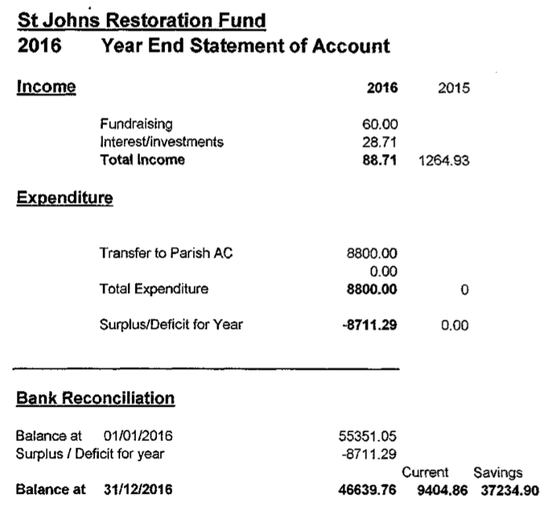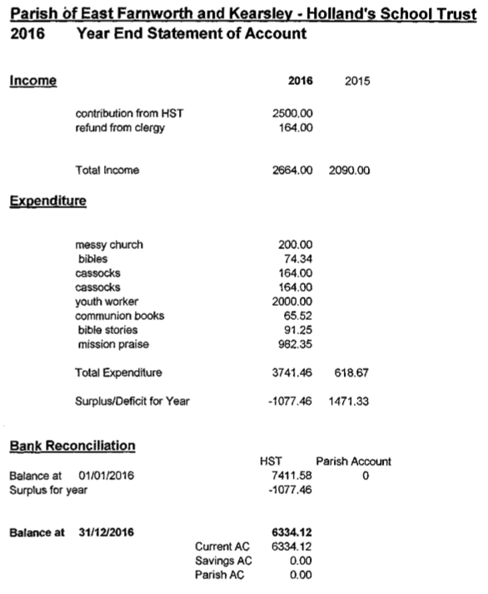
PARISH OF FARNWORTH & KEARSLEY

MINUTES OF THE ANNUAL VESTRY MEETING & THE ANNUAL PAROCHIAL CHURCH MEETING – 24th April 2016.
The Annual Meetings were held after the Communion Service with 35 people present.
ANNUAL VESTRY MEETING
Apologies for absence: Rev Phillip Castle, Shaun Croston, Keith Entwistle and Barry McGlynn.
Minutes of the Annual Vestry Meeting: Held on 26th April 2015, having been available for all present, were taken as read and agreed by all members present that they be approved and signed as a correct record.
Election of Churchwardens: Keith Entwistle and Graham Martin having been proposed and seconded, and with no further nominations, were elected to serve as Churchwardens for 2016/2017.
ANNUAL PAROCHIAL CHURCH MEETING
Apologies for absence: Rev Phillip Castle, Shaun Croston, Keith Entwistle and Barry McGlynn.
Minutes of the Annual Parochial Church Meeting: Held on the 26th April 2014, having been available for all present were taken as read and agreed by all members present that they be approved and signed as a correct record.
Reports:
- Church Electoral Roll: Kim McIntyre reported that the electoral roll started last year at 145 members. Unfortunately 7 of our long standing members have had to be removed to join a greater roll. However over the year these have been replaced by new members, leaving us with a slight increase on the role of 146.
With the amount of new families attending church regularly it might be advantageous for us to promote the electoral roll at family services, and then perhaps we could look forward to increases in 2016/17.
Agreed: To start promoting the electoral roll at the next family service.
A question was raised as to why this had not been done before. The electoral role officer stated that she had only taken over the role last year. Vicar Carol explained that the electoral roll lasts for 6 years when those wishing to remain on it are required to re-sign. There is a closed period every year for 2 weeks before the AGM.
- Parochial Church Council: Included in the Annual Report.
- Financial Statements: The accounts for 2015, which had been audited, were available in the previously circulated Annual Report. The church quota had been paid. A question was raised whether there was a typing error in the Treasurer’s Report (page 6 paragraph 2) which states that our regular giving is down by £14,OOO when according to the accounts this figure should be £2,600? Vicar Carol stated that the £14,000 included a balance which has subsequently been transferred from St Peter’s Trust, to the Youth Project Workers Account. The correct figure is in the region of £2,600.
Thanks were expressed to Sandra Croston, Shaun Croston and Malcolm Wearing for their hard work.
- Fabric and Church Property: Graham Martin thanked the Sides People and the volunteers for all their hard work throughout the year. He made reference to the plans regarding the re-ordering of the church’s interior and the work required to the South elevation of the roof identified in the Quinquennial Inspection.
- Deanery Synod: - included in the Annual Report. The Vicar thanked Alison Mole, Jackie Powell, Jean Smith and Dorothy McGlynn for attending the Deanery Synod meetings throughout the year.
- Child Protection Policy Statement & Report: Included in the Annual Report - a copy of the policy is displayed on the Church Notice Board. Vicar Carol reminded the meeting that we also had a Vulnerable Persons Policy.
- Admitting Children to Holy Communion Policy Report: Vicar Carol reported that one child was admitted to receive Holy Communion last year. We have a policy of admitting Year 3 children and above who attend church regularly. St John’s Church was one of the first churches in the Diocese to adopt this policy.
- Other Reports included in Annual Report: Nigel McFarlane stated he had found the report refreshing to read with lots to reflect on and looked forward to seeing where it takes us. Vicar Carol said that we had been promoting the building plans on the News Sheet and that she had been asked why the need to spend reserves when we are working with an annual £5,000 deficit. She stated that the church had a good history of adapting to situations and fund raising, as in 1998 when four phases of restoration work had been carried out. She emphasised the need to look at how we can raise our giving. The building is in demand for use by other organizations. It is the only big space in Farnworth. In her experience it is the churches that adapt that survive. If we are going to use the building more we need extra toilets and better facilities. We are limited where we can put these and the children have outgrown the Children’s Corner, hopefully we can make a room on the balcony for them. The Quinquennial Report had identified a problem with the South elevation of the roof. Our architect had suggested that if we apply for a Heritage Grant and are successful we can apply for an extra 15% of the cost, which together with our reserves would enable us to fund the ground floor work. We would then have to look at where we could hold our Sunday school.
Rob McIntyre highlighted the fact that for a number of years our expenditure had exceeded the money coming in and as a result our reserves continue to dwindle and if this continued for a further 8 years we would have no reserves at all. Our church is 190 years old; we are only caretakers and we have a duty to look after the building for future generations. We don’t want managed decline until the church gets demolished, so there is an urgent need to look at obtaining the necessary revenue. He concluded by making a practical point that if each week our average 79 communicants pledged to give another £1 per week we could stem the annual deficit.
Vicar Carol thanked all those who had contributed to the reports.
Election of Officers:
- Deputy Wardens: Jackie Powell & Shaun Croston, having been proposed and seconded and with no further nominations, were elected to serve for 2016/2017.
- Deanery Synod Representatives: The number of Deanery Synod Representatives is governed by the number of members on the Electoral Roll. St John’s is entitled to 4 representatives. We currently have 4 representatives, Jean Smith, Jackie Powell, Alison Mole and Dorothy McGlynn in post.
- PCC Representatives: Comprises of 10 representatives. Following an election the following 10 people having been proposed and seconded, were elected to serve for 2016/2017. – Judith Birchall, Sharon Goodwin, Betty Higham, Steve Mann, Sandra Martin, Kim McIntyre, Rob McIntyre, Carol Morgan, Keith Morgan, Katie Wearing.
- Sides People: The following 12 people, having been proposed and seconded, were elected to serve for 2016/2017 – Peter Ingham, Keith Morgan, Carol Morgan, June Eatock, Stan Eatock, Sandra Martin, Victoria Billington, Judith Birchall, Joan Walkden, Sharon Goodwin, Stephanie Buckley and Stella Gee.
- Ex-Officio Members: - The following are also ex-officio members of the PCC - Revd. Carol Pharaoh (Chair), Revd Dr Malcolm Wearing (Ordained Local Minister) Revd. Phillip Castle (Associate Priest), Sister Canon Dorothy Needham (Licensed Lay Worker), Graham Martin (Church Warden), Keith Entwistle (Church Warden) & Deanery Synod Reps. - Alison Mole, Jean Smith, Jackie Powell and Dorothy McGlynn.
Appointment of Auditor to the Council: Vicar Carol expressed thanks to Alan Ratcliffe who had audited the accounts. It was agreed unanimously that Mr Ratcliffe be invited to accept the appointment as Parish Auditor for 2016/2017 and that in recognition of his work he be given a gift.
Any other business: None.
Notice of the first meeting for the newly elected PCC: Thursday 5th May 2016 at 7.30pm.
Archdeacon's Visitation: Wednesday 10th May 2016 at 7.30pm at St John’s, Farnworth and Kearsley Parish Church.
Church Wardens, Deputy Wardens & Sides People must attend and PCC members are strongly encouraged to attend.
Signed …………………………………………………..
Date …………………………………………………..

FARNWORTH & KEARSLEY PCC

ATTENDANCE RECORD 2016-2017

NAME | 5-5-16 | 2-6-16 | 7-7-16 | 1-9-16 | 6-10-16 | 3-11-16 | 5-01-17 | 2-02-17 | 2-03-17
ELECTED MEMBERS
Judith Birchall | √ | √ | √ | A | √ | √ | √ | √ | √ | 8/9
Sharon Goodwin | √ | A | √ | √ | √ | √ | √ | √ | √ | 8/9
Betty Higham | √ | √ | √ | √ | √ | √ | √ | √ | √ | 9/9
Steve Mann | √ | A | √ | A | √ | √ | √ | √ | A | 7/9
Sandra Martin | √ | √ | A | √ | √ | √ | √ | √ | √ | 8/9
Kim McIntyre | √ | √ | √ | A | √ | √ | √ | √ | √ | 8/9
Rob McIntyre | √ | √ | √ | A | √ | √ | √ | √ | √ | 8/9
Carole Morgan | √ | A | √ | √ | √ | √ | √ | √ | √ | 8/9
Keith Morgan | √ | √ | √ | √ | √ | √ | √ | √ | √ | 9/9
Katie Wearing | √ | A | A | A | A | √ | A | A | A | 2/9
EX - OFFICIO
Keith Entwistle | A | √ | √ | √ | A | √ | √ | √ | √ | 7/9
Graham Martin | √ | √ | √ | √ | √ | √ | √ | √ | √ | 9/9
Dorothy McGlynn | √ | √ | √ | √ | √ | √ | √ | √ | √ | 9/9
Alison Mole | √ | √ | √ | √ | √ | A | A | √ | √ | 7/9
Jackie Powell | A | A | A | √ | A | √ | √ | √ | √ | 6/9
Jean Smith | √ | √ | √ | √ | √ | A | A | A | A | 5/9
Carol Pharaoh | √ | √ | √ | √ | √ | √ | √ | √ | √ | 9/9
Kim Lafferty | A | A | A | A | A | A | A | A | A | 0/9
Malcolm Wearing | √ | A | √ | √ | √ | A | √ | √ | √ | 7/9
Dorothy Needham | A | A | A | A | A | √ | √ | A | √ | 3/9
Phillip Castle | A | A | A | A | A | A | A | A | A | 0/9

√ - PRESENT A – APOLOGIES SENT X - ABSENT

PARISH OF FARNWORTH & KEARSLEY

ANNUAL VESTRY & ANNUAL PAROCHIAL CHURCH MEETING
Sunday 23rd April 2017 at 11.30 am
AGENDA

Opening Prayers

ANNUAL VESTRY MEETING

- Apologies for absence
- Minutes of the Annual Vestry Meeting 2016
- Election of Church Wardens

ANNUAL PAROCHIAL CHURCH MEETING

- Apologies for absence
- Minutes of the Annual Parochial Church meeting 2016
- Reports -
  - Electoral Roll
  - PCC Report
  - The Financial Statements
  - Fabric and Church Property Report
  - Deanery Synod Report
  - Safeguarding Report
  - Admitting Children to Holy Communion Policy Report
  - Other reports
- Elections -
  - Deputy Wardens – (3 representatives)
  - Deanery Synod – (4 representatives)
  - PCC – (10 representatives)
  - Sides people
  - Auditor
- Any other Business, notified to the Chair prior to the meeting
- Notice of first meeting of the PCC – Thursday 11th May 2017 at 7.30 pm
- Notice of Archdeacons Visitation – Tuesday 16th May 2017 at 7.00pm at
St John’s Farnworth & Kearsley
PARISH OF FARNWORTH & KEARSLEY

