Toddler Group
St John’s Toddler Time January to December 2019
St John’s toddler time has been running in church on a Monday morning since October 2018 when we had only 4 families attending. The session is prepared and run by myself, with the help of Stella Gee and Denise Entwistle, we meet for an hour and half and incorporate play time, crafts, story, snack, and songs each week. Over this year we have grown in numbers and by December we had up to 20 children attending each week. We ask for a donation of £1 when attending the group to help with the cost of resources and refreshments.
From January until July we continued with our usual free play and crafts each week and included a Bible story once every half term, during the Bible story sessions we read the story and made crafts based around it. Some examples of this was the story of “Jonah and the big fish” which I read to the children and they made whale pictures with painted shapes and “Noah’s Ark” where we had lots of animal based play activities during the session.
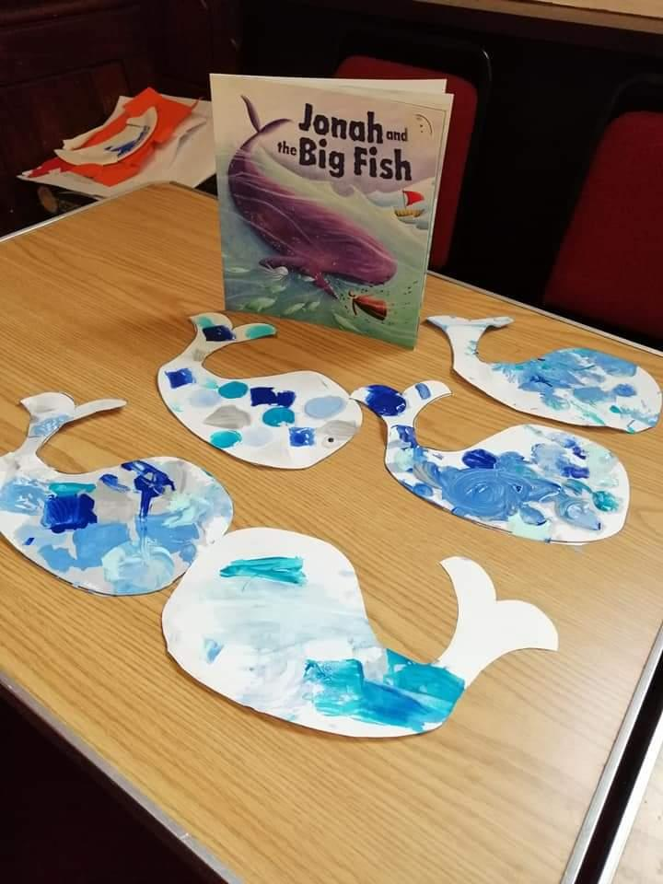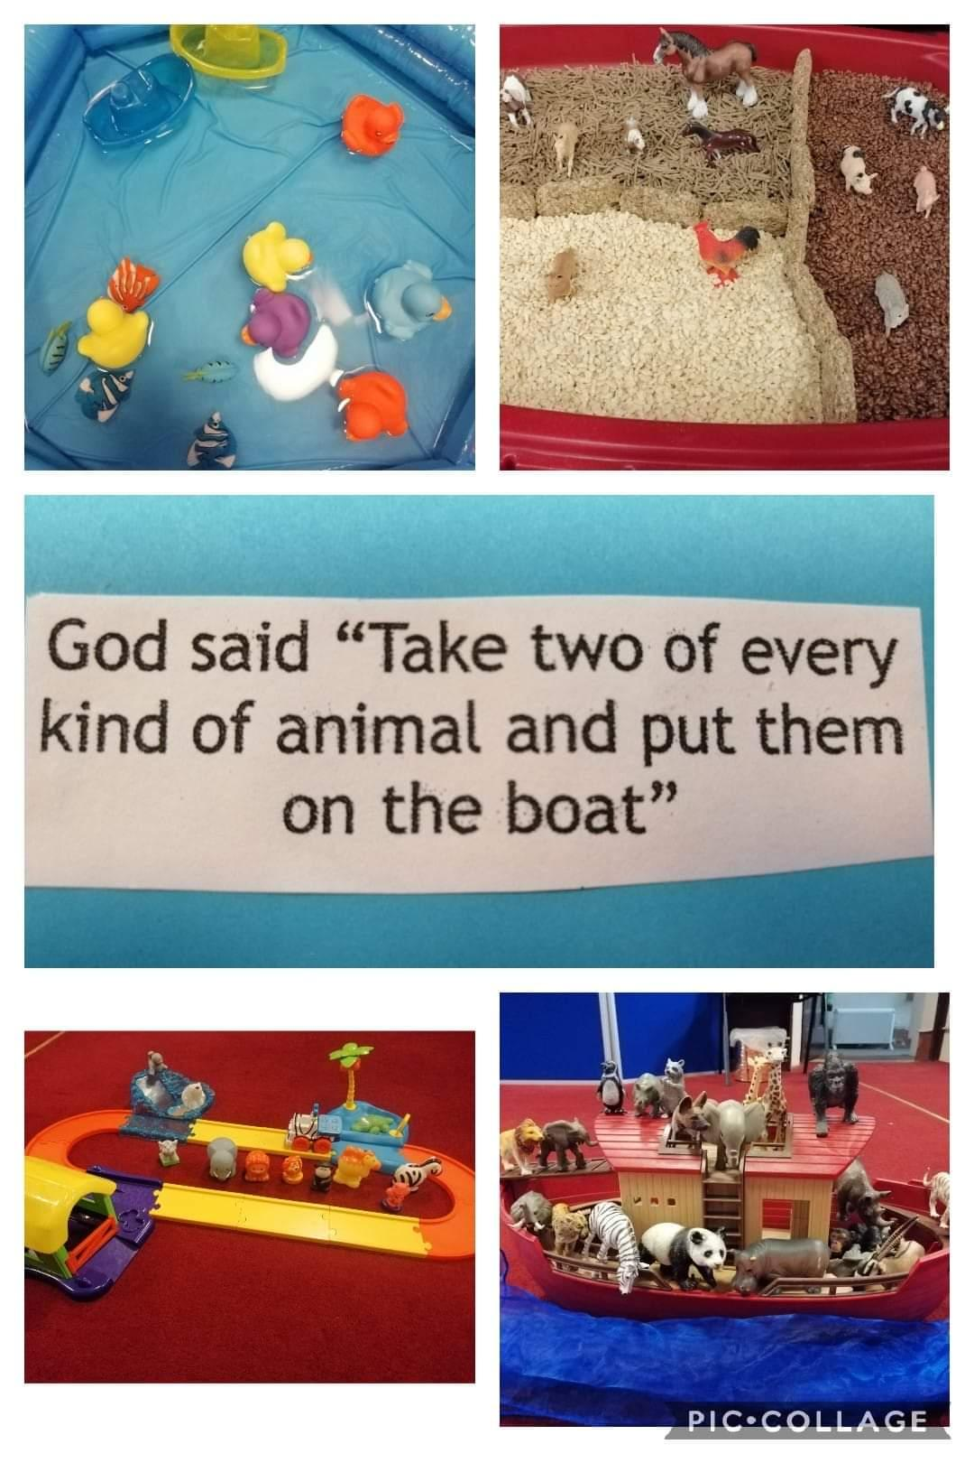
Over the spring term I began to meet with Steph Openshaw from the Children Changing Places project to think about making the group more faith based, the families attending at the time were keen to try this and see where it led, Our last session of the academic year in July was a ‘sports day’ session with lots of games and activities followed by a mini Wiggle Worship delivered by Steph. This was a lovely way to say goodbye and good luck to the 4 children who were leaving us to go to school or nursey.
From September we started to follow the toddlers plan that Steph Openshaw had developed which incorporates a faith based story in to every session as well as taking the children into Church at the end for story and song time. The families have embraced the change in focus and have said that they enjoy learning about God, the stories from the Bible and learning new songs too. The lead up to Christmas saw us reading a story called “Teddy bear, piglet, kitten and me” by Catherine Maccabe, each week we read a part of their journey to the stable and did craft activities based on each. For example when we read the page which said “We went to the Church, we walked through the snow. Inside it was warm in the candlelit glow” our craft was to make a calendar with a picture of our church in the snow which the children then took home with them.
We ended the year with a fantastic Christmas party with lots of crafts, activities, snacks and a visit from Father Christmas (Rob McIntyre) who read the children a story and gave them all their gift of a book.
Steph Buckley

