St.Peter’s C.E.Primary School

Head teachers Report for the Parish – March 2017



“ Learn, Sparkle & Shine…”

2016 was an exceptional year for all at St. Peter’s with a number of noteworthy events taking place.

The year began with a visit from OFSTED on February 2nd 2016, exactly five years since their previous visit.

We were delighted to be informed that the HMI judged our school to be OUTSTANDING and this was further enhanced when in June 2016 the school was rated OUTSTANDING by Manchester Diocese Board of Education in our SIAMS inspection.

The overriding Christian Value that permeates all our work is that of hope – hope for our future and that of all our children.

As children walk through the school entrance doors and step in to St. Peter’s they are asked to imagine themselves taking daily steps down Progress Avenue.

Displayed on our walls are the words; “Where you enter St. Peter’s neither impresses nor depresses us; we just expect that you know you come to school to learn and make progress as you take daily steps down Progress Avenue with us.”

This philosophy led to us being awarded Bolton News Primary School of the Year 2016 and also being shortlisted for the Times Educational Supplement (TES) primary school of the year.

As OFSTED said;
“Each corridor is labelled to reinforce a value or an ambition and emphasises the aspirational ethos which pervades the school. Pupils regularly walk up Progress Avenue, Cooperation Alley or Achievement Road on their way to lessons, assembly or out to play.”

The vision continually reinforced is that Progress Avenue is endless;
- it does not seek to limit someone to a predetermined potential
- it does not assume a natural talent or predisposition.
- It recognises that hard work and effort will lead to greater outcomes and achievement.
- It starts with you and takes you as far as you want to go.
This philosophy has helped our staff to open their minds to the meaning of inclusion and avoid limiting beliefs, both for themselves and the pupils.
By building a belief that anything is possible, you just have to take the first step towards achieving it, the children have been given the power to determine their own destiny.

We believe that acquiring basic literacy and numeracy skills is fundamental for pupils’ future success. Through the implementation of rigorous phonics, reading and mathematics programmes we have ensured that the attainment gap between disadvantaged pupils and their peers is narrowed.

Our exceptional provision in reading was recently validated through being awarded “reading recovery school of the year – 2016,” by the Institute of Education at University College London (UCL).

Our simple mission when entering school is to ensure that each day we are further on our journey than the day before. This philosophy was reflected in our whole school worship theme for the Spring Term.

‘Success won’t just come to you; you have to make it happen! It’s your future and it starts now’

Proverbs 3:6
‘Let God direct your steps!’

Beyond the pupils of St. Peter’s , 2016 allowed us to reach out to other schools and pupils in our role as a National Support School designated by NCTL June 2016. Our team of SLE’s, led by the Head teacher who is an NLE, were given the humbling opportunity to contribute to school improvement work across Bolton and indeed in to Manchester .

Our staffroom wall displays the following words, which epitomise the soul of the school. We are the servants of the next generation and we aspire to give them the best future possible.
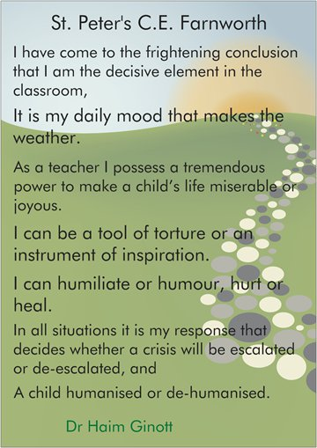

Our links with the church and community are very much valued by the school.

Our entries in to the Kearlsey in Bloom Festival and Kearsley Scarecrow festival brought great joy to the children and certainly added an extra layer of colour to our local area.

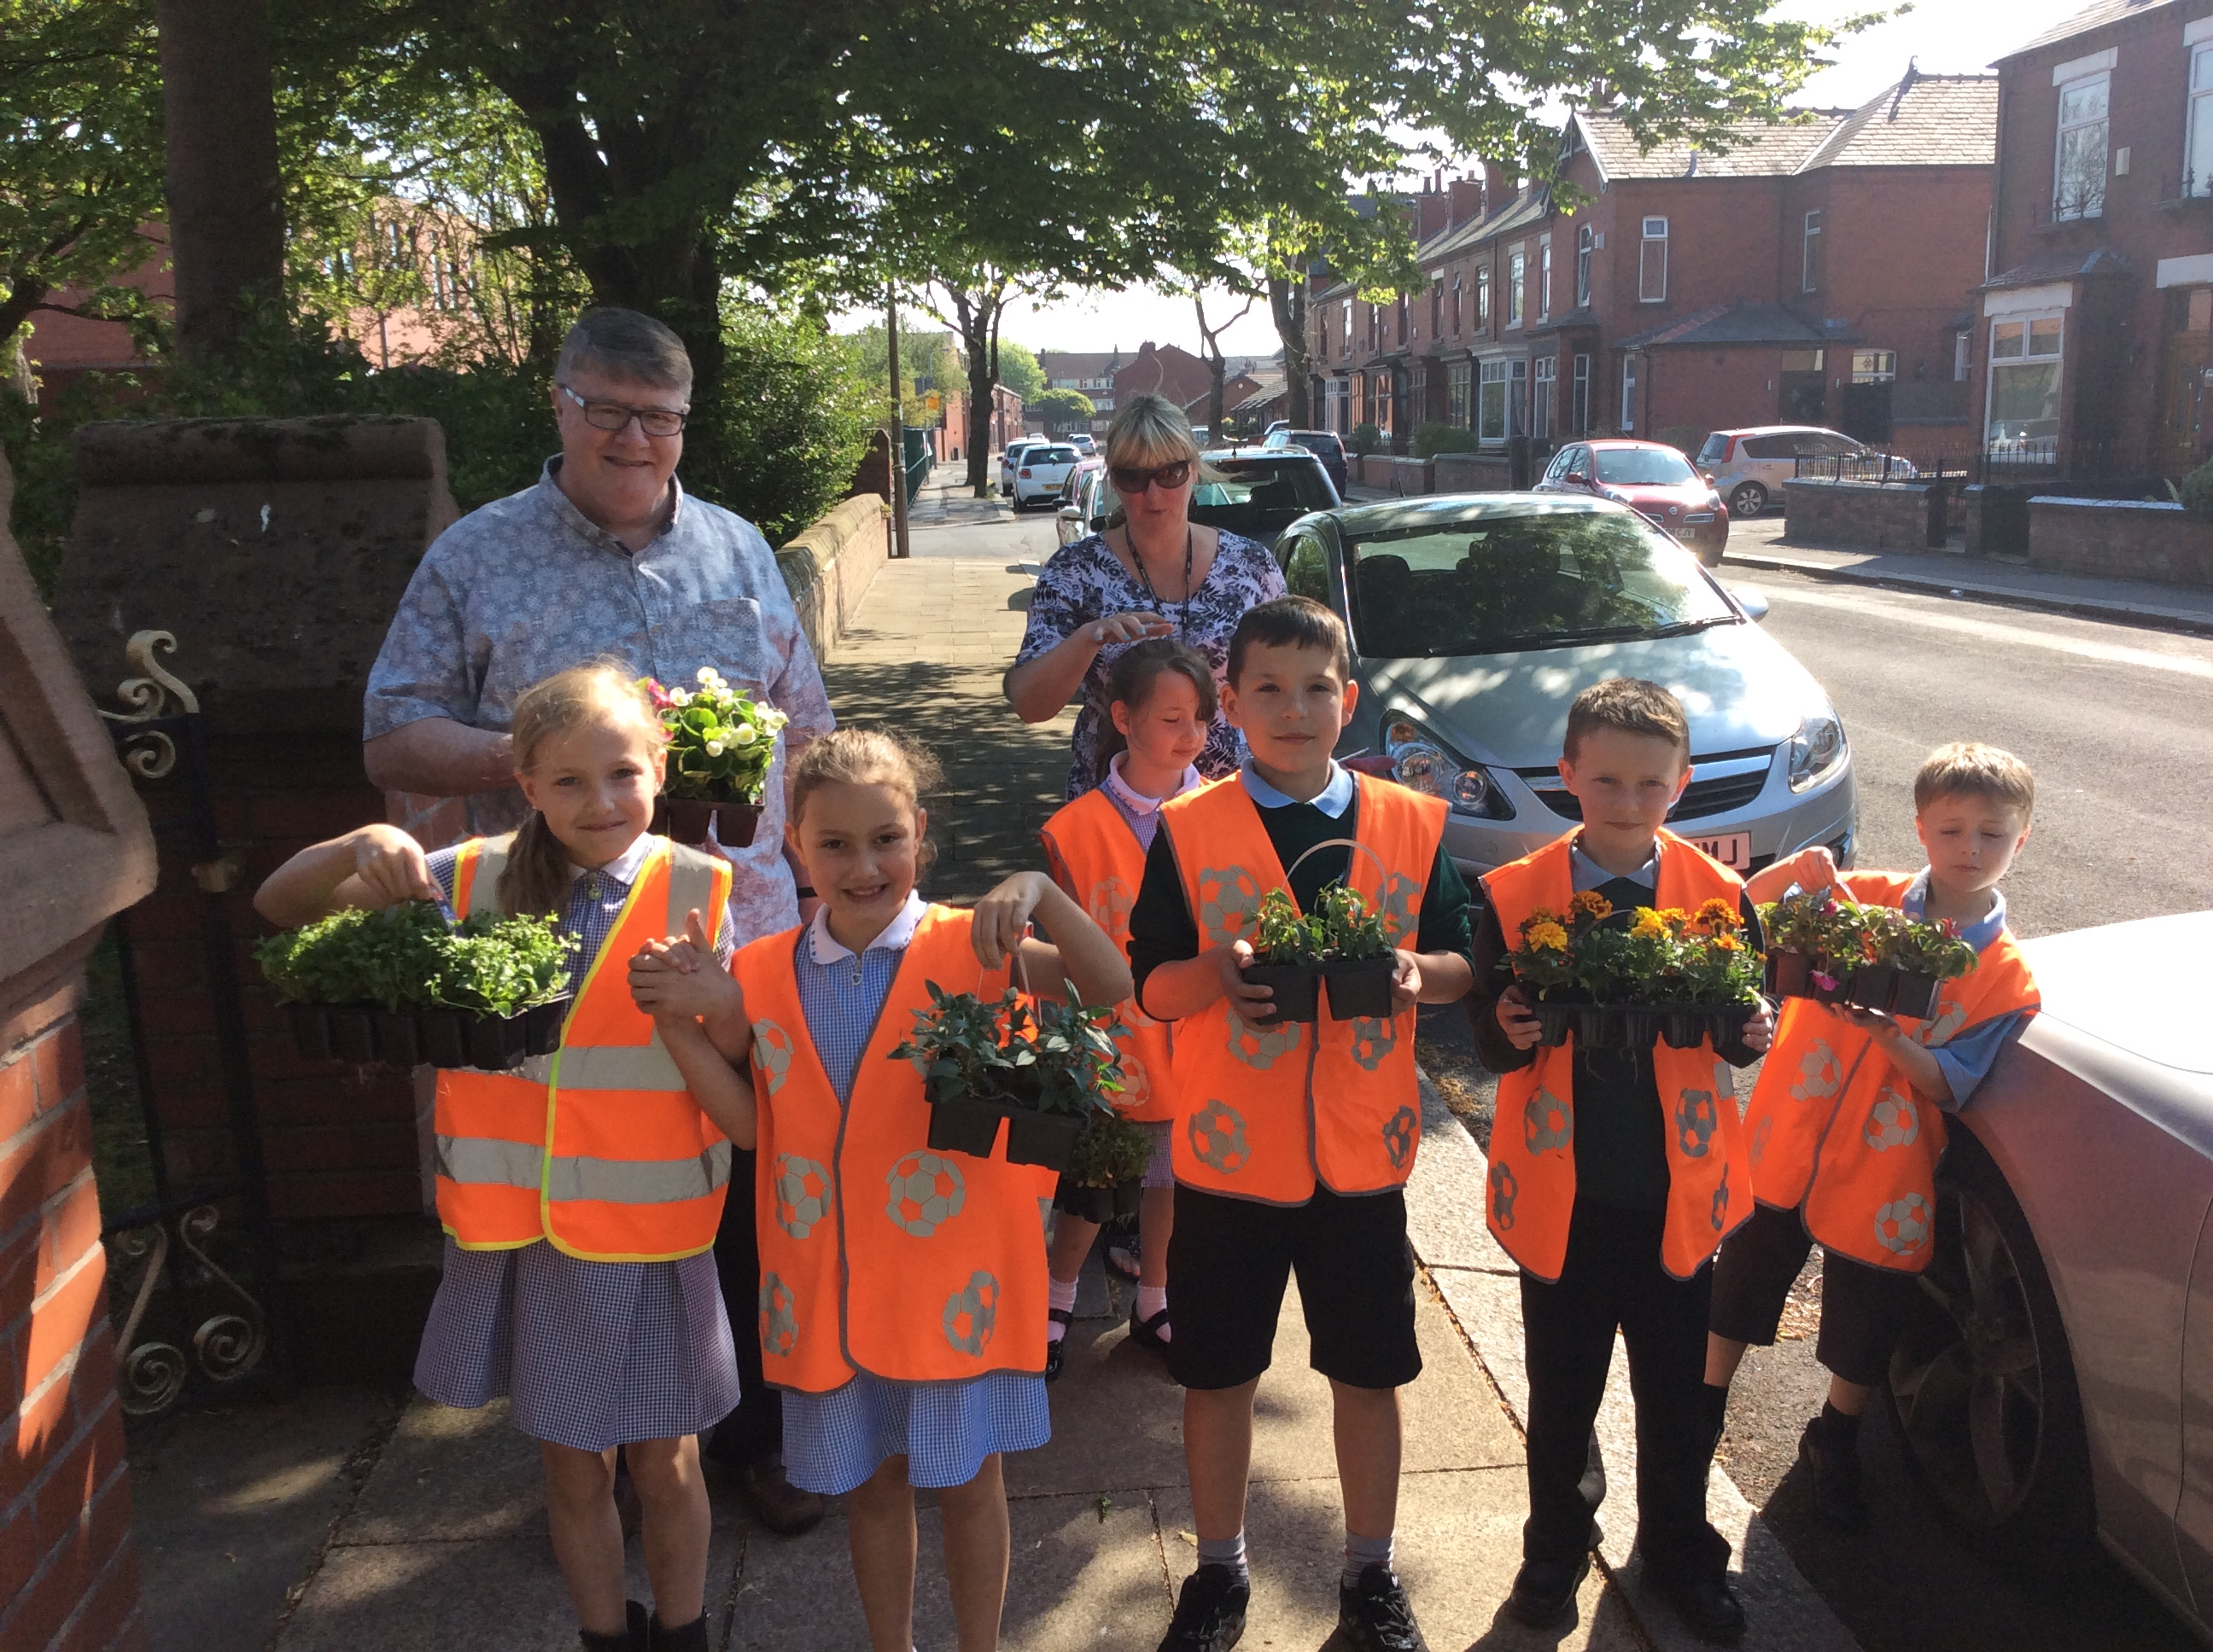

We are reassured by the support and encouragement we receive from our school Governors and from all members of the parish. It would be difficult to imagine leading a school, without such key people! Our thanks go to each one of them and to Vicar Carol for their continuing involvement and blessing.

The future of collaboration in Farnworth is looking exceptionally strong and we look forward to being part of that future, working alongside the church community to build a great future for our children.

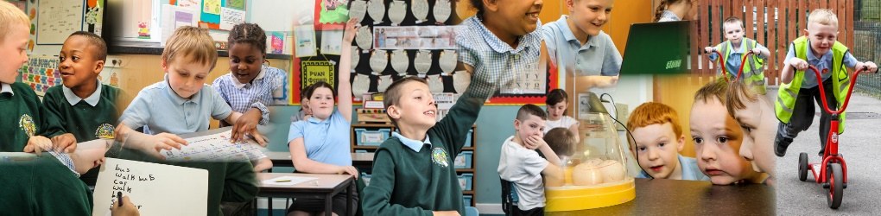
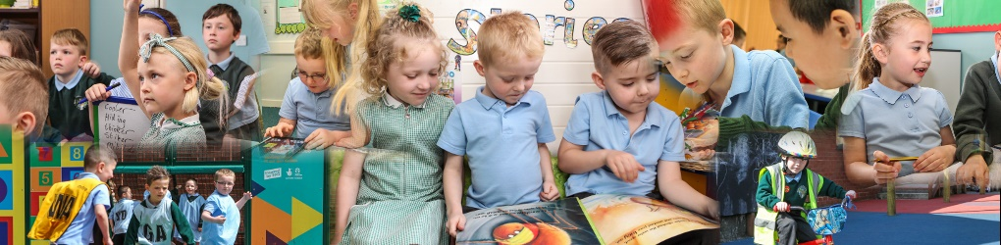

Thank you
Lynn Williams
Head teacher

