St. Peter’s C.E. Primary School

Head teachers Report for the Parish – March 2022 (Report on Jan – Dec 2021)


“Learn, Sparkle & Shine…”

2021 was once again a year filled with challenge, due to the ongoing pandemic, yet also presented an opportunity for our community to pull together, support each other and work with purposeful effort, driving forward our school intent statement.

What is our vision?
As teachers we are often charged with the task of preparing our children for their future. At St. Peter’s we think a little differently, and rather than prepare our children for a future that is imposed upon them, we aim to give them the skills necessary to create the future that they perceive for themselves. Today is the tomorrow of yesterday. By controlling today, we are creating the future of tomorrow. Our vision is to develop our children to enable them to create the future they aspire for themselves.
“Our children will contribute to and prosper in society.”

How will our vision be achieved?
We believe our vision will be achieved if we provide our children with an environment, underpinned by British and Christian values, in which they can “ Learn, Sparkle & Shine…”

Learn = develop wisdom, knowledge and skills.

Sparkle = develop individual character; hope, aspiration and courageous advocacy.

Shine = develop community spirit and learn to live well together.
- We believe inherited traits are only one part of the story of where we may end up. The environment created in our classrooms, the culture of hard work and determination that we encourage, the recognition that we are all able to increase our knowledge through learning, we believe, has an equally valid impact on our future success. (Learn)
- We believe that engaging in a rich and varied curriculum will provide our children with an opportunity to develop a positive attitude to learning and an environment in which they can flourish and thrive. (Sparkle)
- We believe that by using Christian Values to underpin our work, children will be able to spread positive attitudes and shine as a beacon in society. (Shine)
Our daily work is dedicated to achieving these aims.

January 2021-July 2021
January 2021 started with the Government announcement that our country would once again enter a national lockdown, and after having returned to school for one day following the Christmas period, we were told to move to remote learning and open school for children of key workers and vulnerable pupils only. Overnight we swiftly implemented our remote learning policy and successfully moved to online education.
The school continued to welcome between 70-100 pupils each day for face to face education and the staff adapted to a hybrid way of working, with all staff (except SLT who worked on site throughout) participating in a rota of on site and off site work.

Upon reopening in March there were many further challenges, with the implementation of ‘bubbles’, isolation of close contacts a, resulting in bubble closures, often repeatedly, and the arrival of the delta variant, with Bolton being at the forefront of this new wave. Despite this we remained steadfast on our mission to ensure our children were enabled to

“ Learn, Sparkle & Shine…”

Our annual traditional Easter Service went ahead, albeit remotely. This can be found here on our school You Tube Channel.

Click to watch our Easter Service April 2021

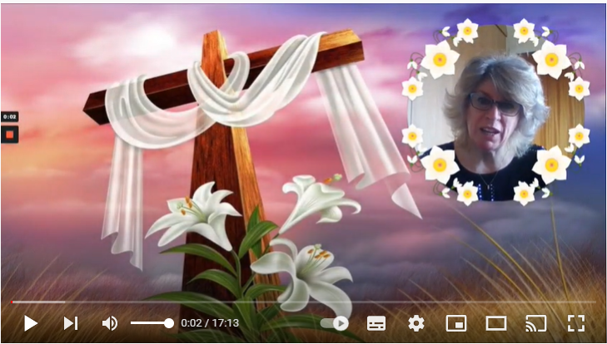

Each week Mrs Williams recorded a whole school worship, which also was published on the school You Tube Channel and was watched across the school at the same time, along with the community and any pupils who were isolating and undertaking remote education.

During summer term we focussed on two themes, each aimed at giving a positive message on how to live life in all its fullness with God’s help and guidance, providing our children with a memorable focus to guide their daily life.

Summer term 1 Theme | Summer tem 2 Theme
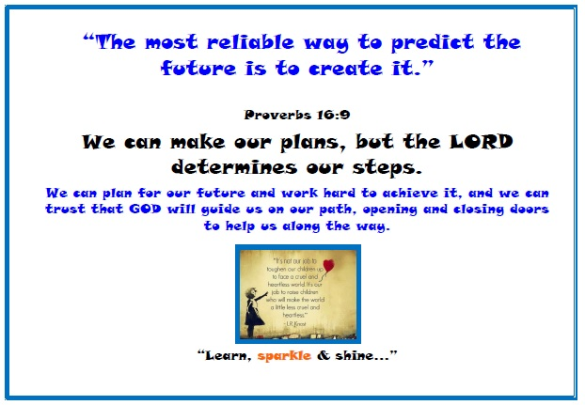 | 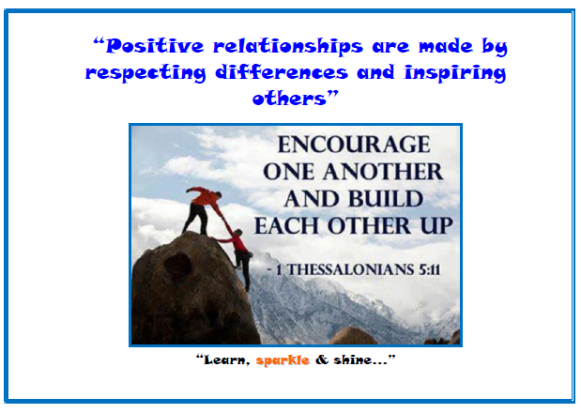

The term ended with more of our annual traditions and services moving on line, which although not the same as face to face events, continue to allow our children to have their achievements recognised and our year 6 leavers to have their time at St. Peter’s commemorated and celebrated.

Annual Awards Service | Year 6 Green Leavers Service | Year 6 Blue Leavers
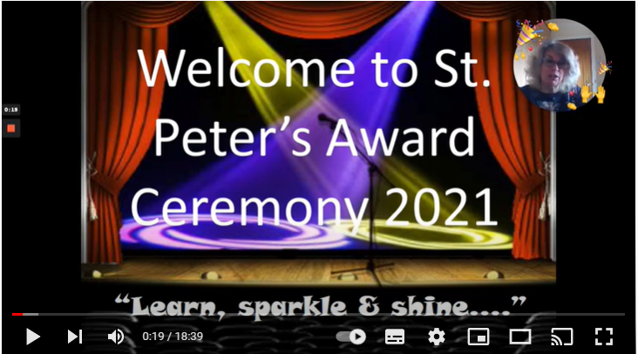 | 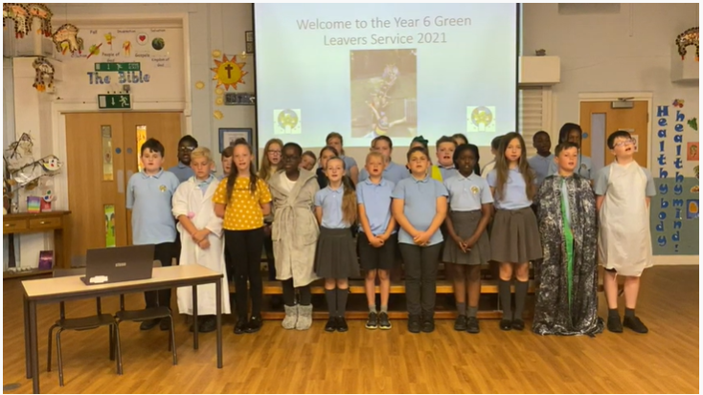 | 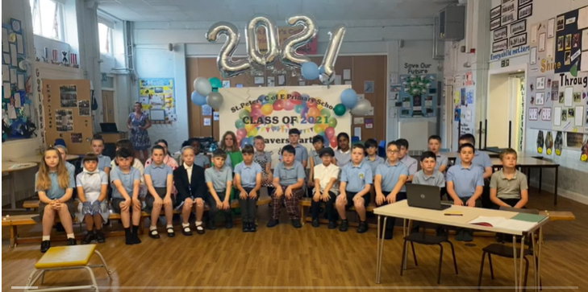

September 2021 – December 2021 The new academic year started with a somewhat unexpected visit from Ofsted in the second week of term, and although we were not anticipating their arrival, we are delighted to say that they caught us ‘as we are’ and proud to report that they judged the school to continue to be outstanding.

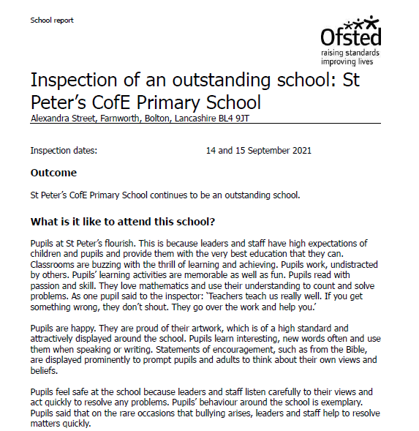

Following the visit from OFSTED the school feels to be in a strong position to move forward with ambition and determination to provide the best possible opportunities for our pupils to ‘flourish’ and fulfil our school vision, aims and intent.

Throughout the autumn term COVID continued to have an impact on the way the school functioned. Bubbles remained in place and in order to minimise transmission of the virus, gatherings remained limited, meaning that our harvest and remembrance services were not open to parents, but were once again recorded and placed on the school You Tube Channel.
Ks1 Harvest | Ks2 Harvest | Remembrance Service
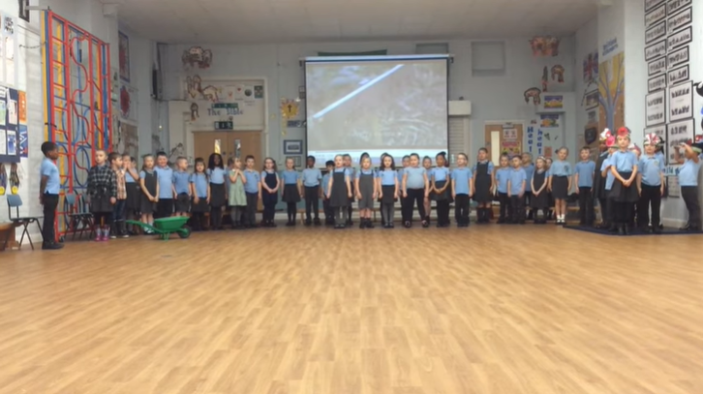 | 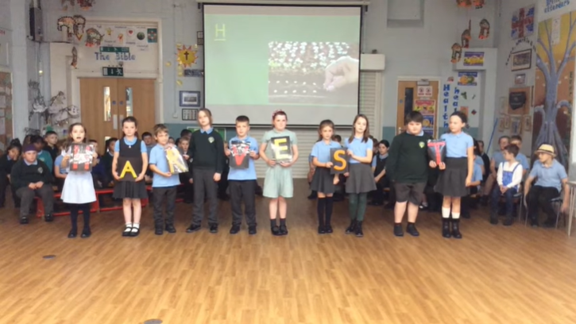 | 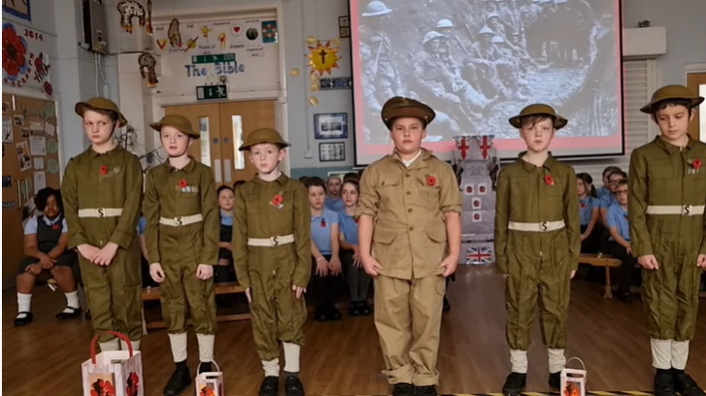

Our theme for the Autumn term focussed on the idea that with God’s help, alongside our own hard work and determination we can achieve all things. The children quickly adopted this new theme and could be heard reciting it daily as they bumped in to different adults around school.

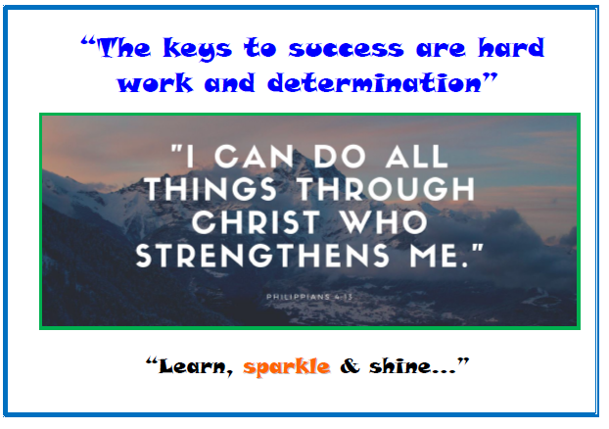

A big focus for the school this year is to develop our pupil voice and promote the courageous advocacy of our pupil leadership groups. Our shine team have been working with Alison Adlum from the Children Changing Places Project every Tuesday lunch time and have written a new school prayer, which is now incorporated in to our weekly worship, with each cohort learning a separate line.

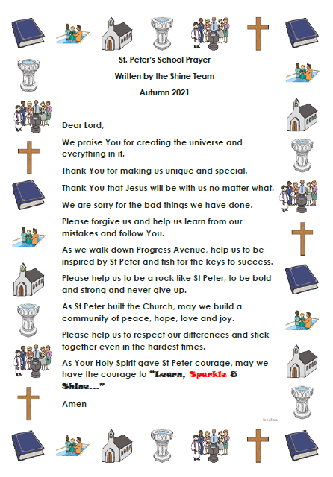
Our school council has also been working hard to develop collaborative projects, and raising awareness of and money for local charities. Prior to Christmas they organised a toy donation, event, resulting in over 600 ‘good as new’ toys being donated to Maddi’s Butterfiles, a charity which works to support children with cancer, a charity very close to the heart of one of pupils.

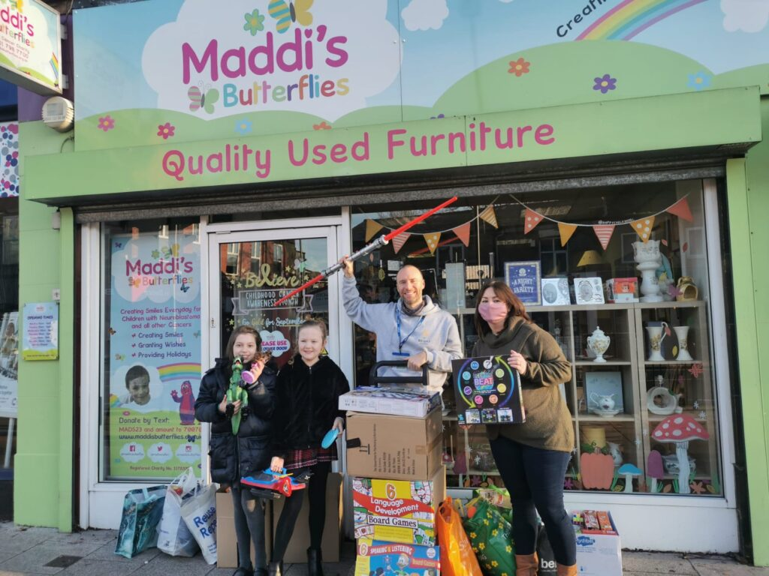

Our Christmas events, continued to be ‘virtual’ but again were made available to our community through our school You Tube Channel. The links can be found below.

Reception Nativity | Ks1 Nativity
 | 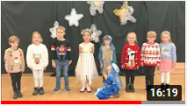
Ks2 Blue Carol Service | Ks2 Green Carol Service
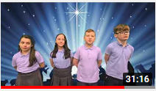 | 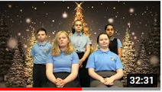

Farnworth continues to be a wonderful community to be a part of. The continuation of the Farnworth Matters project, brining all primary schools across Farnworth together, to work collectively for the greater good of the community is an inspiration for all. It is a pleasure to serve a community with such supportive parents and Governors and such wonderful children. As we move in 2022 and our schools once again open to the wider community we look forward to developing more opportunities for collaboration across the parish and beyond. With God’s help we trust this community can continue to build and develop, so that our children will benefit from a vibrant and aspirant community ethos.

Thank you
Lynn Williams
Head teacher

