St.Peter’s C.E.Primary School

Head teachers Report for the Parish
“ Learn, Sparkle & Shine…”
2020 was an exceptionally challenging year for all, including the St. Peter’s community, however, despite the COVID situation the school continued to promote its ethos and there are many positive achievements to report on.

What is our vision?
As teachers we are often charged with the task of preparing our children for their future. At St. Peter’s we think a little differently, and rather than prepare our children for a future that is imposed upon them, we aim to give them the skills necessary to create the future that they perceive for themselves. Today is the tomorrow of yesterday. By controlling today, we are creating the future of tomorrow. Our vision is to develop our children to enable them to create the future they aspire for themselves.
“Our children will contribute to and prosper in society.”

How will our vision be achieved?
We believe our vision will be achieved if we provide our children with an environment, underpinned by British and Christian values, in which they can “ Learn, Sparkle & Shine…”

Learn = develop wisdom, knowledge and skills.

Sparkle = develop individual character; hope, aspiration and courageous advocacy.

Shine = develop community spirit and learn to live well together.
- We believe inherited traits are only one part of the story of where we may end up. The environment created in our classrooms, the culture of hard work and determination that we encourage, the recognition that we are all able to increase our knowledge through learning, we believe, has an equally valid impact on our future success. (Learn)
- We believe that engaging in a rich and varied curriculum will provide our children with an opportunity to develop a positive attitude to learning and an environment in which they can flourish and thrive. (Sparkle)
- We believe that by using Christian Values to underpin our work, children will be able to spread positive attitudes and shine as a beacon in society. (Shine)
Our daily work is dedicated to achieving these aims.

In June we were re-assessed against the criteria for the Inclusion Quality Mark excellence status and are delighted to say we once again met the standard. We were thrilled with the report below, written by the assessor.

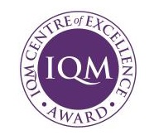
“St Peter’s CE Primary is a larger than average two form entry school with 424 pupils on roll, where the majority of pupils are of White British heritage. It is a vibrant, impressively inclusive school that serves its pupils and community exceptionally well with a strong ambition, heart and soul that marks out this truly inclusive school. This is a school where pupils and staff are encouraged to achieve their full potential, to develop as individual learners and to contribute to the school, their community and society. The staff at the school recognise that the challenges facing their pupils are not just academic and that there is a need to, educate the whole child and often their families as well. This is aptly demonstrated by their vision, ‘rather than prepare our children for a future that is imposed upon them, we aim to give them the skills necessary to create the future that they perceive for themselves. Our vision is to develop our children to enable them to create the future they aspire for themselves. Our children will contribute to and prosper in society. This superbly inclusive vision will be achieved by providing the children with an environment, underpinned by values, in which they can, ‘Learn, Sparkle & Shine’. Where pupils come to school to ‘learn’, so that they can all achieve and that there are the highest expectations for all; to ‘sparkle’, recognising and celebrating the achievements of all pupils and ‘shine’ by representing the school in the wider community and by working towards the school’s Christian values for personal development and becoming good citizens of the future. A fantastic vision and inclusive ethos that is ingrained in the very fabric of the school, its staff and its pupils. These are facts I can attest to from previous reviews and from the evidence of this online review.
This is a school that continues to know its pupils, its families and community well and is determined to help everyone that is involved to the best of its ability. Everyone involved with the school, works hard on a daily basis to make a difference to its pupils and their families. Mutual respect is evident in every area of the school. All adults who work here, led by the extremely aspirational and inspirational Head-teacher and her senior team, have a clear vision for the school and their pupils with a relentless drive for all to succeed, but they also support their colleagues and work together extremely well.”

The school was also shortlisted for three prestigious awards in November 2020.

The TES Primary school of the year award and Educate Awards SEND provider of the year and most inspirational primary school.

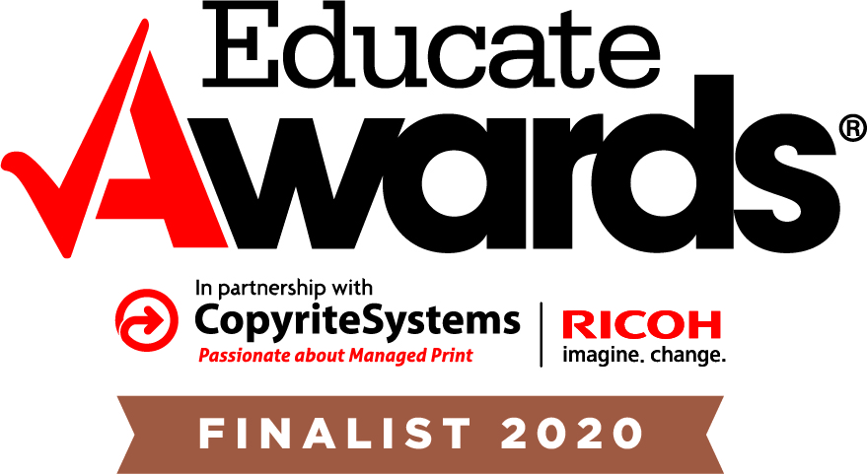 | 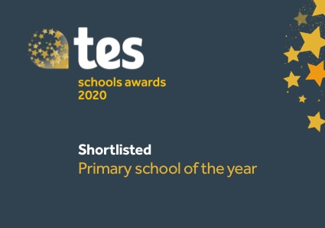

Children missed over a term of school in the Spring and Summer of 2020. Whilst school remained open over lockdown for vulnerable children and those of key workers, for the vast majority of children school provided home learning from the beginning of March 2020.
At the time this included setting online learning via tapestry and class blogs, and sending paper copies of work packs home. Purple mash, TT rock stars and LBQ were platforms that the children were already subscribed to and were used widely to support home learning. Reading books were also sent home. The detailed curriculum knowledge organisers were placed on the website for pupils to access, alongside the measures facts and spelling lists that children are expected to learn in the year group.
This provision was enhanced by the use of Microsoft teams, which was introduced in June 2020 for the purpose of offering emotional support and ‘virtually’ seeing children.
The school you tube channel was used to post on line tutorials and weekly challenge tasks for Ks1 children.
One of our staff reinvented herself as Professor Brain and created a vast array of phonics videos which the children (and their parents) loved. These videos can all be found on our school website here. Phonics with Professor Brain
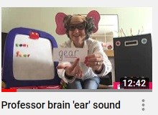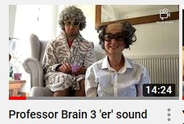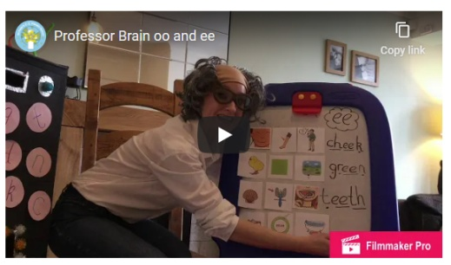
CPOMS was introduced for logging phone calls between staff and parents, particularly vulnerable pupils and all safeguarding issues were logged and followed up.
Food parcels were provided by Magic Breakfast and were hand delivered in the community. This service continued throughout the summer holidays using amazon delivery service.
At the time 145 children were eligible for FSM (now 153). These families were provided with vouchers through the Government scheme. This required a lot of administration time, setting up and managing each week, but ensured the families were able to purchase the food they needed.
Communication with the community remained strong and a daily newsletter was posted on the school website, school APP and twitter.
School reopened on 8th June to pupils in YR, Y1 and Y6. Once all the places had been allocated the additional capacity was offered to Y5 pupils. Over 140 out of the 420 children in total returned.
Transition of pupils in to the reception class of St Peter’s looked very different, however the introduction of ‘tapestry’ for the pre induction pupils proved to be very successful. Over 90% of parents logged on and engaged with the transition programme, including sharing videos of their children. Staff felt they got to know the children very well prior to them starting and the transition was smooth. All children had a home visit from a member of school staff and were presented with a goody bag containing information about the class and a story book. The reception class blog was set up prior to September and messages to parents were posted this way.
Year 6 leavers were given a leavers goody bag, which was presented to them in a 1;1 appointment with their class teacher, with their family.
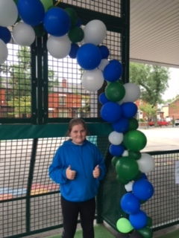
The autumn term was challenging due to the high level of COVID transmission in the community, but school remained a stable and positive environment. School was able to operate safely within the guidance of the full and thorough risk assessment. The staff and children adapted well and quickly became used to the ‘new normal.’
During the Autumn term our outward facing community work was able to continue and we raised over £1000 for community causes including Children in Need and Macmillan nurses.

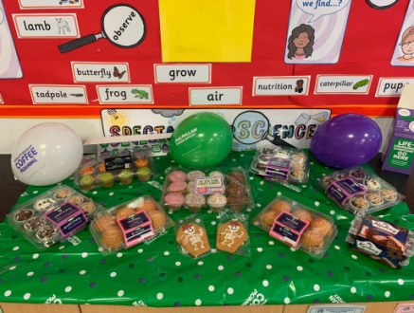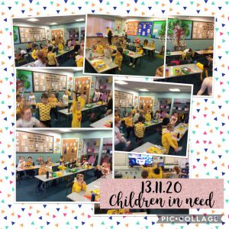

We were able to hold our usual harvest, Remembrance and Christmas services, albeit virtually. These are available to view on our school You Tube Channel, by clicking on the links below.

Harvest

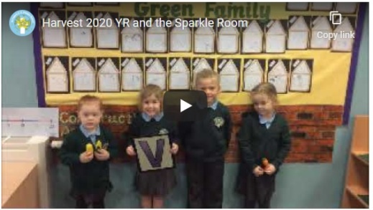 | 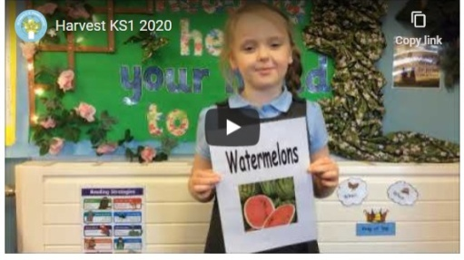 | 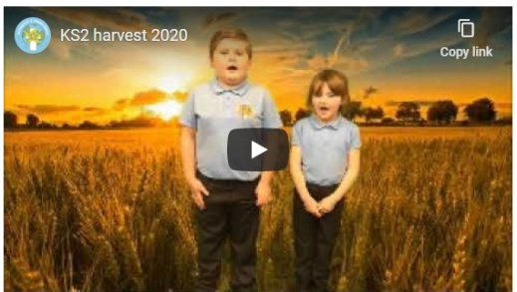

Remembrance

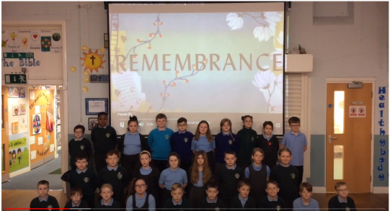

Christmas

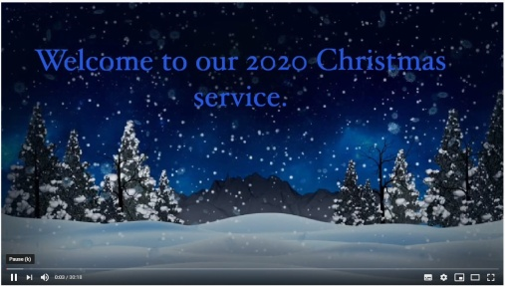 | 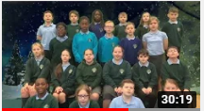 | 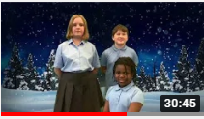

The Children Changing Places project has been very beneficial to the pupils and Wiggle Worship is a hit with EYFS and KS1. Thanks go the entire team.

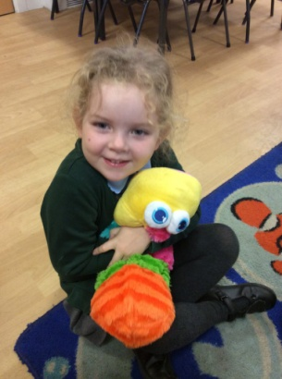

Farnworth continues to be a wonderful community to be a part of. It is a pleasure to serve a community with such supportive parents and Governors and such wonderful children. With God’s help we trust this community can continue to build and develop, so that our children will benefit from a vibrant and aspirant community ethos.

Thank you
L. M. Williams
Head teacher

