# St.Peter’s C.E.Primary School

# Head teachers Report for the Parish



“ Learn, Sparkle & Shine…”

2017 was another exceptional year for all at St. Peter’s with a number of noteworthy events taking place.

We were once again delighted with the outcomes of the pupils in the Y6 SAT’s. Combining the data across the 3 years 2015-2017, the progress made by the children across KS2 places the school in the top 2-4% of all schools nationally. This is a remarkable achievement and is a reflection of the stable, dedicated and committed staff team, who work tirelessly to ensure all pupils are able to walk down ‘Progress Ave’ as they enter the doors of our school.

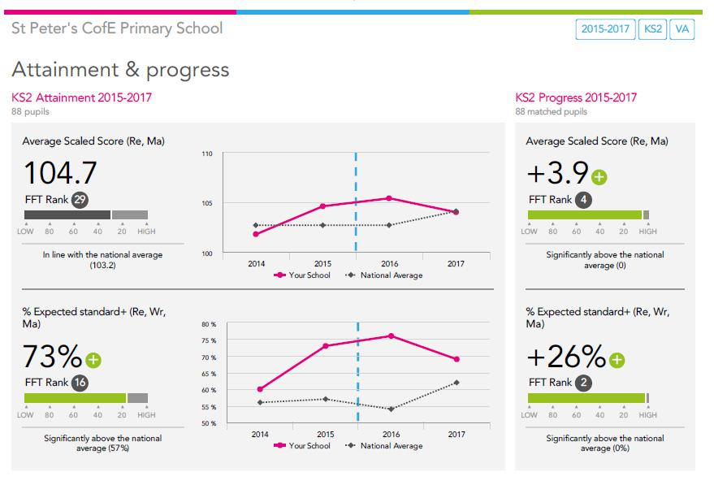

Our links with the church and community are very much valued by the school and a highlight of the year was the participation of our Year 4 children in the recording of a CD at St. John’s Church. Working in collaboration with Paul Saxon and a number of other schools from the local community, the children combined their efforts to create an amazing CD, with the collective voices of all the children. We were also delighted that one of our pupils was awarded the prize for designing the CD cover.

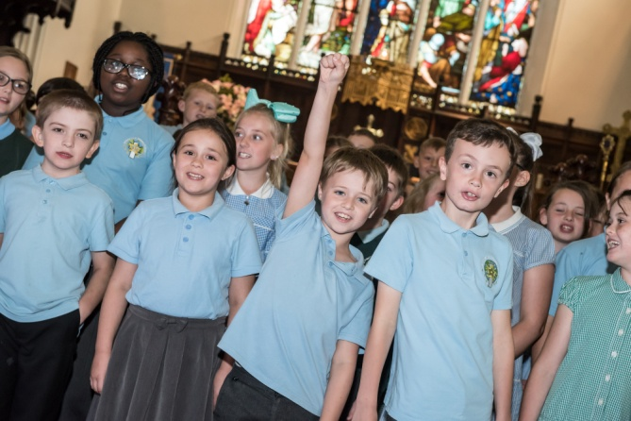

A further highlight of our school year was the remembrance service led by Year 5. This is always a very moving poignant service and as usual the Y5 children did not let us down. Each child made a poppy using the end of a recycled plastic bottle, which was then placed on a collective display, draped over our school cross in the grounds. The finished result was stunning.

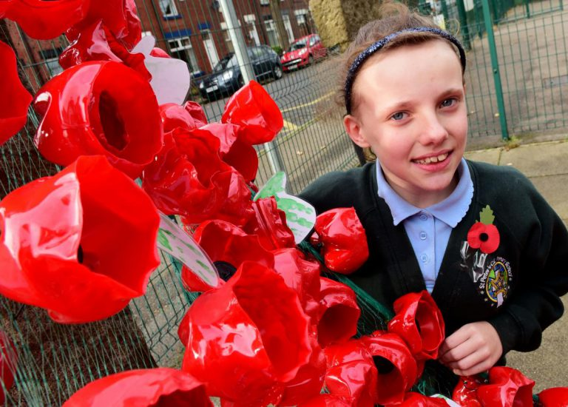 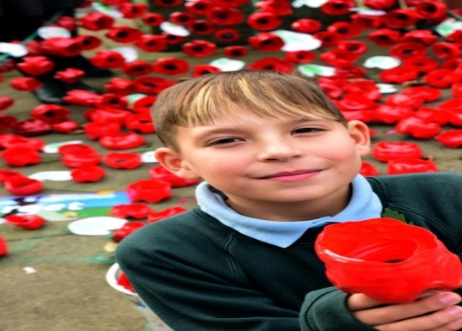

We are also delighted to be able to participate in the ‘Experience’ events held throughout the year at St. John’s Church. Each of our KS2 classes has visited the church at some point over the course of the year engaging with activities linked to Creation, Christmas and Easter. The opportunity to visit the Church and engage with the activities in a fun and engaging way, creates highly effective learning opportunity for the children. Thank you.

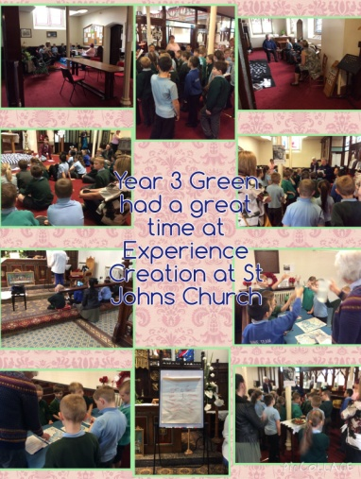 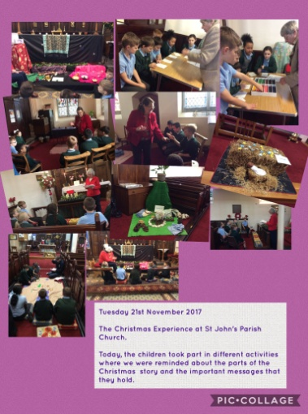 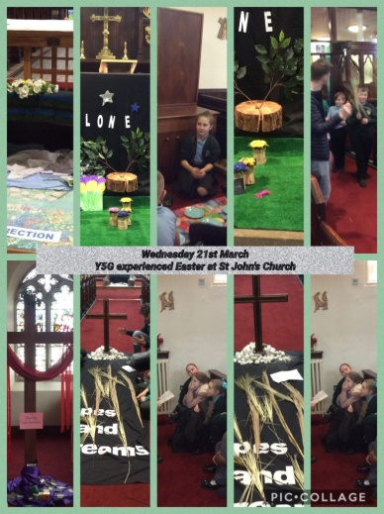

Our latest community event has been the opportunity to work with a group of exceptionally talented musicians on a music based project known as The Harmonise project. The***Harmonise*** project is run by an award winning charity called Music Action International. Four superb musicians worked with year 5 on their mission to bring the stories of refugees into the classroom in a sensitive and inclusive way. Once again the learning opportunities provided were exceptional and the engagement of the children with people from other communities was inspirational. The future for global citizenship is looking strong for the children of Farnworth.

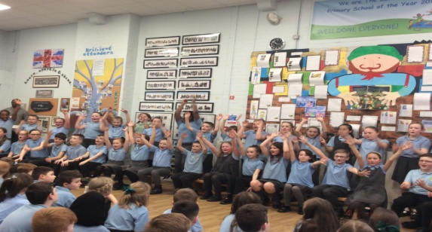

2017 also saw the schools work with parents and staff recognised through the achievement of the leading Parent Partnership Award and the Investors in People award.

The broad and rich cultural education provided for the children was also recognised through the achievement of The Arts Council quality mark - Arts Mark Gold.

|  |  |  |
| --- | --- | --- |
| IIP_SOLID_ACRED_LOGO_2020_CMYK-300x100 | LPPA-2017-20 | arts-mark-gold-cropped |

Our current theme in school is;



Our daily worship is centred around one of our values and the children are openly discussing their thoughts around each of these values in turn. The support of Sr. Dorothy in guiding many of these discussions and leading a weekly worship session is invaluable. Our thanks go to her. Each class has created a canvas to reflect our values; these canvases are now proudly displayed in school.

We continue to be reassured by the support and encouragement we receive from our school Governors and from all members of the parish. It would be difficult to imagine leading a school, without such key people! Our thanks go to each one of them and to Vicar Carol for their continuing involvement and blessing.

The future of collaboration in Farnworth is looking exceptionally strong and we look forward to being part of that future, working alongside the church community to build a great future for our children.

Thank you

**Lynn Williams**

**Head teacher**