St John’s CE Primary School
Head teacher’s Report for the Parish 2015-16

Spring term 2016
We again combined Comic Relief celebrations with our non-uniform day towards the Easter Bingo – which sells out every year and we couldn’t do without Keith Entwistle and a team of volunteers from St John’s Church. As usual we thoroughly enjoyed our Easter Experience in church and thank the team behind it.
Summer term 2016
This term the school held its first ‘What Makes Britain Great Week’ and we were visited by a range of services and enjoyed ‘tea- parties’ and other wonderful events.

All of our Year 6 children received St John’s Ambulance training and our Year 5 and 6 enjoyed an ‘Anti-Discrimination Workshop’.

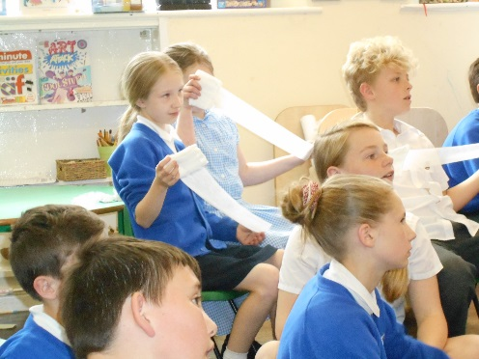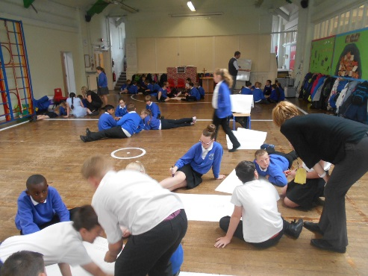

Our children helped to plant flowers and shrubs as part of ‘Kearsley in Bloom’ to help improve the appearance of the front of the school.
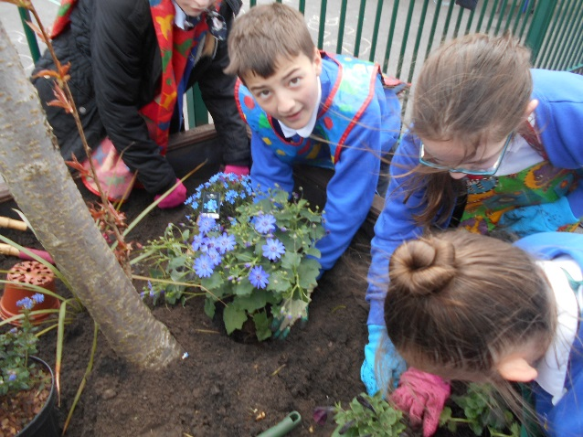

Autumn term 2016
We held our annual Harvest Festival where we gave thanks for God’s good gifts.
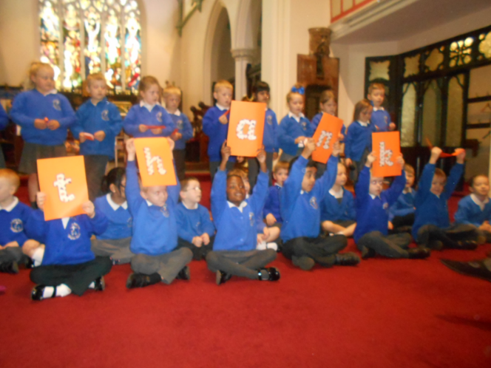
The whole school took part in the ‘Race for Life’ around the school field raising money and awareness for cancer research.
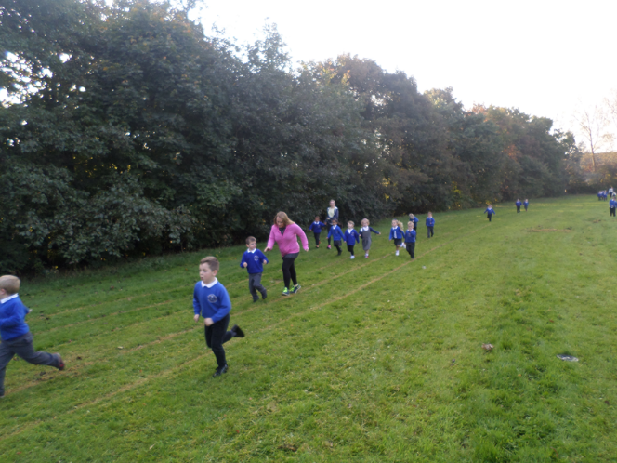
The school was rewarded with another ‘Good’ rating at the SIAMS Inspection in November where it was recognised the strong links with the church and community St John’s Kearsley has.

The children had the opportunity to take part in an Inter Faith Day at the Well where they had hands on experience of other faiths and beliefs.
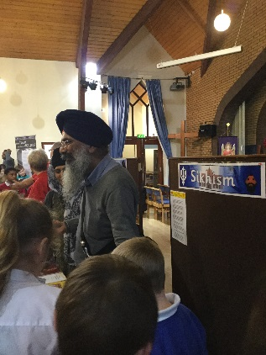

We welcomed Paul Saxon and his Energize Club into school to run sessions for the children.
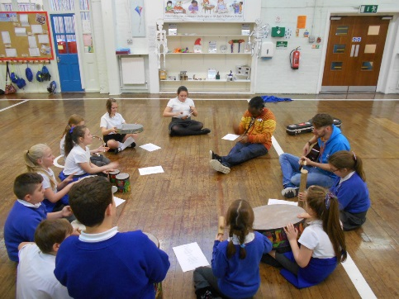
Mrs Coucill one of our Foundation Governors visited Year 6 to teach them about the Eucharist.
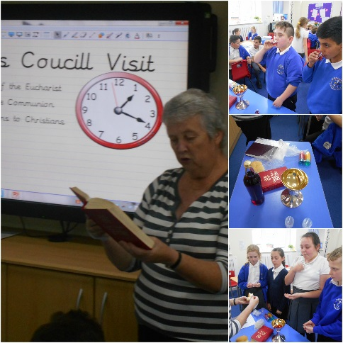
We held our ever popular ‘Christmas Tree Dressing Ceremony’, the infants performed their Nativity plays to a packed house.
Suzanne Howard
Head teacher (from January 2017)

