St John’s CE Primary School
Head teachers Report for the Parish
Spring term 2017
St John’s CE Kearsley welcomed their new Head teacher Ms Suzanne Howard who returned to Bolton after 10 years as Head teacher at a Church of England School in East Lancashire. Paul Saxon from Zac’s Youth Bar met with the Head teacher early in January to explain the work that they did and his role in offering mentoring to children as well as supporting in Worship. Our themes for worship were ‘Hope’ and ‘Forgiveness’. We held a Mothers’ day lunch in school which was very well attended and our School Council visited Farnworth Care Home to chat with and read with the residents. Mrs Howard was honoured to lead the Reading at St John’s Church one Sunday in March as St John’s re-joined the church rota. As usual our Year 5 children thoroughly enjoyed ‘Easter Experience’ in church and we thank the team behind it. We held two services in St John’s; one for the Infants who looked at ‘New Life’ and the Juniors who focussed on retelling the events of ‘Holy Week’ through readings, prayers, poems and re-enactments. Both services were well attended and our School Council served refreshments between the services at a Community Coffee morning held in the school hall. We held our first Egg Decorating Contest in school where the infants decorated an egg template and the juniors used their creative skills to decorate hard-boiled egg. The Chair of Governors had the difficult task of judging winners and runners up for each class. The PTFA held their annual Easter Egg Bingo where it was ‘eyes down for a full house!’
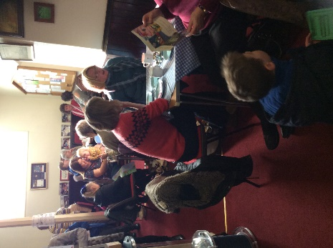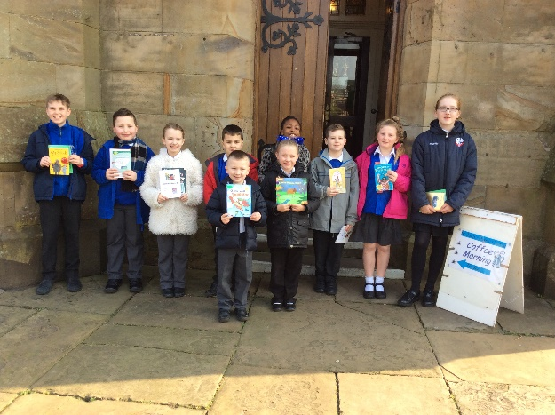

Summer term 2017
This term the school took part in St John’s Flower Festival arranged by one of our governors Mrs Steph Buckley. School sponsored a display and the school choir opened the festival whilst all classes visited the exhibition throughout the day to see the wonderful display for themselves. Year 5 supported St John’s Coffee Morning by taking over some reading books and reading and chatting with the church congregation. Mrs Barr, our Deputy Head, was proud to be asked to read the Intercessions at St John’s Church as representative of St John’s CE Kearsley. Our Year 3 children were thrilled to take part in ‘Experience Creation’ at St John’s Church and came back asking some very philosophical questions! Mrs Howard attended the Diocesan Cluster Meeting at St Simon and St Jude’s Primary School in Bolton and was officially welcomed by The Director of Education Cannon Maurice Smith. Our Themes for Worship were ‘Encouragement’ and ‘Kindness’. Our Year 6 attended the Leavers’ Service at Manchester Cathedral which was very poignant after the tragedy affecting the MEN Arena. Our PTFA held a series of Fathers’ Day Workshops which culminated in a Fathers’ Day Lunch at school on the Friday which went down a treat with hungry dads, Uncles and granddads! We held a Governors’ Coffee Morning at school to revisit our ‘Vison and Values’ with parents to set out ‘What St John’s is all about?’ Our Year 2 went over to St John’s Church whilst studying ‘Baptism’ which was a great hands on experience and our Year 5 were lucky enough to take part in a ‘Sacred Places Trail’ at St Peter’s Church with transported funded by Manchester Diocese. The Year 6 took part in the annual ‘Footprints all over the World’ which was a good preparation for their own Leavers’ Service held at St John’s for all their families and friends in the last week of term! School and the PTFA joined forces to ensure all children received a Good News Bible to take with them onto secondary school for their spiritual journey ahead. We held our end of year Celebration Worship which not only celebrated the achievements of all the children but gave us all an opportunity to say a fond farewell to Mr Bob Atkinson who retired as Chair of Governors after 10 years of service to the children and community of St John’s.
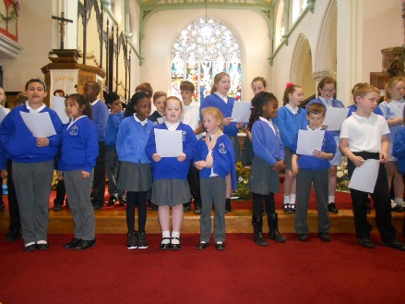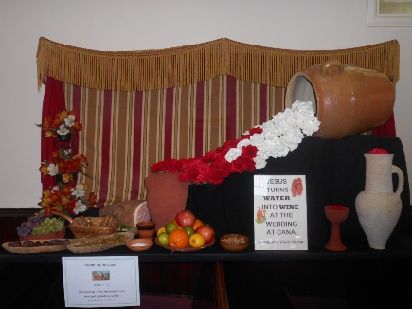
Autumn term 2017
September saw the launch of a new PSHE scheme called ‘Heartsmart’ as we welcomed ‘Boris’ the Robot into our Worship. The children were introduced to the ‘High 5s’ which became the focus of our worship looking at ‘Don’t Forget to Let Love in’! The children embraced this new way of looking at ‘Love’ as a theme for Worship which was taken forward by Rev Pharaoh as well as Paul Saxon on our weekly visits to church. The School Council held a Macmillan Coffee Morning where cakes donations and refreshments were served by them and the School Prefects –raising over £100 for this worthwhile cause. We welcomed our newest members of St John’s School in a special Reception service where all the children received a wooden cross as a keepsake to treasure as they move through school.
We held an Infant and a Junior Harvest Service at St John’s and families generously donated foods and toiletries to the Farnworth Foodbank. Mrs Howard attended the Diocesan Cluster Meeting at St Paul’s CE Primary in Astley Bridge. Our Year 4 children took part in the ‘Experience Christmas’ event at St John’s and they all came back with a sense of wonder and excitement for the coming Advent. Rev Pharaoh and some Governors came into school to help all classes make Christingles with Y6 and Y2 taking and lighting their Christingles as part of the Infant and junior services at St John’s Church to make the start of Advent. We followed this with our annual ‘Tree Dressing Ceremony’ with all staff leading the event with a range of poems, readings and prayers. This was Mrs Howard’s first experience of the ‘Tree Dressing’ and it proved to be a wonderful start to the Christmas festivities. Our Reception children went over to Farnworth Care Home to sing carols for the residents and there was not a dry eye in the house. The PTFA had funded Snow White for all the children performed by a visiting pantomime group and Mrs Farrow’s instrumental group thrilled parents with her first Christmas concert. We invited Grosvenor Nursery staff and children over to watch our Infant Nativity ‘The Angel Express’ and our Junior children performed a wonderful Junior Carol Service retelling the first Christmas through hymns and readings to a packed church. Mrs Howard and Mrs Barr attended the Candlelit Carol Service at St John’s where Mrs Howard led a reading which was a fabulous way to end her first year at St John’s CE Kearsley Primary.
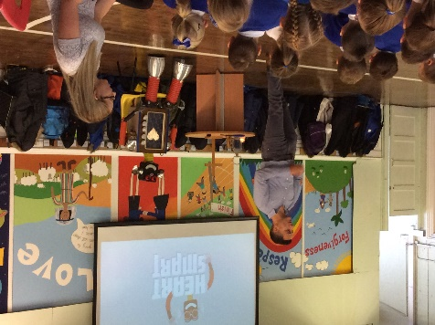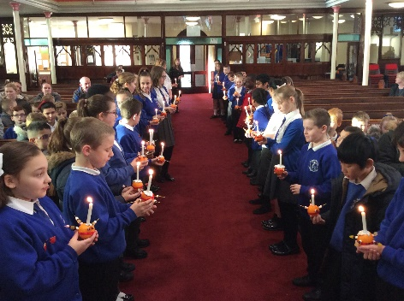

Suzanne Howard
Head teacher

