St John’s CE Primary School
Head teacher’s Report for the Parish
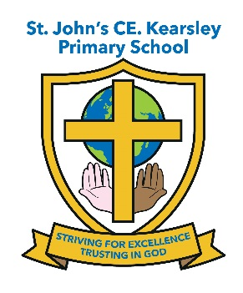
(January 2020 - December 2020)
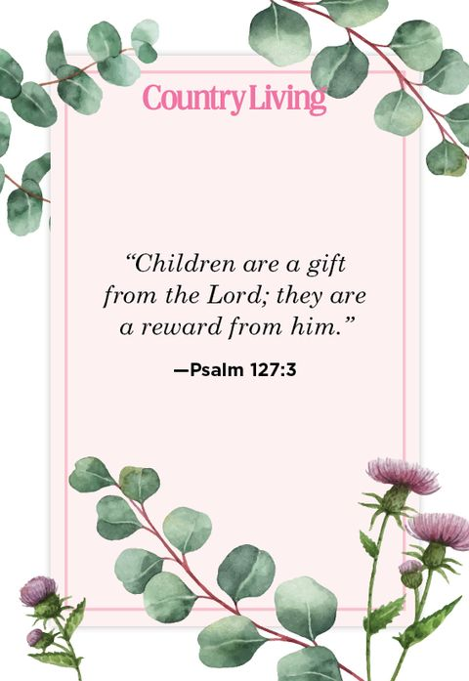
This year’s report follows what can only be described as one of the most challenging times our children and families have ever faced. Without the strength and support of my whole school community and the other Head teachers within this Parish I know the task of keeping the school going on an even keel would have been much harder. I feel truly blessed to be the Head teacher of St John’s CE Kearsley at what was such a worrying and testing time for all of the school and church community

Spring term 2020

All children continued to attend church on Thursday mornings until we were unable to do so when school closed to all but essential worker and vulnerable children on Friday 20th March.
This term’s whole school themes for HEARTSMART were ‘Don’t Rub it in Rub it Out’ and ‘Fake is a mistake’ as well as covering our school values of Forgiveness, Respect, Equality, Kindness and Encouragement. Worship was led by the staff, with Father Stephen following on from the weekly focus introduced each Monday in Worship by the Head teacher. It was great to begin to see a regular worship structure in church as the children became used to following the openings and closing rituals that Father Stephen introduced and they really enjoyed learning some new worship songs a long with the actions to accompany them.
Unfortunately just as the Spring term was getting going and we were looking forward to creating new spiritual memories with Father Stephen at the helm of St John’s the COVID pandemic hit and so all of our usual events and activities held within the spring term had to be cancelled. Experience Easter at St John’s Church, our annual Easter Services at St John’s church for both the Infant and the Junior Units
As part of our Easter Celebrations all children would normally take part in the decorating an egg competition. Again all this had to stop
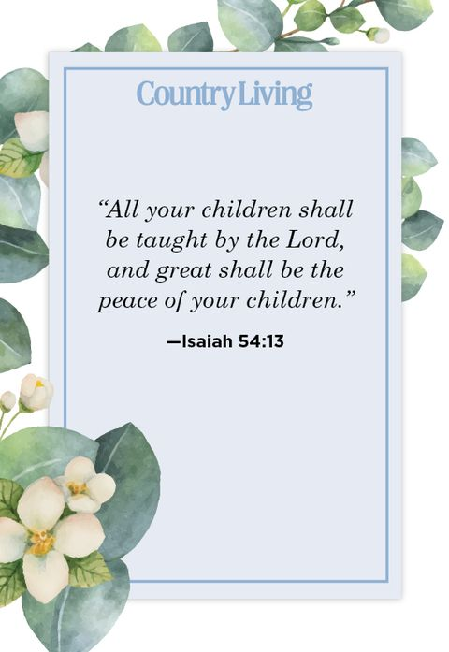
Summer term 2020
Unfortunately school remained closed to all but Key worker families and vulnerable children for the whole of the Summer term. The school did its best to provide suitable learning opportunities to all children at home during this time and ensured appropriate support for families at the point of need through our Pastoral Officer and Behaviour and Engagement Mentor making welfare calls to families and sign posting them to agencies and Charites throughout the height of the pandemic.

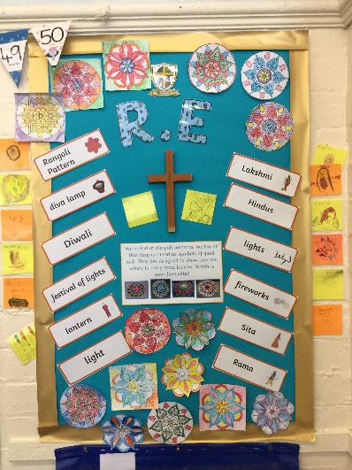

St John’s just wasn’t the same without the children and for many it was their ultimate faith that God had a plan for us all that got us through such a mentally and emotionally challenging time for all concerned.
Autumn term 2020
Unfortunately we have not been able to attend church since September due to COVID restrictions which has been a real shame for the children as it’s an integral part of what being a member of St John’s school. Father Stephen has sent across some content for us to use within Collective Worship on a monthly basis to supplement what school has been using up to Christmas. The Diocese have provided high quality weekly Collective Worship resources and videos which school has been using alongside their own to supplement collective worship especially during the 3rd lockdown and has formed part of the school’s weekly RE provision for home learning.
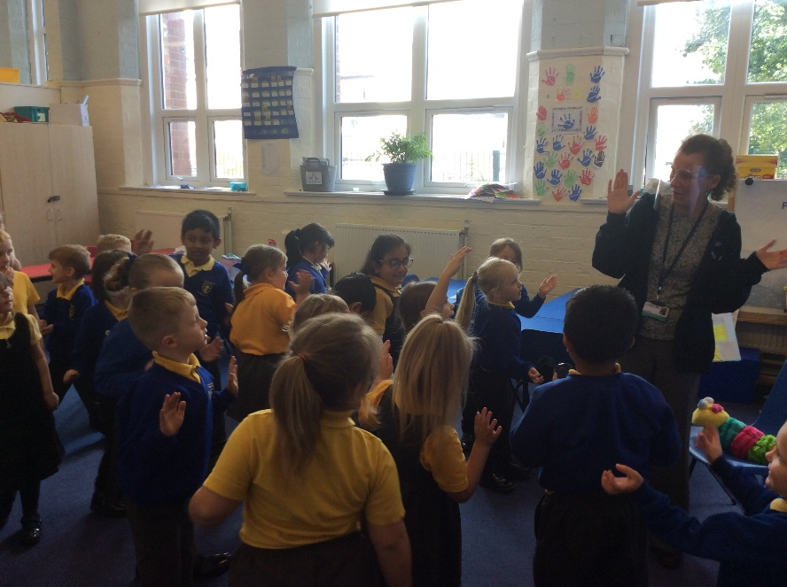
Reception were able to hold 3 ‘Wiggle Worship’ within the Autumn term led by Steph from Changing Places Team – this event was held separately for each bubble and the children loved it but unfortunately we could not include parents this time.
The school collected donations for the Harvest which once quarantined was dropped off at Farnworth Foodbank and each Unit had a Harvest Service within school with reading and prayers created by the children.
Robins really enjoyed learning about Diwali and tasting celebratory Indian food and making their Puja lamps, the children really enjoyed listening to Mrs Waland explain her family traditions and how they all celebrate this important Hindu festival.
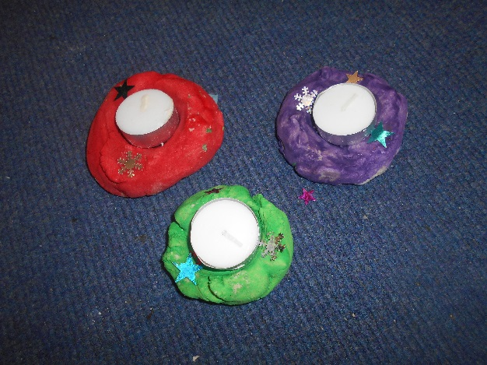
School managed to ensure we held a Christingle Service at St John’s as normal with all classes making Christingles and learning about their significance. This was recorded and uploaded to Twitter and the school’s FB account for parents to share in.
The annual ‘Tree Dressing Ceremony took place on 30th November with each class teacher leading a reading, poem or prayer. This was again recorded and uploaded to social media for families to enjoy. However Experience Christmas at St John’s Church had to be cancelled due to COVID restrictions again another disappointment for the children as this is highlight in their celebrations.
School worked really hard to ensure the magic of Christmas continued despite the pandemic and the Infants performed of ‘Off to Bethlehem’ on 14th December again this was recorded and uploaded for families to share and enjoy. The Juniors held a Carol Service in school separately within their bubbles on 17th December which was videoed and uploaded alongside the other festivities to enjoy. School finished for the Christmas holidays feeling extremely proud of the way the whole school community had pulled together to try to keep things as normal as possible for the children of St John’s

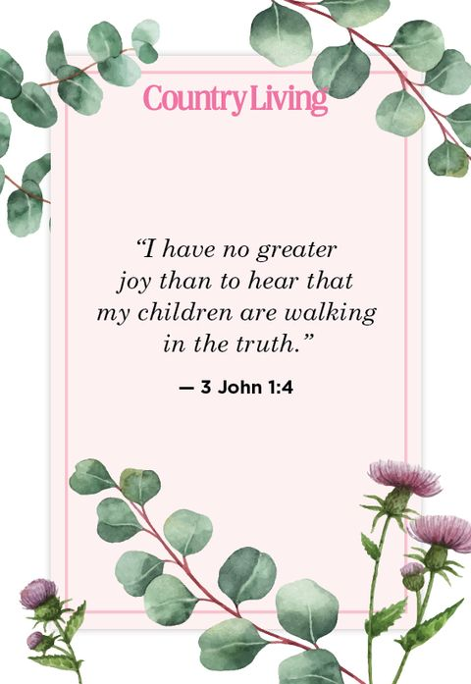

Finally I would like to thank all of my staff and Governors for all their hard work and continued support through what has been a very challenging time for the family of St John’s.
Suzanne Howard
Head teacher

