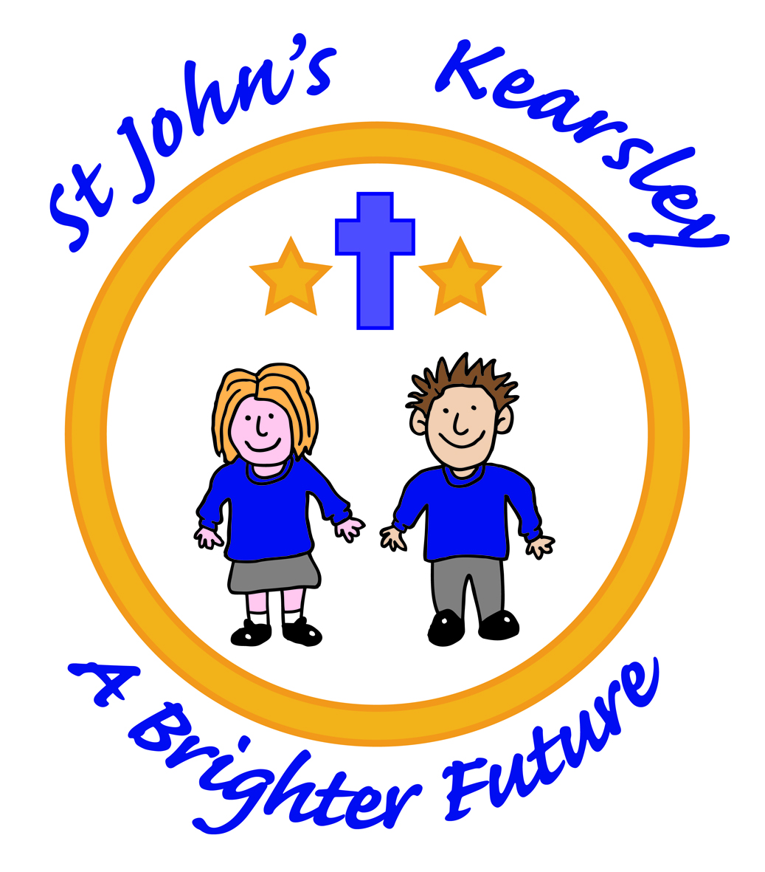

St John’s CE Primary School
Head teacher’s Report for the Parish
(January 2018 - December 2018)

‘Therefore, if anyone is in Christ, the new creation has come.
The old has gone, the new is here!’
2 Corinthians 5:17
Spring term 2018
All children continued to attend church on Thursday mornings for Worship led by Paul Saxon from Zac’s Youth Bar or Reverend Carol Pharaoh. The school’s Spring term’s theme for HEARTSMART were ‘Too Much Selfie Isn’t Healthy’ and ‘Don’t Rub it in Rub it Out!’ Daily worship was led by the staff with Paul and Rev Carol following on from the weekly focus introduced each Monday in Worship by the Ms Howard.
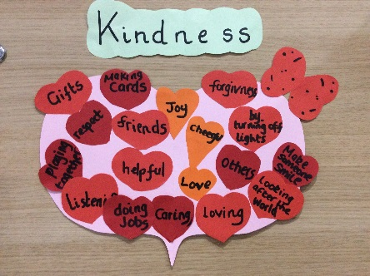
A consistent number our Year 6 children regularly attended Zac’s Youth Bar and accessed the ‘Energize Club’ after school on Wednesdays.
School remained on the official rota for church readings, however due to the short notice given, school was sadly unable to lead the readings at the worship on Mothers’ Day in March. We held our annual Mothers’ day lunch in school which was very well attended and all visiting ladies received some flowers as a thank you for all they do for us.
The school received a visit from Malcom Finney Assistant Director of Education of Manchester Diocese who was keen to hear how Ms Howard was getting on and had a tour of the school. He also made contact with Jill Rhodes to book an Ethos Health check for the Autumn Term 2018.
Our Year 5 children took part in Experience Easter at St John’s Church and school held two Easter Services at St John’s one for the Infants and one for the Juniors. The Infants focused on the theme of ‘New Life’ whilst the Juniors led us through the Easter story with readings, poems and prayers. Both events were well attended by families and friends.
As part of our Easter Celebrations all children took part in the decorating an egg competition. The Infants designed and coloured an egg template and the juniors decorated hard-boiled eggs. Competition was fierce and Rob McIntyre as Chair had a difficult job judging the winners and runners up.

‘If we confess our sins, he is faithful and just and will forgive us our sins and purify us from all unrighteousness.’ 1 John 1:9

‘Finally, all of you, have unity of mind, sympathy, brotherly love, a tender heart, and a humble mind.’ 1 Peter 3:8

Summer term 2018
The Summer term’s whole school themes for HEARTSMART were ‘Fake is a Mistake!’ and ‘No Way Through isn’t True!’
Year 3 took part in Experience Creation at St John’s Church on Wednesday 23rd May where the child had the opportunity to experience this wonderful event through a series of hands on activities.
The Year 6 children took part in the annual Leavers’ Service at Manchester Cathedral on 11th June and were accompanied by some Governors for this special occasion to mark the end of their time in a Church of England Primary School.
Year 2 enjoyed a wonderful visit to St John’s church on 12th June where they were given a tour of the church and discussed the different Stations of the Cross with Vicar Carol. School invited held all significant men to join us for a Fathers’ Day Lunch at school on the Friday which went down a treat with hungry dads, Uncles and granddads!
Miss Steele our RE and Collective Worship Leader attended the RE Teaching and Learning Conference on 27th June which covered ‘increasing knowledge for those teaching RE and classroom activities to support good learning’ and ‘finding commonality and recognising & discussion differences with respect in the classroom’ -
School hosted the St John’s Church Summer Fair which was opened by one of our children ‘Sophia’ who played the clarinet on 7th July.
Year 6 attended ‘Footprints All Over the World’ event on 11th July where the children took part in activities based on perseverance, hopes, dreams and ambitions for their move to secondary school.
Year 6 led their Leavers’ Service at St John’s church just before we finished for summer where they looked back over their spiritual journey at St John’s school and received a Bible to take with them to secondary school and a Moving On book from the Church.

‘Fear not, for I am with you; be not dismayed, for I am your God; I will strengthen you, I will help you, I will uphold you with my righteous right hand’ Isaiah 41:10

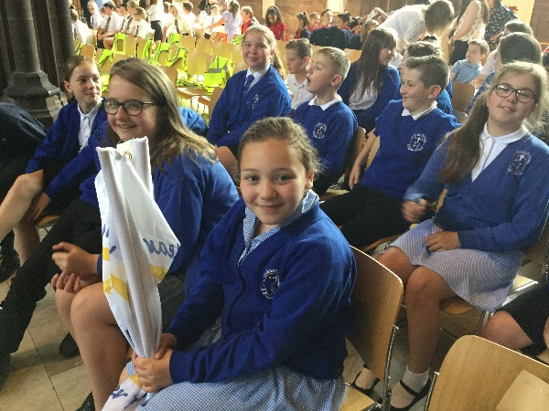

‘We love because He first loved us.’ John 4:19

Autumn term 2018
September saw the school continue to develop Collective Worship mixing ‘Heartsmart’ with our school vales of Forgiveness, Respect, Equality, Kindness, Love and Encouragement (FREKLE). The children continued to develop their Reflective Worship by creating Reflective Worship Scrapbooks to evaluate worship and what it means to them. School continued to enjoy worship led by Rev Pharaoh as well as Paul Saxon on our weekly visits to church. The School Council held a Macmillan Coffee Morning where cakes donations and refreshments were served by them and the School Prefects –raising over £100 for this worthwhile cause.
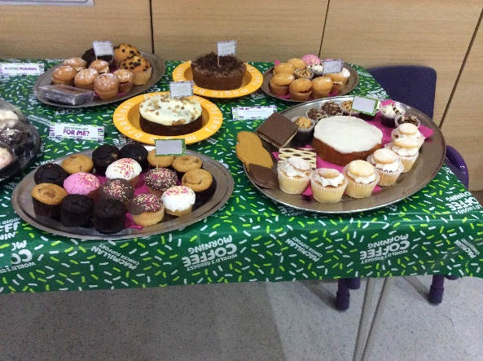

We welcomed our newest members of St John’s School in a special Reception service where all the children received a wooden cross as a keepsake to treasure as they move through school.
We held an Infant and a Junior Harvest Service at St John’s and families generously donated foods and toiletries to the Farnworth Foodbank.
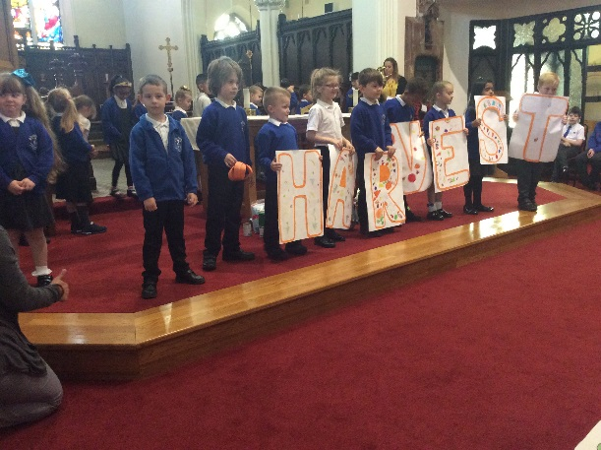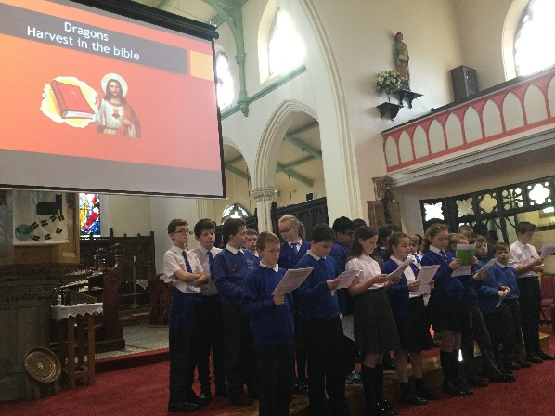

Our Year 3 children took part in the ‘Experience Christmas’ event at St John’s and they all came back with a sense of wonder and excitement for the coming Advent. Paul Saxon came into school to help all classes make Christingles with Y6 and Y2 taking and lighting their Christingles as part of the Infant and junior services at St John’s Church to make the start of Advent.
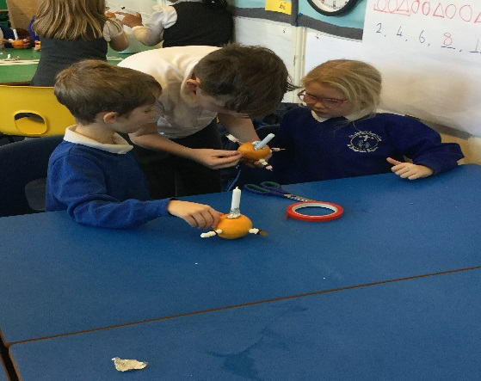
We followed this with our annual ‘Tree Dressing Ceremony’ with all staff leading the event with a range of poems, readings and prayers. Our Reception children went over to Farnworth Care Home to sing carols for the residents and to watch a special nativity for the residents. The PTA had funded Aladdin for all the children performed by a visiting pantomime group and Mrs Farrow’s instrumental group thrilled parents with her their Christmas concert with guest appearance from St John’s ‘Little Voices Club’ who brought the house down with a selection of festive songs with help from the staff members. We invited Grosvenor Nursery staff and children over to watch our Infant Nativity ‘The Inn Keeper’s Breakfast’ and our Junior children performed a wonderful Junior Carol Service retelling the first Christmas through hymns and readings to a packed church. As part of our Christmas celebrations the Infants and Junior got together to share stories they had written based on ‘The Bear and the Hare’ which was a fabulous example of the different ages and stages coming together through a love of literature. Finally Mrs Howard and Mrs Barr attended the Candlelit Carol Service at St John’s where Mrs Howard led a reading which was a wonderful way to end the year at St John’s CE Kearsley Primary.
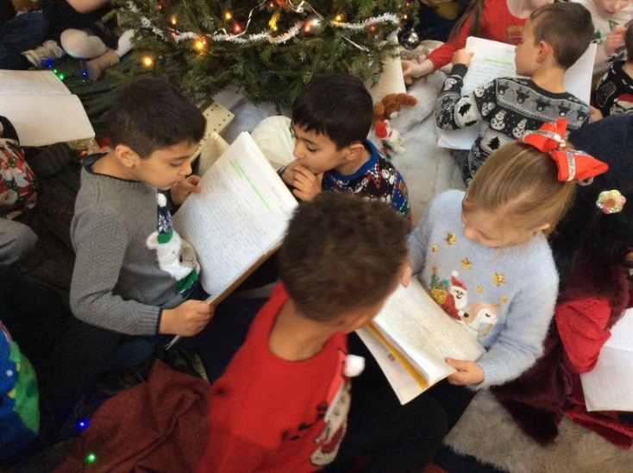

‘For God so loved the world that he gave his one and only Son, that whoever believes in him shall not perish but have eternal life’ John 3:16

Suzanne Howard
Head teacher

