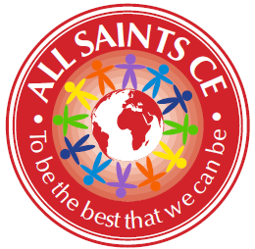
Report from All Saints’ CE Primary

We have had a great year at All Saints, with lots of exciting events both in and out of school. Although our SATs results fell this year, this was in line with the national picture as a result of the new tests being introduced. Our progress was good, as several of our children are below national average lower down school. We were especially pleased with our Maths progress which was in the top 30 in Bolton.

Enrichment

And God saw everything that he had made, and behold, it was very good. Genesis 1:31
A big part of our mission is to provide our children with the opportunity to experience our wonderful world. This includes regular visits to art galleries and museums – we are very blessed in being so close to a train station so Manchester is a regular haunt of ours! Each class also go on trips related to the topics that they are learning, which last year included Skipton Castle, Tatton Park, Cadbury World and Smithills Farm.

The highlight though was our whole school trip to Thornton Cleveleys. About 18 months ago, we discovered that the vast majority of our children had never seen the sea. We applied for a grant to help with the travel costs and set off last June. I wish I could have bottled the look on the children’s faces! They all had a paddle, made sandcastles and had fish and chips and ice cream. It was one of those days that make you glad to be alive.

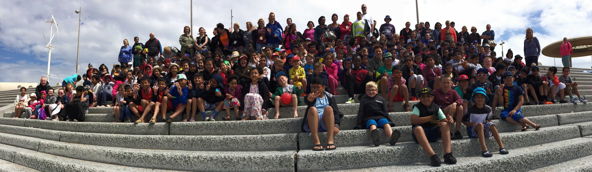

Church and Community

So then you are no longer strangers and aliens, but you are fellow citizens with the saints and members of the household of God, Ephesians 2:19
We have continued to strengthen our links with the church and wider community. Several of our classes have benefitted from the ‘Experience…’ events at St John’s church and always come back full of enthusiasm. We held our carol service in church again and had a few more parents attend. Our school council wrote and read the nativity readings in their own words this time, which added a special touch. Paul has been running a weekly club supporting children with their spiritual wellbeing. Vicar Carol and Paul have also continued to deliver collective worship sessions in school.

Last June, we had the honour of welcoming a Headteacher from Lahore to the school. Meeting a Christian from Pakistan was a revelation to lots of the children and they learned a lot about the work of the Church in other parts of the world.

The schools in Farnworth continue to forge a strong partnership with collaboration at all levels. This includes our continued teacher training programme which supports us in recruiting high quality teachers. On a personal note, the support from other Headteachers is invaluable.

Governors

This service that you perform is not only supplying the needs of the Lord’s people but is also overflowing in many expressions of thanks to God. 2 Corinthians 9:11-12
Our governors have continued to develop their role in school improvement. They have been involved with learning walks, book scrutinies and more training which is helping them to know school better as well as them becoming familiar faces for the children. We also have a number of governors who join us on trips or for our theme weeks. We are currently working on updating our long term vision for the school. We need to say a special thank you to Jackie Powell, whose latest term of office expired this year. Jackie has given generously of her time over her years as a foundation governor and we are very grateful to her.

Conclusion

I continue to be grateful and proud of the work that we do in school. Our children are blessed to have a nurturing team of staff who give of their time and their talents to support their progress, both academically and spiritually.

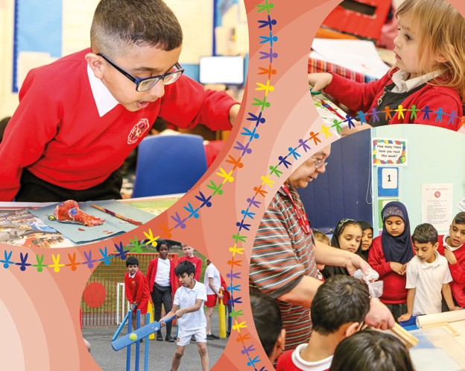 | 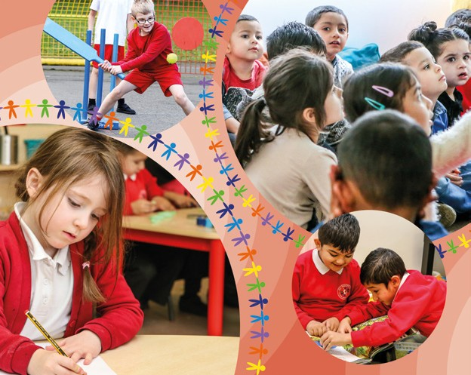 | 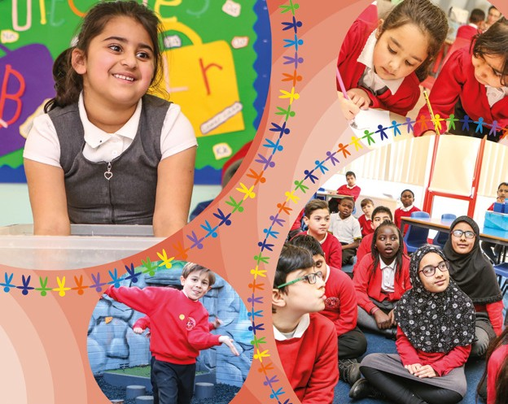

Katie Hague
Headteacher

