All Saints’ CE Primary School
Head teachers Report for the Parish
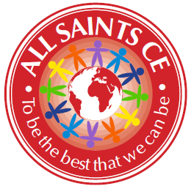

At All Saints, our mission continues to be to ensure that our children get the very best education, which gives them the very best opportunities in life. This has been more of a challenge than ever this year, but we are so proud of what our staff, governors and families have managed to achieve.

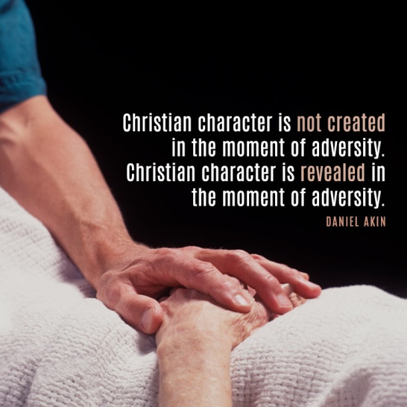

Covid-19 at All Saints

Being at the heart of our school community, we knew that we would need to provide home learning as soon as school shut. We provided a variety of work from March to June, including home learning text books, work set on class dojo, links to websites such as TT rockstars and Read Write Inc. We also sent home exercise books, stationery packs and Amazon fire tablets for families without devices. All families were phoned fortnightly, with more vulnerable children phoned weekly. Mrs Hague did home visits to families who we couldn’t get hold of at all. Food parcels and then vouchers were also provided. All of this meant that we were as sure as we could be that our school community had everything they needed. School remained open for the children of key workers and those who were vulnerable.

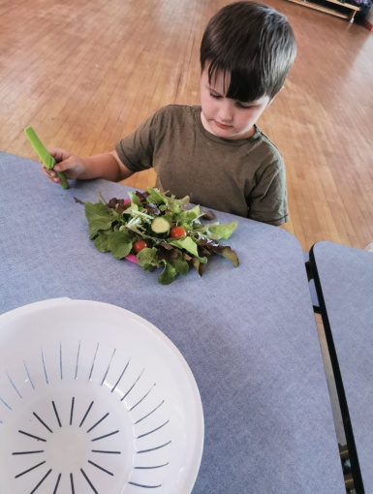 | 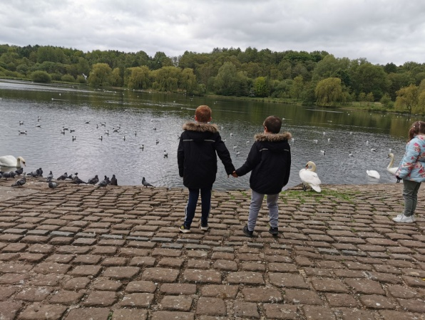 | 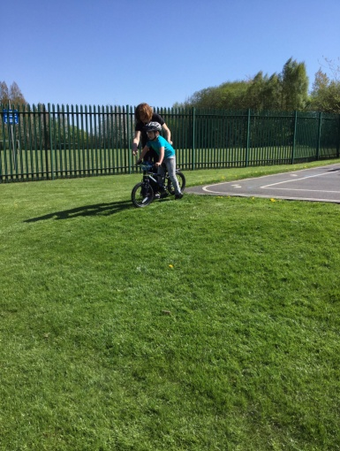
One of our key worker children looking forward to eating the salad that they had grown during lockdown!! | 2 of our key workers who are brothers, enjoying a walk to Moses Gate. | One of our key worker children learning how to ride a bike during lockdown.

We assessed the children in Autumn term and then implemented a curriculum which supported the children back into school and began to address the gaps caused by absence. We also started doing live weekly homework on zoom so that we would be better prepared for any future lockdown. This has stood us in very good stead during this lockdown, as staff and families were already familiar with the technology. Every class has had at least 3 live zoom lessons a day, with additional work being set through pre-recorded videos or worksheets. All lessons have been saved to our school Youtube channel so that families could access them at a time that suited them if they missed the live time slot. Engagement has been at around 90%.

Of course our biggest challenge was the loss of our lovely Sandra Martin. Our whole community was devastated by her death. Sandra was at the heart of our school for over 20 years and is still missed every day. I write this on her birthday, when we had hoped to open her memorial in the school grounds. Sadly, that will have to wait until we can meet up in higher numbers. We have built an outdoor seating area in her name, which I can just picture her sitting on and watching the children play. We were able to use it as the stable in our nativity at Christmas! Sandra would have loved it.

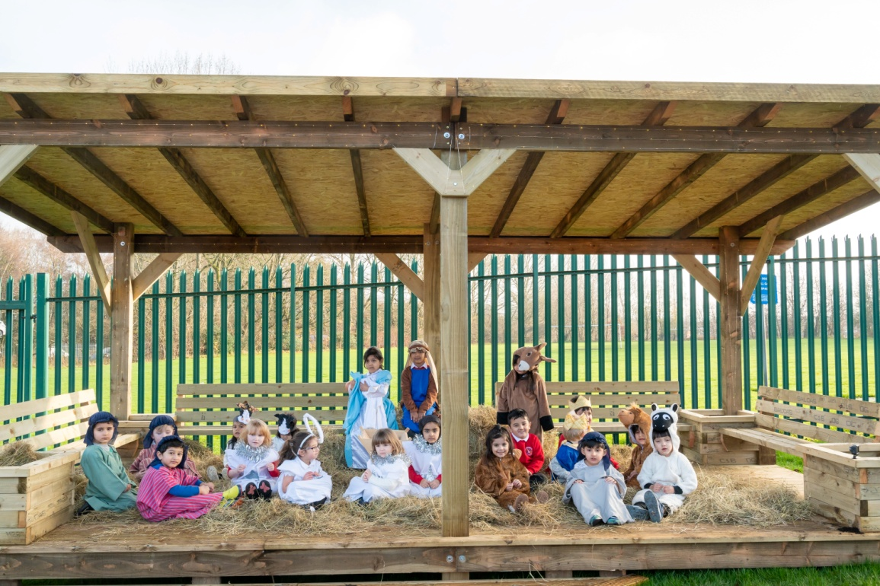

Our ‘normal’ school life has continued as well as possible. We raised around £1000 in Autumn term for the foodbank, Children in Need, and Bolton Hospice. We were able to hold a Harvest service, a Nativity service and a carol service. These were all filmed and shared with parents on our Youtube channel.

Despite the challenges that the year brought us, I am the proudest I have ever been. Our staff have pulled together amazingly well. Despite their own anxieties (and more than a few tears), they worked out how best to work with the children in school, supporting the return, and managing home learning during 2 lockdowns. Many of them were also juggling home schooling their own children and running their own households. Several of them have had covid themselves. Despite all of this, they have approached every day with good grace, with humour, and without (public) complaint! The team work has been truly outstanding. I am beyond thankful to every one of them for their support of me, of each other, and of our families. We are blessed. The support and guidance from our Governors has also been invaluable over the last year.

We are looking forward to a time when we can operate school normally, have visitors in and come back to church. And when the only bubbles in school will be of the soap variety!

We can’t always see where the road leads, but God promises there’s something better up ahead we just have to trust Him. – Psalm 56:3
Katie Hague
Head teacher

