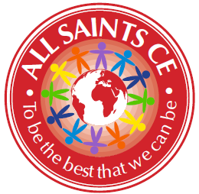
Report from All Saints’ CE Primary

The Staff and Governors at All Saints continue to show endless passion and determination that our children will be the very best that they can be. 2021 was another challenging year, but our children are flourishing despite this.



This quote by Joel Osteen has spoken to me a lot over the last year. I think we have all had days when we wondered how any plan could include more lockdowns and restrictions. However, the team at All Saints has continued to pull together more than ever before, and have managed to minimise the impact of all of the disruption. All Saints truly is a delightful place to work, and turning up every day to such a positive team ethos has made things far easier than they might have been! In addition to continuing to teach to a high standard, we have also managed to keep up with our enrichment activities; ensuring that our children experience all of God’s world.

 | 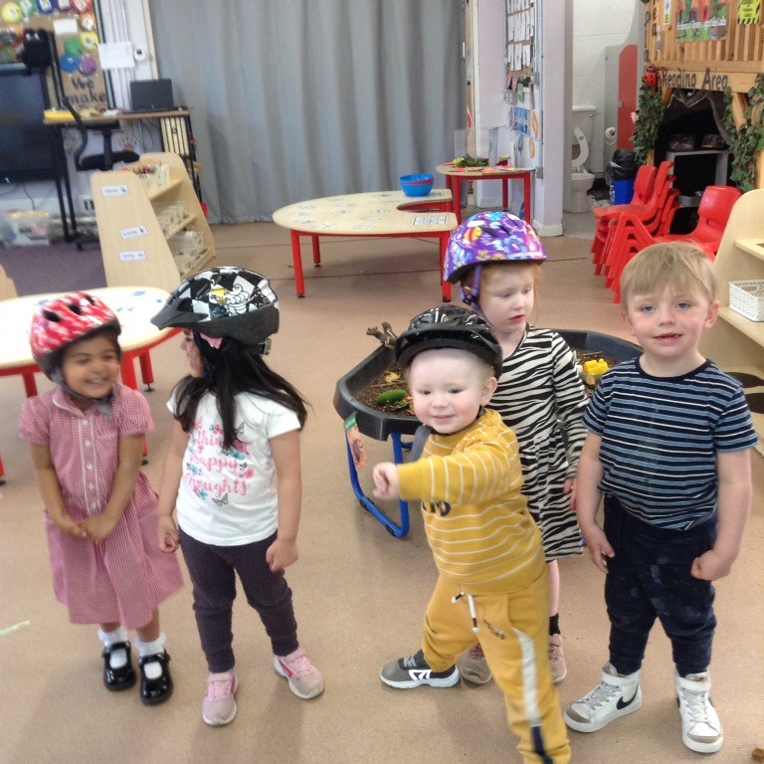 | 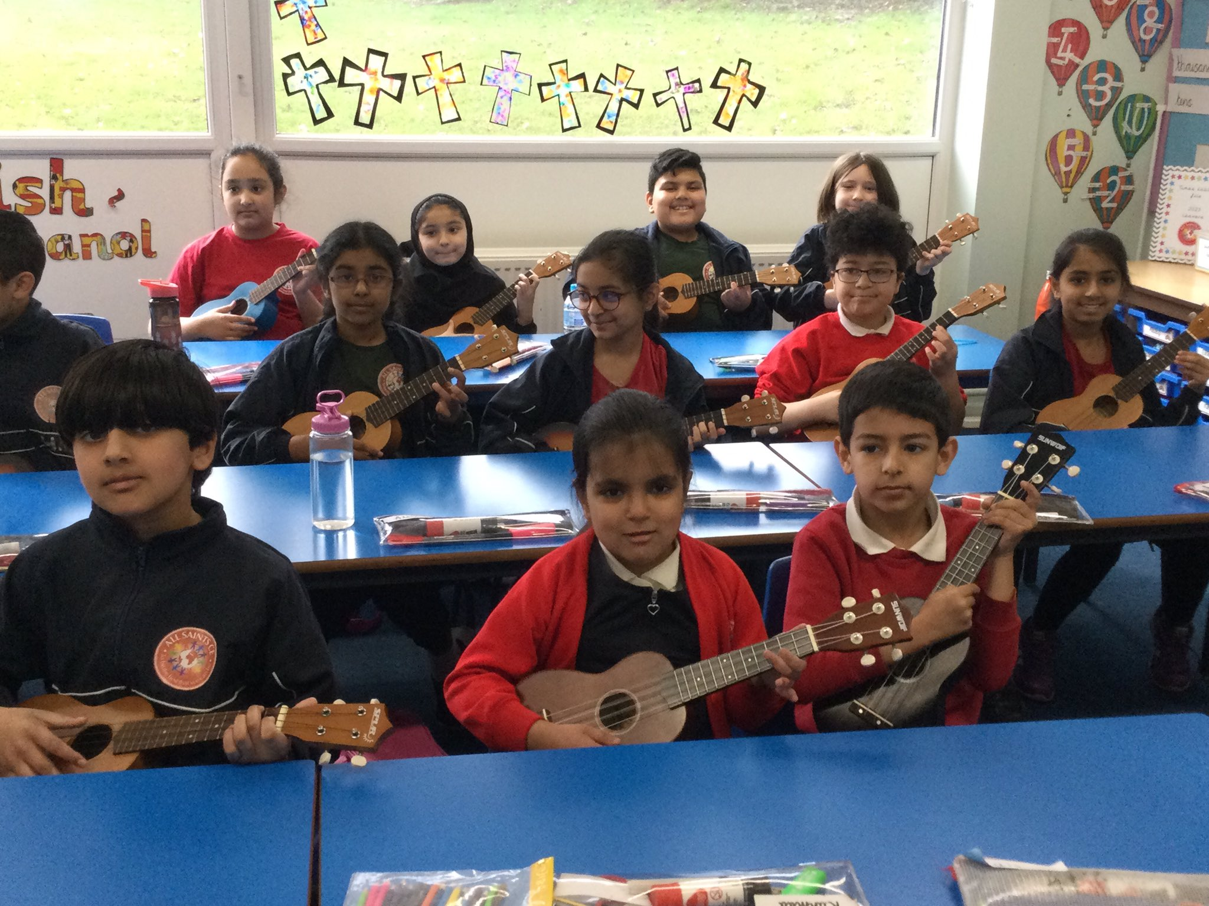 | 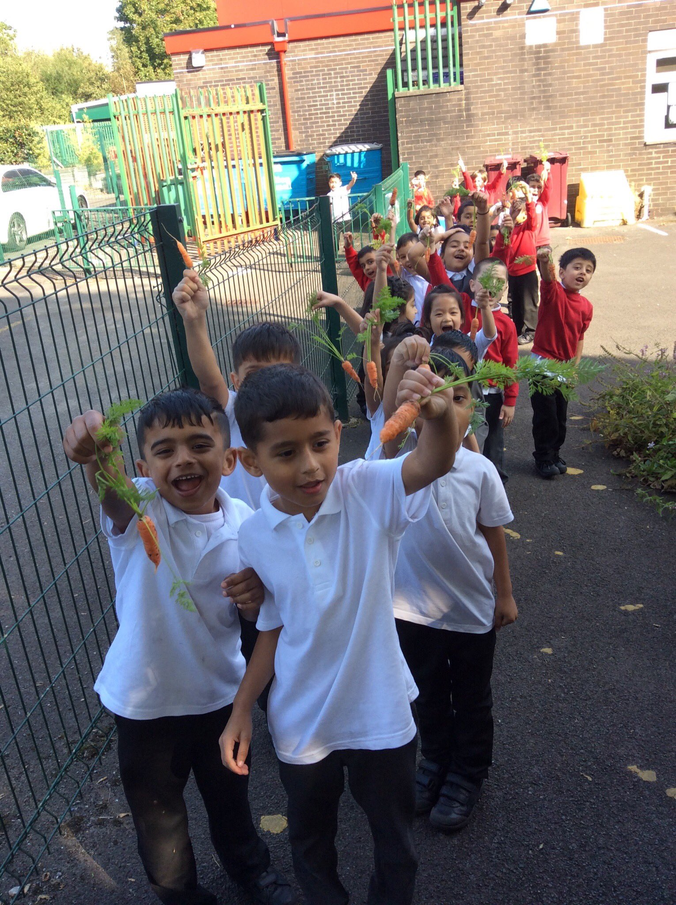 | 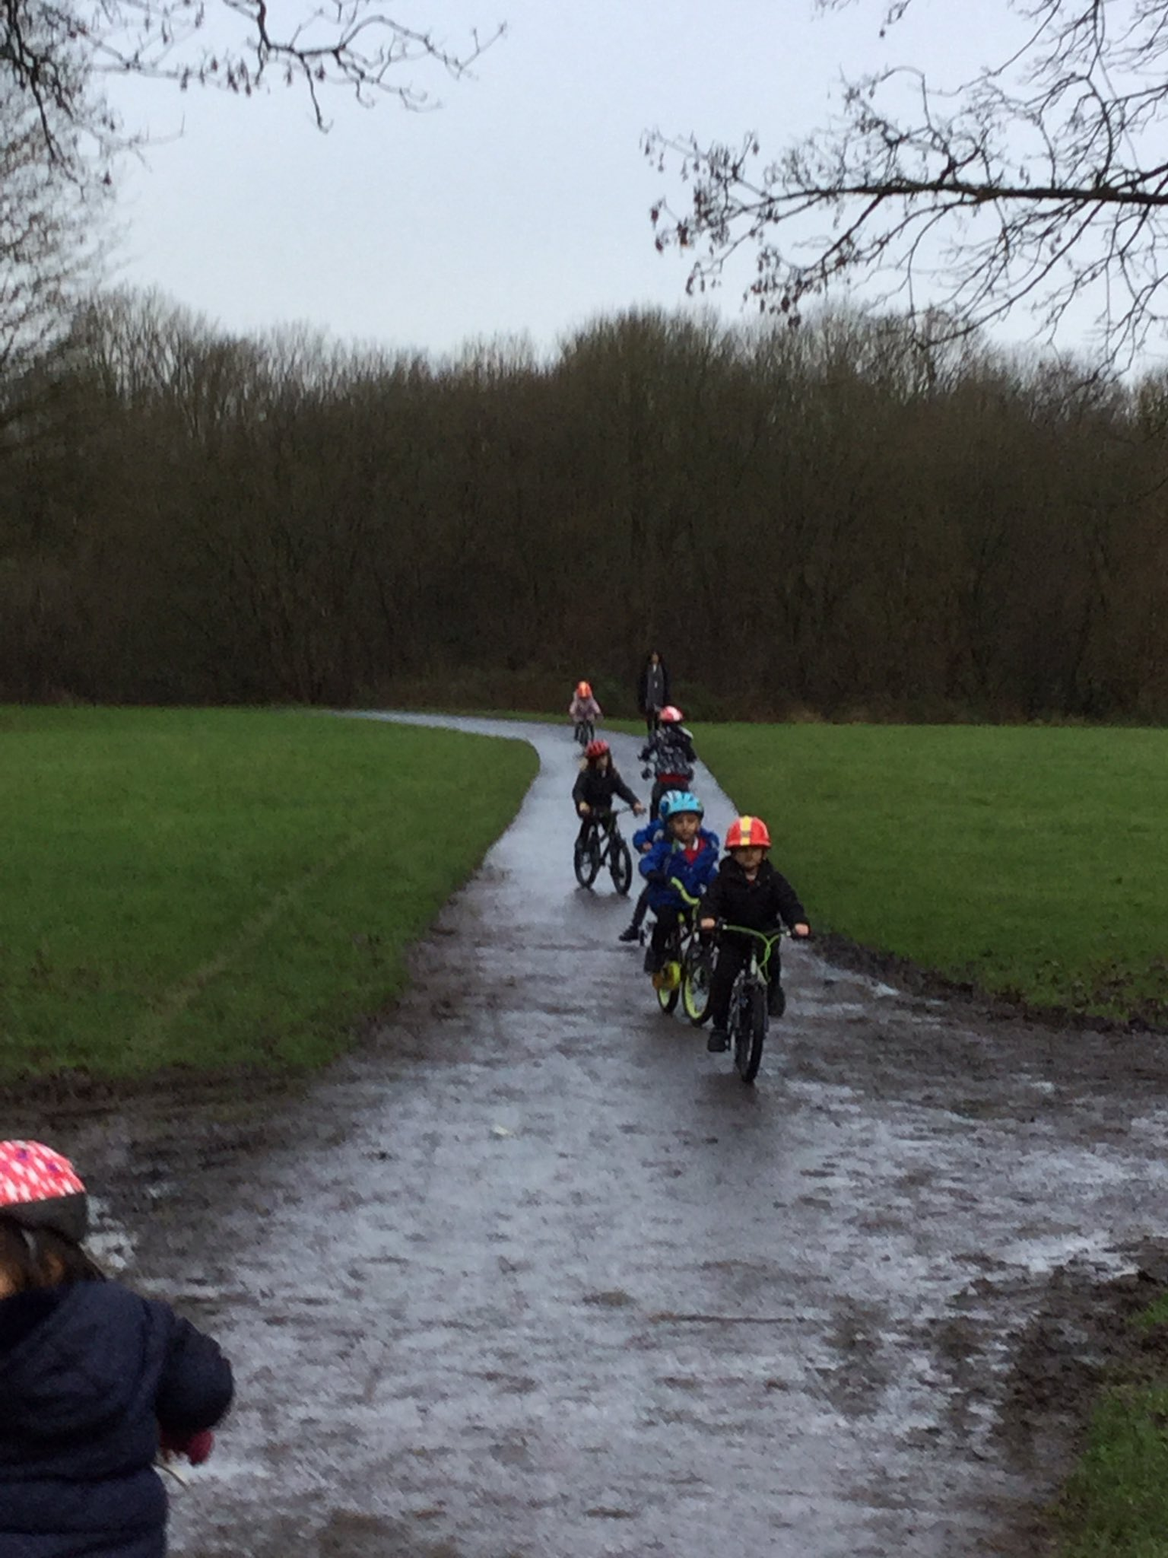
Sports Day | Early Years ready for cycling! | Learning the ukulele | Picking the carrots we’ve grown | A trip to Moses Gate park

Celebrations
Our biggest success of the year was our Ofsted inspection, which recognised the great start in life that we give to our children. We were so very proud of our children, families, staff and governors, who portrayed the determination that we have to improve outcomes. However, we don’t only exist for Ofsted and so we participate in a continuous journey of reflection and school improvement. This year, this has seen us working with 8 other Bolton schools and with the university on a coaching programme. This is in addition to the peer review programme that we’ve been working on with St Peters, Kearsley West and Cherry Tree. The feedback from when other people visit our school is always overwhelmingly positive but there are, of course, always areas for improvement. We welcome these insights so that we ensure that our journey of school improvement continues and our provision for our children is the best it can be.

“Live generously and graciously toward others, the way God lives toward you.” Matthew 5:48

One of the things that makes me most proud is that visitors to school regularly comment on our Christian ethos. We are regularly told what a lovely school it is, how welcoming we are, how well behaved our children are, and how helpful everybody is. This is testament to the team we have built over the years and is the foundation on which we build all of our success. Our school is a real family, and we try hard to ensure that we look after each other in the way that a family would. This builds on our whole school value of Fellowship, Friendship and Hope.

Moving on
A huge part of the success that we have achieved has been down to our Governors. We have a passionate and committed team who add immense value to our work as a school. Sadly, the last year has seen two of our longest serving Governors step down. Anthony Slack and Aidan Meaghan have both served as Chair over their time at the school, and were both huge advocates for us. Although they will always be part of our All Saints family, they have both stepped down from our board. We are lucky to have Sylvia Oakes as our new chair, ably supported by a number of our foundation governors. We thank everyone for their time and energy.

The Schools White Paper means that we are likely to see more changes over the next few years, which can be a scary proposition. However, I am secure in the foundations that we have built, and in God’s grand plan.

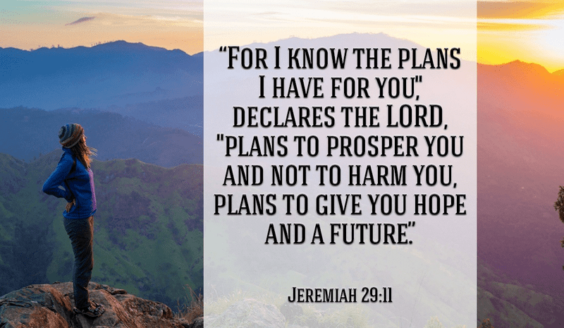
Katie Hague
Headteacher
March 2022

