3rd Farnworth St John's Rainbows
St John’s Rainbows is a very happy and busy group. We meet on a Wednesday evening in School. We are always full and have a waiting list, which is a good sign.
We do lots of crafts and gain confidence in our abilities. We have shared activities with the Guides and Brownies. There is myself and Heather, Group Leaders, and we have two young leaders in training from Guides, Catlin and Keely. They delivered our Christmas programme and did a good job. We have shared party nights with the Brownies and trips out.
In October we went on a sleep over with Brownies to the Lego Land and Sea Life Centre, it was an amazing experience even for the leaders and we managed to get some sleep whilst watching the sharks swim by.
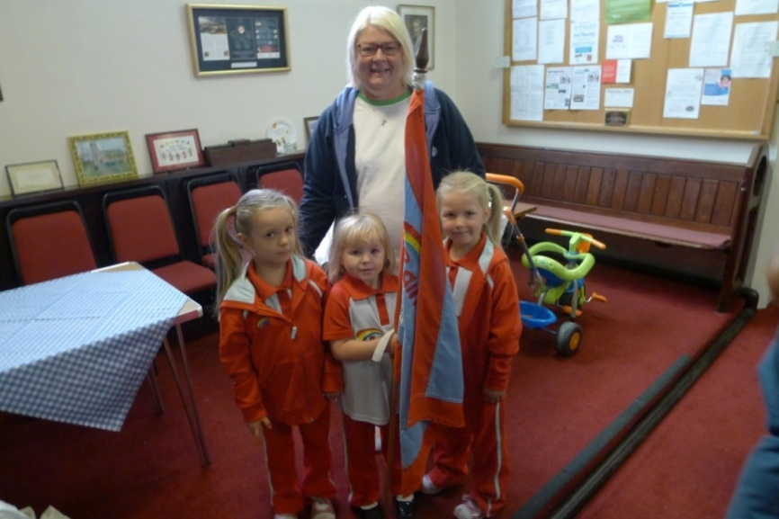

We have had some success in getting girls to join the Family Service and they love carrying the flag with pride. Due to our success, I have had to recently recruit another adult helper as I am at my limited permitted number of 18 for a group.
We love working with the girls and also have close relationship as a whole Guiding Group. St John’s is very healthy in its Guiding Units.
Yours in Guiding,
Sandra Martin Unit Leader

