3rd Farnworth St John's Rainbows
St Johns rainbows is a very happy and busy group. We meet on a Wednesday evening in school. We are always full and have a waiting list which is a good sign.
We do lots of crafts and gain confidence in our abilities. We have shared activities with the guides and Brownies. There is myself and Heather group leaders and we have two young leaders in training from guides Caitlin and Keely. They have gained in confidence and have been taking a more active part in the rainbow programme.
We had an exciting time taking part in the church flower festival, the girls got busy painting, drawing and colouring. We chose the story of Noah’s Ark which included a rainbow of beautiful flowers, a boat and lots of colourful animals. We had lots of fun and we visited the flower festival and saw our finished display a very proud moment.
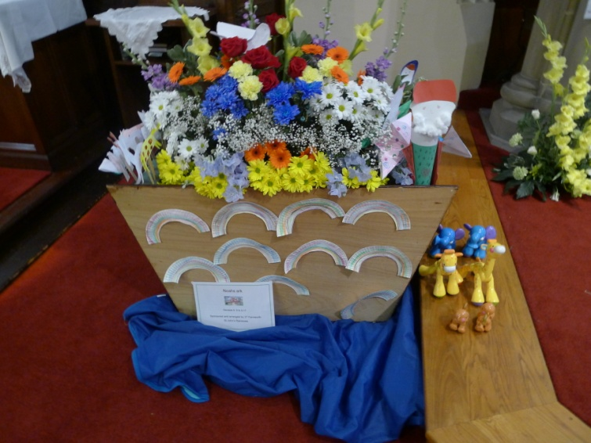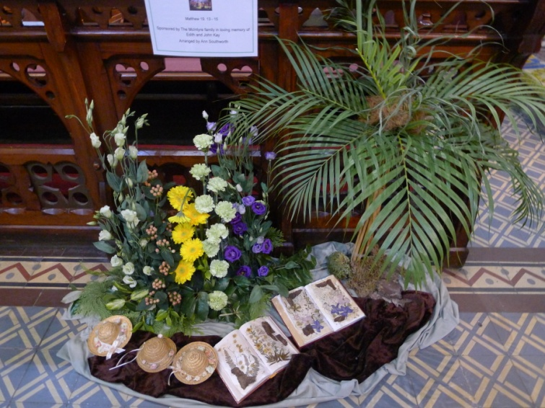
We have done lots of craft activities the girls love taking the things home they have created from cards to Christmas gliders lots of fun. They enjoy a very noisy game to a nice quite game (think we sometimes prefer the quitter one).
Rainbows is a joy to lead and we have a close relationship with the brownies and guide group we are very lucky and St Johns to have such a flourishing guide movement.
Yours in Guiding,
Sandra Martin Unit Leader

