3rd Farnworth St John's Rainbows
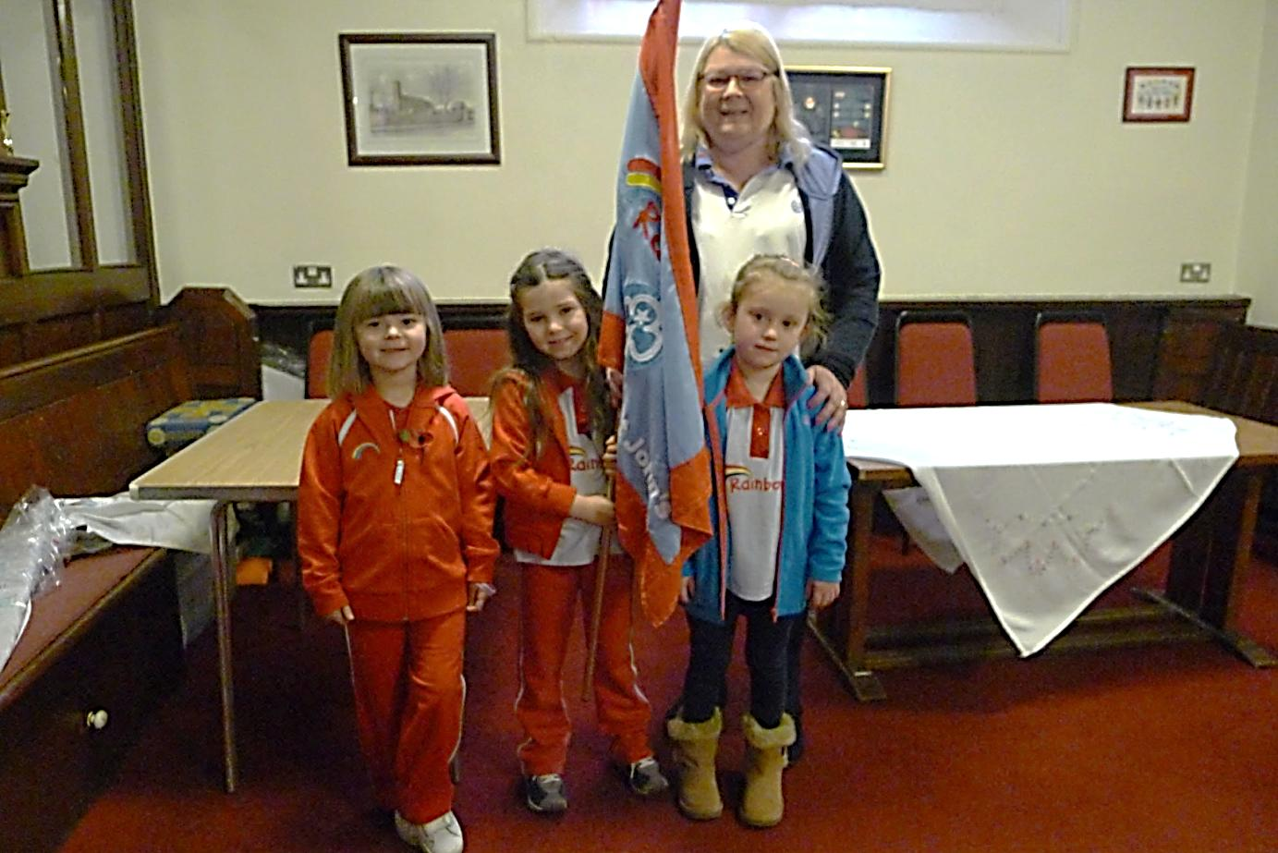
St Johns rainbows is a very happy and busy group. We meet on a Wednesday evening in school. We are always full and have a waiting list which is a good sign.
The girls enjoy lots of craft activities and cooking. They like taking things home. They enjoy a very noisy game to a nice quite game (think we sometimes prefer the quieter one).
This year is very exciting for the Guide movement as for the first time we are following a knew badge programme from September 2019 which follows girls from rainbows through to guides. Activities are levelled to fit the age range and each girl will have a badge book they can earn lots of badges which for rainbows is extra exciting as this is knew.
As leaders myself and Heather have to keep up our training which involves first response, knew badge programme and county leaders’ day training
Rainbows is a joy to lead and we have a close relationship with the brownies and guide group we are very lucky and St Johns to have such a flourishing guide movement.
Yours in Guiding,
Sandra (unit leader) Heather (assistant leader)

