3rd Farnworth St John's Guides
2016 has been a hectic year for 3Rd Farnworth Guides filled with fun, excitement and laughter. We have been doing lots of different badges as well as lots of fun residential experiences. Here is just a rundown of some of the things we have done over the past year. Our Guide unit has on average 16-20 girls.
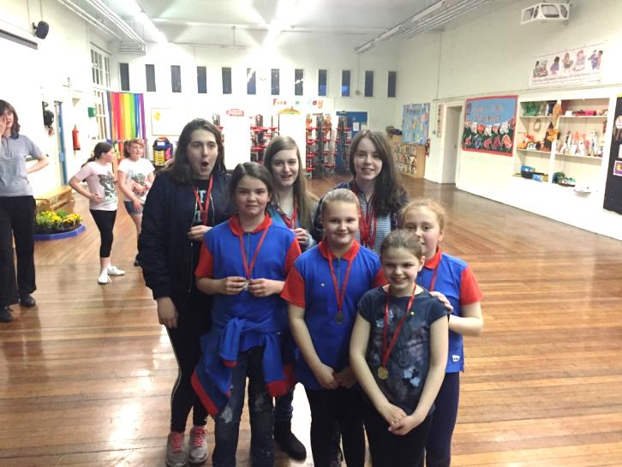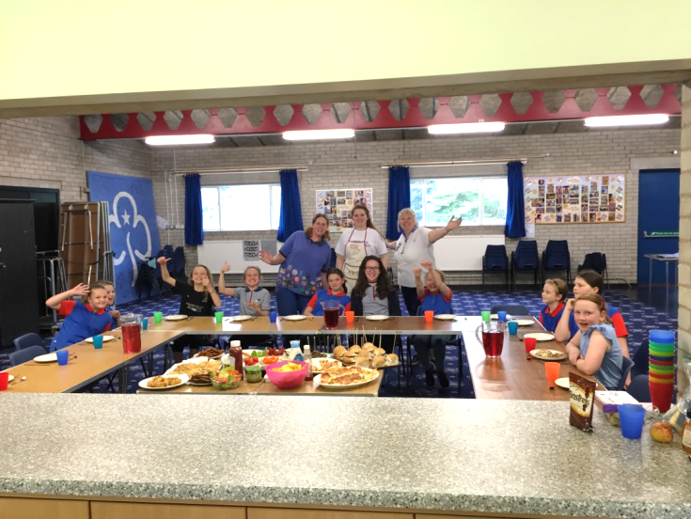

Backwoods Cooking at Bibby’s Farm and Ready Steady Cook. (May)
In May, our Guides did their cook and outdoor cook badge. We learnt about health and safety in the kitchen and how to plan a healthy meal on a budget, which meant a trip to the supermarket comparing brands. On our Ready Steady Cook day, we created a feast for our entire unit which included homemade pizza (including the dough!), fish goujons, homemade bread, and other delights.
We also took part in a backwoods cooking day at Bibby’s Farm. We learnt how to light a fire safely, what to do if any accidents happen and lots of outdoor cooking techniques. We skinned rabbits, descaled and deboned fish and even had squirrel!!!!! As you can imagine not all of the Guides liked that!!!
Target Sports at Bibby’s Farm
This year our unit has had lots of new girls which meant lots of firsts! So when we took part in the target sports competition at Bibby’s Farm, it was first time many of them had slept under canvas! We took part in lots of target activities which included, rifle shooting, pistol shooting, archery and crossbow. On the Saturday we had several sessions to practice and develop our skills in the target sports and then on the Sunday we began the competition against other Scout groups! Our Guides were amazing. We came 3rd in Archery and 2nd in Crossbow!
GOLD Rwanda 2016 (August)
In summer, our Guide Leader Jenny was selected to represent Girl Guiding UK on a GOLD project (Guiding Overseas Linked with Development) to Rwanda. GOLD projects provide sustainable community or guiding based development projects, from leadership skills training to delivering advocacy programmes to young women.
In Rwanda, the project was to provide leadership skills workshops for Leaders and Young Leaders, to run workshops with girls on new programme resources and to provide first aid training to Troop Leaders. Jenny travelled around the rural areas of Rwanda providing training which was sustainable so leaders out there could re-use ideas, games and activities with the limited resources they had yet develop young women out there. It was a fantastic experience which showed the importance of world Guiding and women’s rights. After the project the GOLD Rwanda team travelled on and went trekking to see the Gorillas! A once in a lifetime experience!
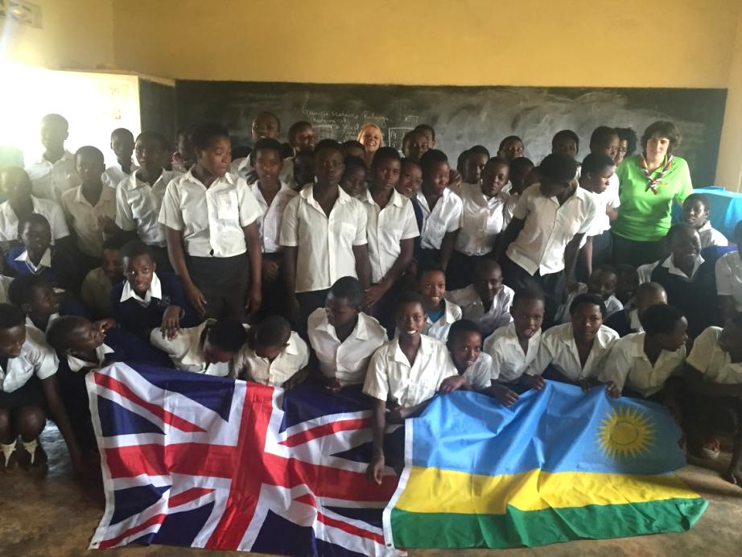
Waddow- A taste of Adventure 2016 (December)
Before Christmas we had a little getaway to Waddow Hall. For one of our Guides it was the first time she had slept away from home (She enjoyed it that much she has already booked on to camping this summer). We were very fortunate with the weather, a very sunny weekend which was brilliant as we were doing lots of outdoor activities! We did caving, crate challenge, nightline and grass sledging. At night time we made Christmas gifts for our friends and family.
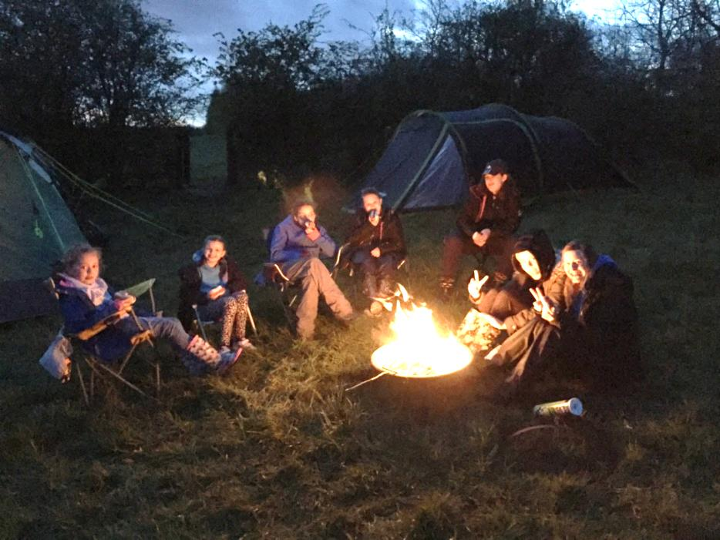
The next year will see us going further afield with our unit, we are going to Switzerland and Disneyland Paris in 2018. Also, our Senior Section leader Dot and senior section member Hannah are going to Canada this summer (2017) as part of a county trip. Finally, all of this is not possible without the support of both the church and school.
Jenny Jones

