**3rd Farnworth St John's Brownies**

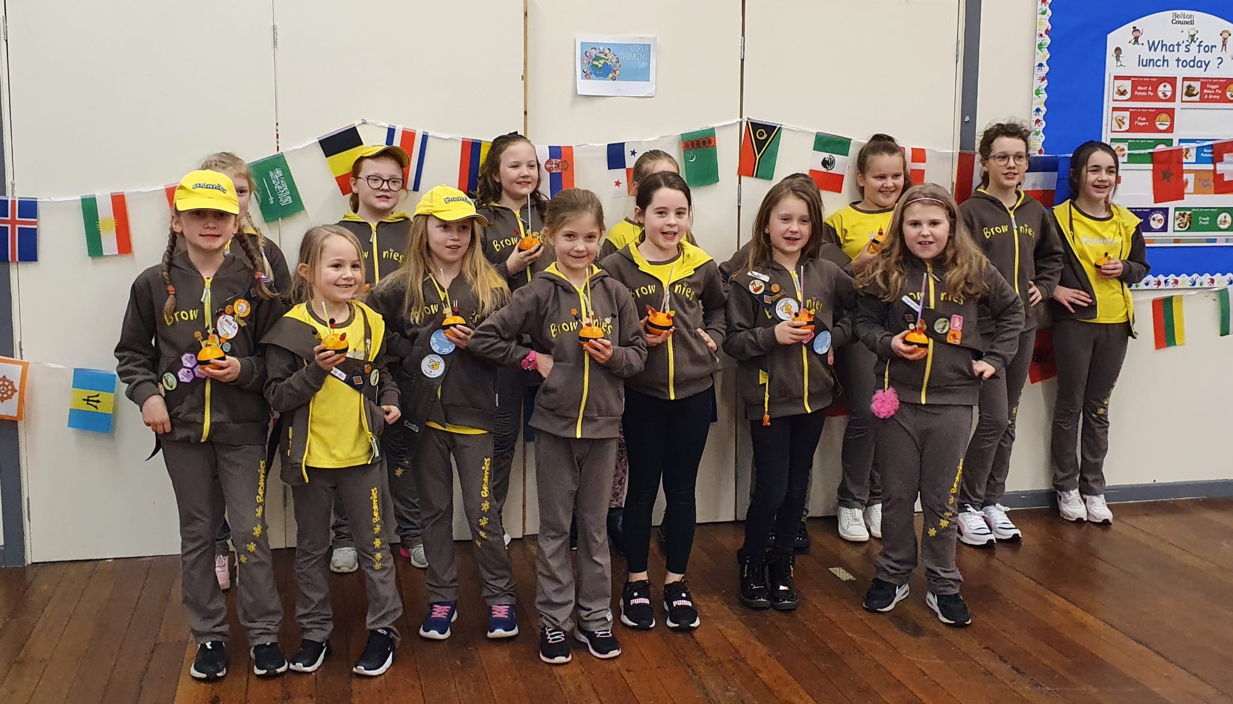

Brownies restarted after the Covid Lockdown on 5th October 2021. We were all very apprehensive about returning we had Risk Assessments in place, and limited the number of girls to 16. We only had one Brownie from before Lockdown and 15 new girls.

We very soon got to know each other. We made Promise Boxes to keep our Enrolment Badge in and the girls made their Promise at the Halloween Party.

We worked towards our Charities Badge by holding a Dazzling Divas and Dad Danceathon in aid of Children in Need/Girlguiding and raised a staggering £835.

In November we started working on the Brownie Programme working towards Take Action Award and completed the Make Change Badge. Our first Church Parade was Remembrance Sunday; we laid a wreath and poppy pictures that we had made.

December was a very busy month for the Brownies. It began with our Bottle Tombola and Christmas Tree Tombola at the Church Christmas Fair. The Brownies enjoyed making an edible Advent Calendar and a selection of Christmas Crafts.

We all enjoyed Goldilocks and the Three Bears Pantomime performed by Stagedoor Productions at Walmsley Parish Hall, Egerton.

The girls attended The All Age Service and sang, He’s got the whole world in his hands. At this service the Brownies were presented with the Performing Badge and Charities Badge.

We ended our term with our Christmas Party, playing games, dancing, eating and receiving a Christmas gift from Santa. It is amazing what the girls have achieved since we started back at Brownies on 5th October after Covid. Well done to you all and your supportive parents. We are looking forward to 2022 and lots of new and exciting challenges.

**Susan Stevens**