3rd Farnworth St John's Brownies
This year we have had at least 24 girls on our register. We have welcomed girls from our Rainbow unit as well as girls new to guiding. Several of our girls have moved up to Guides and we also said goodbye to our young leaders Rachel Taylor and Hannah Grimes as they went to university.
During the year the girls have worked on several badges as a pack which includes communications badge, out and about badge, science badge, friends to animals badge to name just a few.
Last May bank holiday Skylark (Dot) took some of the girls on the county weekend camp at Scarisbrick Hall near Southport. The girls did orienteering, camping skills including cooking on a campfire. They also went into Southport and got treated to pizza.
We always try to encourage the girls to attend church parade where some read the prayers and the reading. The brownies also took part in the flower festival in church, the bible story they chose was The Feeding Of The 5000.
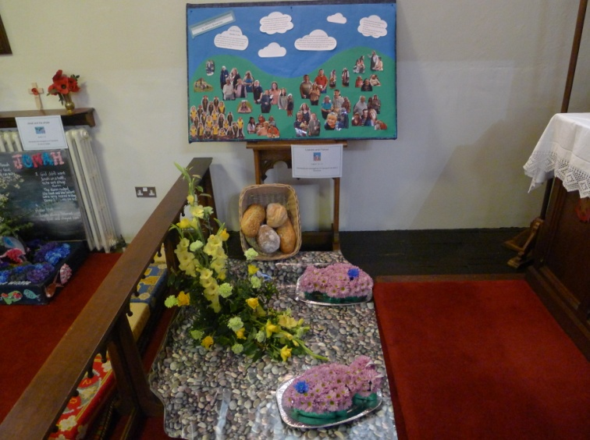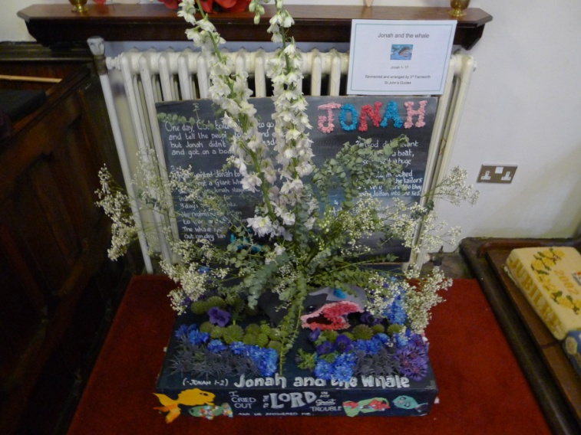
The girls have also done their own individual badges which include agility, swimmers dance, writers, toymaker and artist badges.
Skylark (Dot Grimes) Alison Mole and Jackie Powell

