3rd Farnworth St John's Brownies 2020
The Brownies celebrated Shrove Tuesday by cooking Pancakes over a candle, an activity which they really enjoyed.
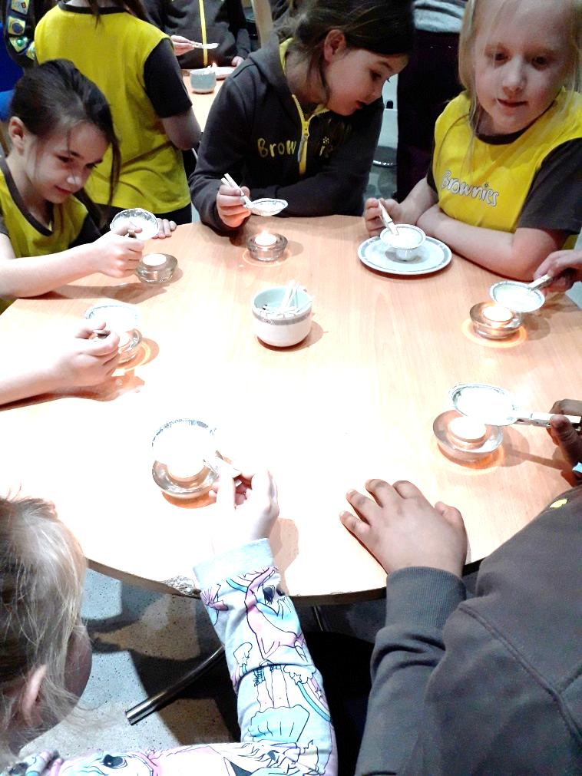
At our final meeting of the year, in March, we made Button Heart pictures in a box frame for Mothering Sunday gifts. We did not know at the time how relevant the wording would be “Mothers are like Buttons, they hold everything together”.
The following week, unfortunately, due to Covid 19, St Johns Brownies had to stop meeting when the Country went into Lockdown.
It was with great sadness in May that we said goodbye to our Sister in Guiding, Sandra Martin, St Johns Rainbow Leader after she contracted Covid 19. Sandra will be missed by so many friends as she was involved in so many aspects of Church and wider Community life.
We kept in contact with the Brownies during Lockdown by posting out Jig-Saw pieces for them to decorate and return a lovely idea from Alison. We have welcomed Heather Birchall as Assistant Leader.
Even though we have not met since March and have not taken subscriptions from the girls, we still have had to pay an Annual Subscription to Girlguiding UK.
Susan Stevens

