3rd Farnworth St John's Brownies
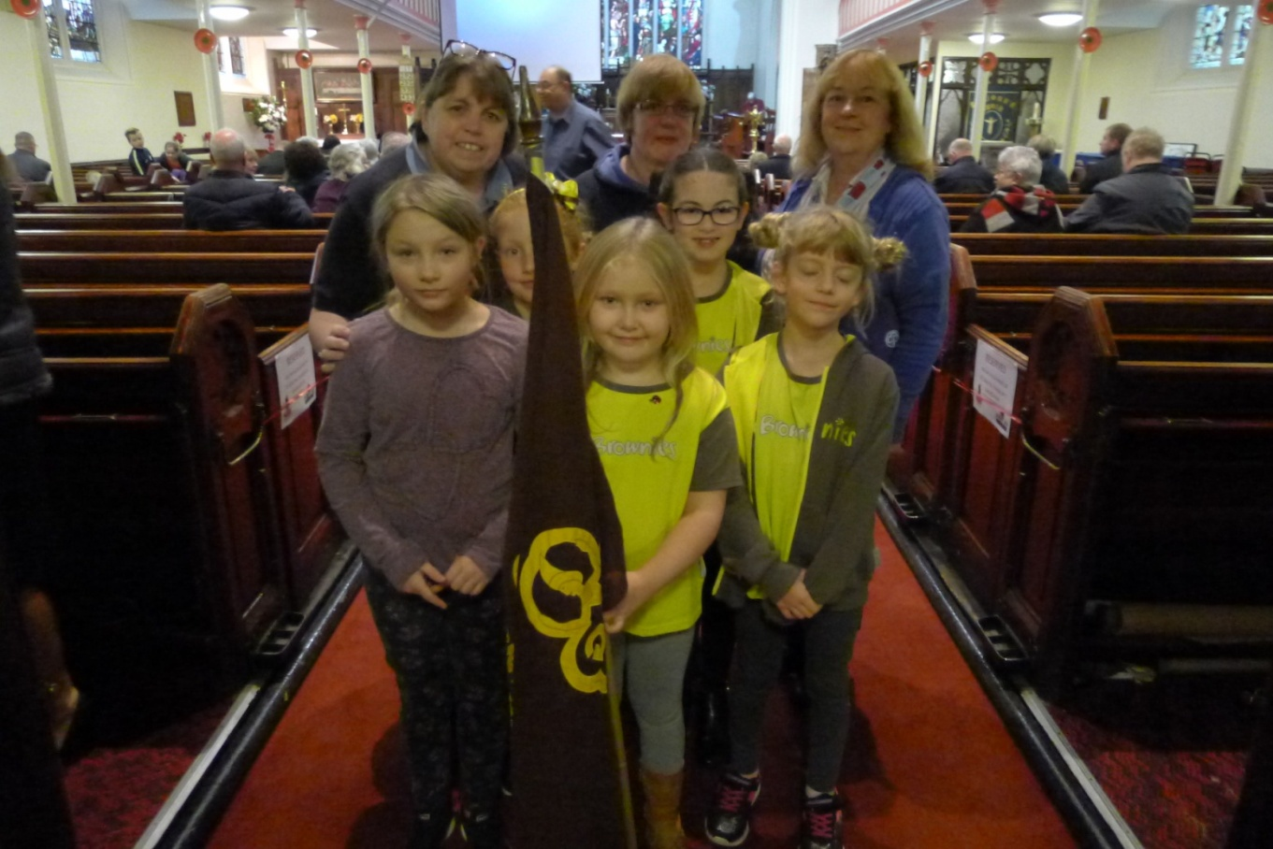
This year the brownies celebrated their 90th birthday to commemorate this they gave £100 towards new vestments for church and early next year they are going to plant a tree in the new church yard.
The girls have enjoyed doing different activities, crafts and badges. The badges achieved include swimmer, swimmer advanced, seasons, toymaker, home skills and hostess and all the girls are working on the healthy heart badge.
Last summer the girls did a sponsored walk to raise money to provide toilets in third world countries, they raised £648 which bought several.
A few of the girls who attend church parade continue to enjoy taking part in the service by doing the readings or prayers.
We said a sad goodbye to Skylark (Dot Grimes) although she continues to run the senior section. We welcomed back Snowy (Susan Stevens).
Susan, Alison and Jackie

