Whitsuntide Walk 1955
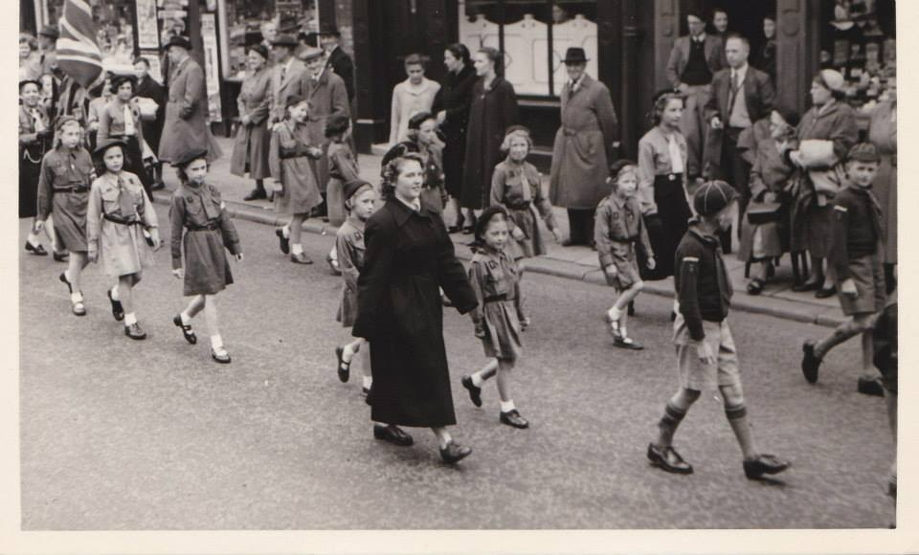
3rd Farnworth St John’s Brownies walking along Longcauseway during the Whitsuntide Walk, in 1955.
The brownies on the front left of the photograph are Dorothy Lever, Christine Worsley and Elizabeth Hardman. They are following Norma Rushton (Brown Owl) and the lady to her left (nearest pavement) is Marion Cragg (Pack Leader). Dorothy and Elizabeth followed in Norma’s footsteps and became Brownie Guiders. The photograph was sent by Christine, who now lives in South Africa.

