Diocese of Manchester
Parish of Farnworth & Kearsley
Annual Report for 2020

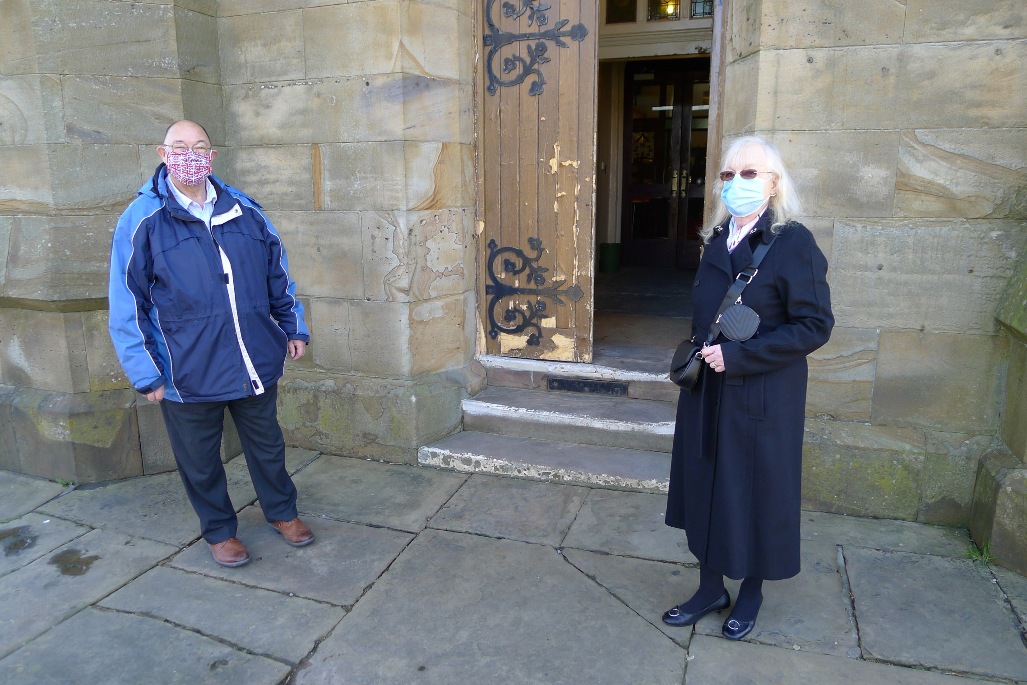

20 May 2021

Index of Report

Chair …………………………………………………………… Page 3
Secretary …………………………………………………………… Page 4
Treasurer …………………………………………………………... Page 12
Planned Giving and Gift Aid ………………………………………….. Page 12
Wardens …………………………………………………………… Page 12
Team Vicar …………………………………………………………… Page 14
Authorised Lay Ministry ………………………………………….. Page 15
Electoral Roll Officer ………………………………………….. Page 15
Child Protection …………………………………………….…….. Page 16
Sunday School ...………………………………………………... Page 16
Church Website ……………………………………………..……. Page 16
All Saints CE Primary School Head teacher ….……………. Page 17
St John’s CE Primary School Head teacher …….………..… Page 19
St Peter’s CE Primary School Head teacher ………….......... Page 22
3rd Farnworth St John’s Brownies ………………………… Page 26
3rd Farnworth St John’s Rainbows ………………………… Page 27
Statement of Accounts ………………………………………….. Page 28
Minutes of the Annual Parish & Annual Parochial Church Meeting Page 29

Chair’s Report

2020 was a terrible year, for oh so many reasons! Should I list them? I think to do so would waste my time and yours. As one thing I know for sure, you have found them as painful as I have.
COVID 19 has ravaged our traditions, our way of life, our health, and families. Everything that was hard has been made more difficult and our shared mission ‘To Proclaim the Good News’ has suffered as a result.
Without Mission, what’s the point of anything?
I feel I should offer some platitudes, some optimism? to put a positive spin on the year, but I fear to do so would be patronising. Honestly, if I could hand the year in and get a refund I would, I’d even take store credit.
So, this year’s report isn’t going to say anything else about 2020. I intend to blank it out, wipe it from my brain, or at least bury it in the deepest, darkest regions of my mind, next to where I store memories of School PE lessons.
Instead, I am going to offer you three quotes. You have heard them before.
'I am the resurrection and the life,' says the Lord. 'Those who believe in me, even though they die, will live, and everyone who lives and believes in me will never die.'
John 11.25,26
We brought nothing into the world, and we take nothing out.
The Lord gave, and the Lord has taken away; blessed be the name of the Lord.
1 Timothy 6.7; Job 1.21b
I am convinced that neither death, nor life, nor angels, nor rulers, nor things present, nor things to come, nor powers, nor height, nor depth, nor anything else in all creation, will be able to separate us from the love of God in Christ Jesus our Lord.
Romans 8.38,39
These are the verses read out at the beginning of funerals. Yet, they are not about sadness or grief. They are about Faith, Hope and Love. All of which remains with us as Faithful Servants of Christ. And nothing, the readings remind us, not even the most virulent of Viruses, will ever change that.
With every Blessing,
Fr Stephen
Team Rector and Chair of St John the Evangelist Church PCC

PCC Secretary’s Report
I would like to take this opportunity to thank our Rector Father Stephen Nolan, Revd Kim Lafferty, Revd Dr Malcolm Wearing, Church Wardens, Treasurer and members of the PCC for their support throughout this difficult year. The PCC met at both ‘live meetings’ in church and ‘virtual meetings’ on Zoom, on 9 occasions, during the period January to December 2020.
A special thank you must go to Revd Dr Malcolm Wearing for moving our Sunday Services on-line and into our homes, and to Revd. Kim Lafferty for hosting our virtual PCC meetings; live streaming daily Evening Prayer and setting up the weekly virtual ‘Coffee and Chat’ for the whole team.
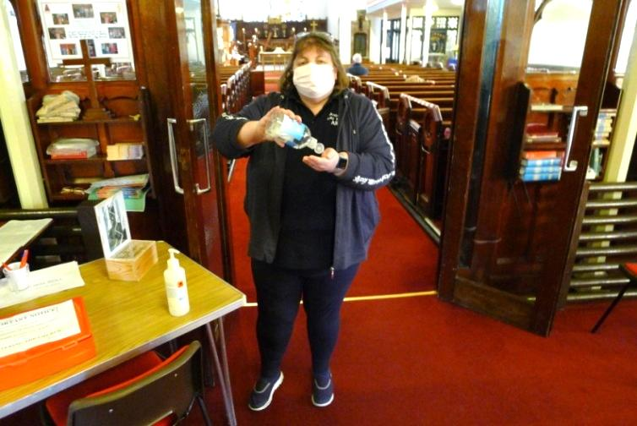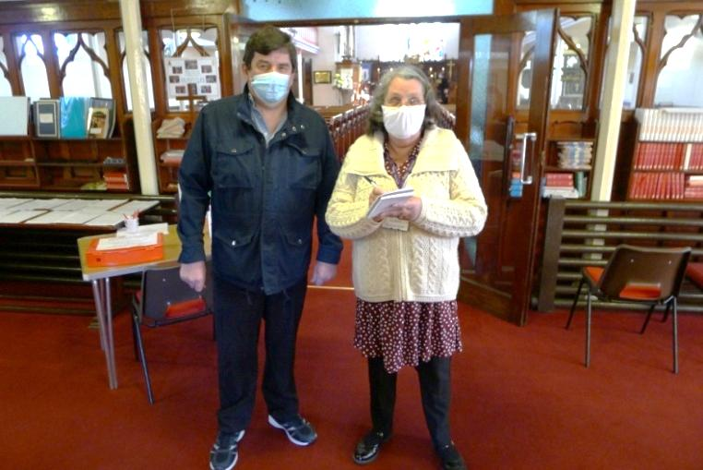
Alison Mole Graham Martin & Judith Birchall
I would especially like to thank Dr. Steven Mann for being our permanent host; Judith Birchall, Graham Martin and Alison Mole for being our volunteers. They have turned-up every Sunday when we have been allowed to open our church for public worship during the Covid Pandemic. They have also been responsible for meeting and greeting members of the congregation who have attended live services; keeping them safe and being responsible for our track and trace records.
JANUARY
In January we approved our ‘Brand New’ Mission Action Plan. This showed how we at St John’s would play our part, as a local church, in the Diocesan Vision of ‘A worshipping, growing and transforming presence at the heart of the community’.
MISSION ACTION PLAN
Priority 1 - (PARISH) ALL SAINTS LANGUAGE AND NATURE PROJECT
Nature Walk
In spring of 2020, we had planned to host a nature walk for all the children of All Saints Primary School. The walk would task the students to locate aspects of nature in both English and Urdu. ‘Titch’, the Rector’s dog, would be alongside and in support. The students would be encouraged to share what they had found with their parents and guardians. It was hoped that this activity would encourage English speaking in the home and in particular also reinforce the Churches Mission in the Care of the Environment – 5th Mark of Mission
Priority 2 - (PARISH) SCHOOL MINISTRY
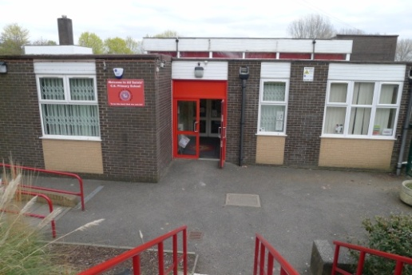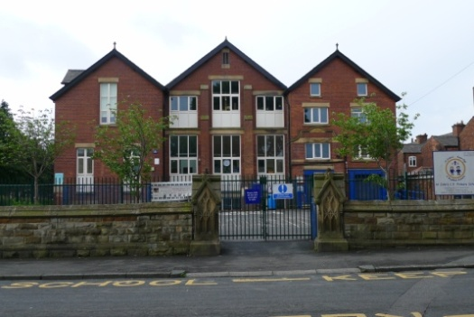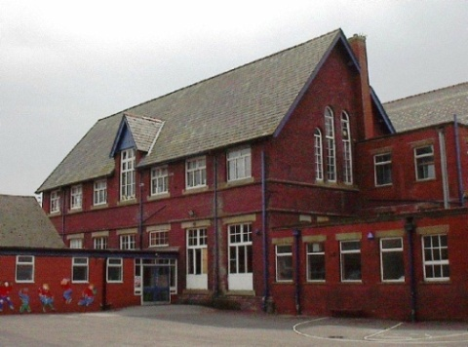
All Saints School St John’s School St Peter’s School
The Rector said that the Parish boasts three Church Schools within its boundaries. Assemblies had been increased and plans were afoot to increase them further. We planned to continue to support each school seasonally through Experience Easter and Christmas. Church Tours, In-class Nativities, and Weekly Church Assemblies at St John’s were to be increased.
Priority 3 – (PARISH) FARNWORTH CARE HOME LINKS
Care Home Visits
Titch and the Team Rector were paying monthly visits to Farnworth Care Home to bring a little light and to build links with staff and residents. It was hoped this would lead to Holy Communion being offered regularly, as well as other seasonal opportunities, to reduce the effects of isolation.
Priority 4 – (PARISH) FINANCIAL PLANNING
Stewardship cost cutting and new Parish Share agreement
The Rector advised that St John’s was facing some difficult financial problems, not least seen through a reduction in giving. However, armed with a four-year projection plan, we were attempting to reduce our costs; increase our giving through a stewardship campaign and reach a Parish Share agreement which was affordable, yet challenging.
Priority 5 – (BENIFICE WIDE STUDY GROUP)
Bible Study with food
These excellent study sessions were for people of all ability and offered Benefice wide. They began with food and then a leisurely stroll through elements of the Holy Bible. It was hoped these sessions would encourage both discipleship and provide an ‘in route’ for all those adults partaking in confirmation classes
Next Retreat – Foxhill Centre
The retreat weekend centred at Foxhill Centre, would provide an opportunity to make space for God in a beautiful setting, encourage discipleship and help participants grow spiritually.
Priority 7 – (DEANERY WIDE) CONNECT PROJECT
Project teamed with the Changing Places team.
Invites had been given to all children progressing from CE schools in our Benefice plus Prestolee Community School. Each child, with staff, had been invited to attend St John’s Church in June 2020. This would enable them meet with CE secondary school pupils and staff, in a fun packed day, led by the ‘Changing Places’ team. It was hoped this would help to ease the transition and continue to keep faith at the forefront of our young peoples ‘lives.
MARCH
We held our meeting on 4th March, when Father Stephen updated us on the progress made on our Mission Action Plan since the last meeting: -
MISSION ACTION PLAN Update: -
Priority 1 – (PARISH) ALLSAINTS LANGUAGE & NATURE PROJECT: - All the paperwork had now been completed for the nature walk, which was to take place in the summer.
Priority 2 – (PARISH SCHOOLS MINISTRY) St John’s, All Saints and St Peter’s:- Assemblies had been increased at All Saints School. The weekly Church Assemblies, already taking place at St John’s, had been ‘opened-up’ to parents and carers on the last Thursday of the month. Sister Dorothy Needham was leading worship at St Peter’s School. A seasonal experience Easter project had been arranged.
Priority 3 – (PARISH) FARNWORTH CARE HOME LINKS. Care Home Visits: - All the residents, at Farnworth Care Home, had now been visited in their rooms by the Team Rector and his dog Titch. The Team Rector was doing home visits across the Benefice.
Priority 4 – (PARISH) Financial Planning Stewardship cost cutting and new Parish share agreement: - A stewardship campaign was in the process of being arranged and due to take place after Easter, when everyone would be encouraged to give by Standing Order.
Priority 5 – (WORKING WITH ASYLUM SEEKERS) Welcome Packs: - Revd Dr Malcolm Wearing was organizing ‘Welcome Packs’ for newly arrived asylum seekers, which included a bible, information about local service locations and some essential items.
Priority 6 – (BENEFICE WIDE) STUDY GROUP Bible Study with food: - Between 6 and 15 people were now attending the Benefice wide study groups.
Priority 7 – (BENEFICE WIDE RETREATS) Next Retreat – Foxhill Centre: - The next weekend retreat had been arranged to take place in May, at the Foxhill Centre.
Priority 8 – (DEANERY WIDE) CONNECT PROJECT - Project teamed with the Changing Places team. Between 50 and 80 children, progressing from the CE primary schools in our Benefice plus Prestolee Community School, had been invited to attend the event in June 2020, at St John’s Church.
We arranged our Annual Parochial Church Meeting for Sunday 26th April 2020, in church, at 11.00am.
We were not to know that on Monday 23rd March 2020, our country would be in lockdown and our church would be closed to public worship, Sunday Services would move online and our ‘Brand New’ Mission Action Plan would not come to fruition.
Our popular monthly church magazine, which was enjoyed by both younger and older members of our local community alike, was suspended.
The Annual Parochial Church Meeting had to be postponed and the term of office of our elected officers had to be extended.
MAY
In May we held our first virtual PCC meeting on Zoom, hosted by Revd. Kim Lafferty. This was a learning curve for us all and especially challenging for the secretary, who was only able to access the meeting on her landline and record the minutes over the telephone.
Father Stephen opened the meeting with prayer and asked us to hold Graham Martin and his family in our thoughts, following the sad loss of his wife Sandra Martin to the Coronavirus.
He thanked Revd Kim Lafferty and Revd Dr Malcolm Wearing for all their hard work streaming Sunday Worship, daily Evening Prayer, Reflections and Hymns, during his two periods of self-isolation.
Members agreed to follow the diocese advice and not to have the church yard grass cut during lockdown. Father Stephen told members he had caught the person who had been fly-tipping in the church yard, spoken to them and they had promised not to do it again.
It was reported that there had been an attempted ‘break-in’ to the church boiler house. A padlock had been cut off and a crowbar had been used to try and gain entry. Members were informed that a steel sheet had now been fitted to the boiler house door.
In response to the large number of enquiries from concerned parents, regarding being unable to sign the ‘Attendance Book for School Admissions’ due to church closure during the pandemic, Father Stephen had spoken to the Area Dean about the matter. He informed the meeting that it would be the responsibility of schools to agree a strategy.

JULY
During the month of July two ‘virtual’ meetings were held. One on the 9th and the other on 30th July. On 9th July the RE-OPENING OF CHURCHES FOR PUBLIC WORSHIP was addressed and a CHURCH RE-OPENING ROADMAP planned. Weddings that couldn’t take place due to church closure had been postponed until next year and all Baptisms had been cancelled up to September 2020.
Members were reminded that we were still in the middle of a pandemic and had to move slowly when going forward. Those in the critically vulnerable category were advised not to attend.
It was agreed that CHURCHES WOULD RE-OPEN FOR TEAM SERVICES - at St John’s on Sunday 26th July; Holy Trinity Sunday 2nd August; St Saviours Sunday 9th August and St Stephen’s on Sunday 16th August, all at 10.00am. Once all the churches had hosted one Team Service we began our regular pattern of Worship, from Sunday 23rd August 2020.
A RISK ASSESSMENT of St John’s building had been carried out by Father Stephen, which he circulated prior to the meeting and was unanimously approved.
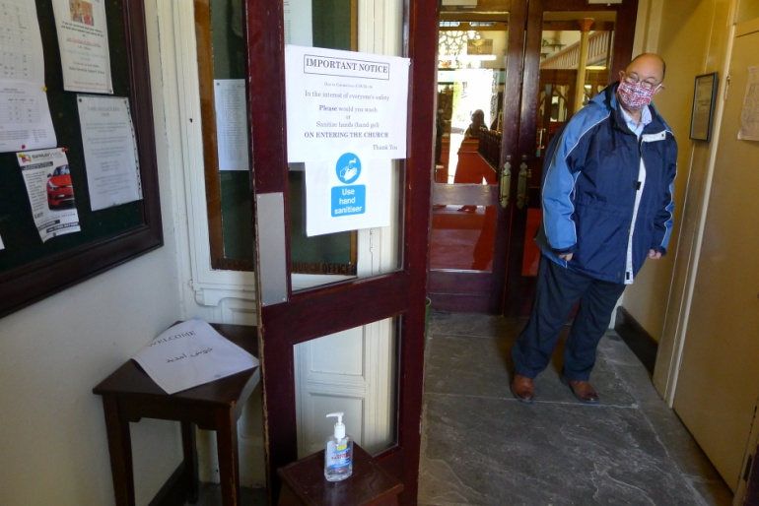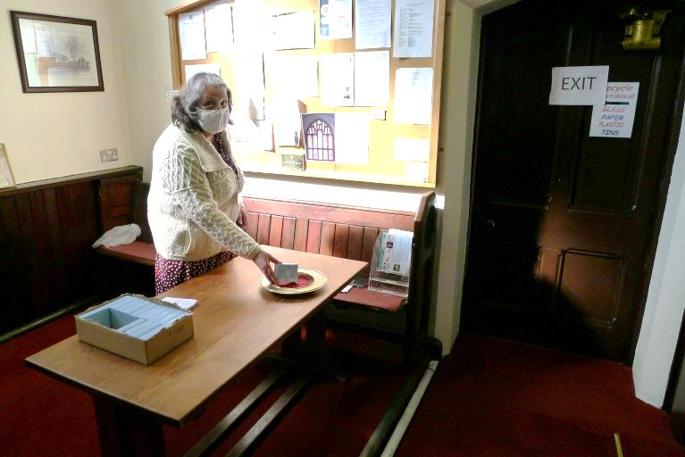
Steve Mann Judith Birchall
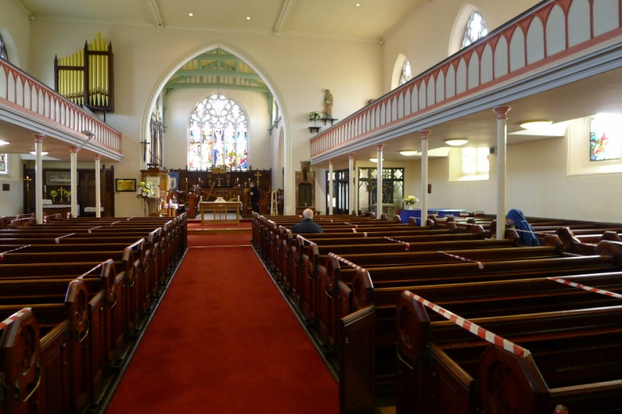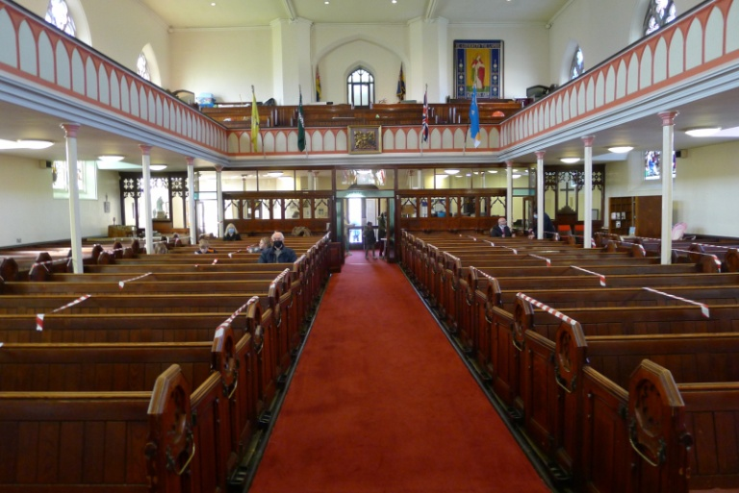
Church when it re-opened
Church would look very different when it re-opened. The main door had to remain open and 40 socially distanced spaces had been made available where people could sit. There was a permanent host, Dr. Steven Mann, on the main entrance door. If the situation arose where more people attended than we had available places, they had to be advised of the situation and refused admission.
The host had to pass people on to a volunteer, who was responsible for recording their name and contact telephone number, before directing them to their seat. Once in their allocated seat, people were not allowed to move. Children were not allowed to run around the church.
Music was played on the sound system on entry and during Communion; there were no Service or Hymn Books and no singing. Service sheets were on the pew seat and following the service they had to be taken home and destroyed.
Notices were displayed in prominent positions requesting people to bring a facemask with them; put it on before entering church and wear it throughout the service.
Following a service, no one was allowed to enter the church building for 72 hours. If anyone did enter the church, within the 72 hour period, it had to be deep cleaned as people would be more at risk when they were undertaking the normal cleaning.
RETIREMENT OF CHURCH ARMY EVANGELIST
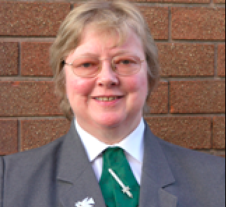
Sister Dorothy Needham
Father Stephen formally announced that our Church Army Evangelist, Sister Canon Dorothy Needham, would be retiring at the end of September and that we were unable to fill her position. He thanked Sister Dorothy for all her hard work, during her time at St John’s. Sister Dorothy invited members to her last service, which was to be held at St Paul’s Peel, on Sunday 27th September 2020.
Father Stephen informed members that a donation of £400 had been received to cut the church yard grass. This was due to be undertaken on Monday 13th July.
It was agreed that the waste bin in the church yard, which had originally been erected for litter but was increasingly being used as a bin for ‘dog poo’, to be removed.
Members agreed that the church yard was to be locked on 26th December 2020. It was explained that this is a requirement to stop the church yard becoming a public right of way.
At the meeting held on 30th July, a full review of the Team Service, held at 10.00am on Sunday 26thJuly at St John’s Church, was undertaken.
AUGUST
In August Father Stephen gave a MISSION ACTION PLAN Update:-
Priority 8 - (DEANERY WIDE) CONNECT PROJECT – Project teamed with Changing Places Team: - Father Stephen reported that sadly, due to the current pandemic, the ‘Connect Project’ scheduled to have taken place at St John’s Church in June, had not taken place. He told members that we would continue to spread the news of Jesus Christ through our School Experiences.
He said he had arranged a meeting with the Head Teacher of St Peter’s School, Lynn Williams on 7th September, to discuss Assemblies and Collective Worship, following the retirement of Sister Canon Dorothy Needham at the end of September.
He informed the meeting that there was to be a competition on the subject of ‘Hope’ and the entries would be displayed at Bolton Parish Church.

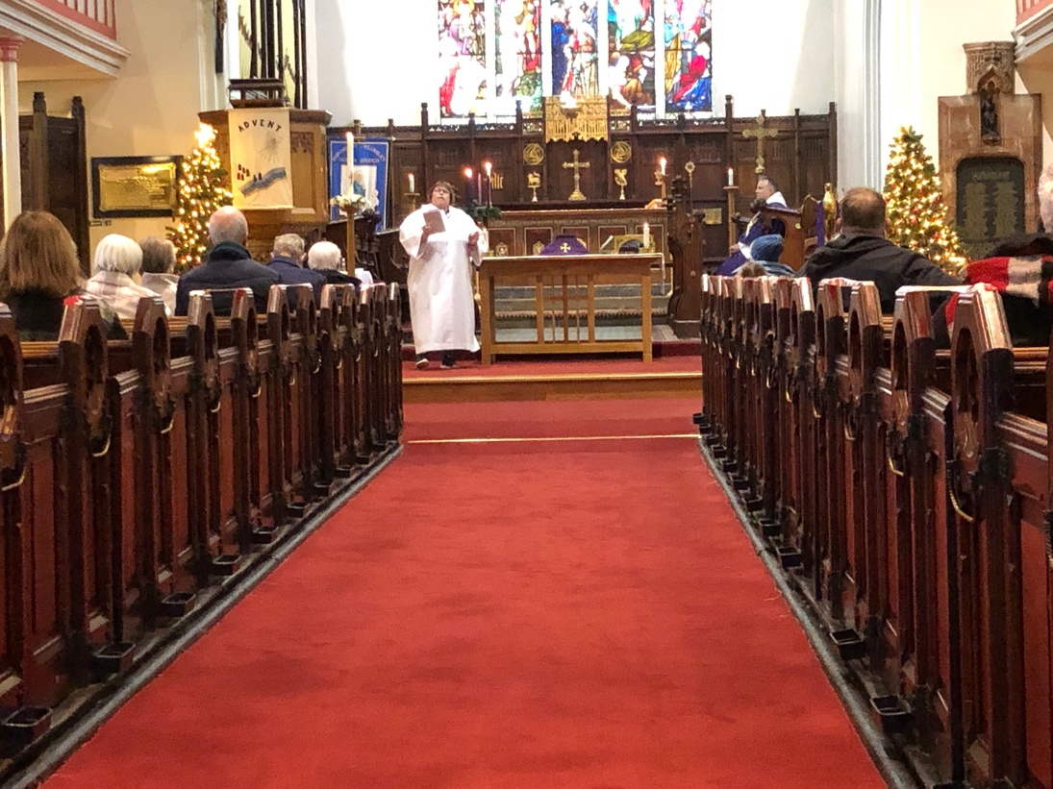
We unanimously, agreed to sponsor the Re-Commissioning of Alison Mole as an Authorised Lay Minister in Children’s Ministry and Worship.
The secretary told members that 2 of the 6 bell ropes had been delivered, prior to the Pandemic Lockdown and were in the safe keeping of Jim Andrews of the Lancashire Association of Change Ringers.
Members were informed that of the 10 extra Ashes Plots approved last year, only 2 were left. A suggestion was made that we apply for a faculty for a further row of 10 Ashes Plots. This would ‘buy more time’ to further consider how a Garden of Remembrance with a column on which to engrave names, might work. It was agreed that this should be discussed further at a future meeting.
SCHOOL NEWS: - Signing of Schools Application Forms: - Father Stephen explained that this year, due to Coronavirus Restrictions, parents/carers would be asked to forward their Schools Application Forms to Revd Kim Lafferty’s Vicarage, with a SAE by Monday 5th October. The signing would take place that week. The aim was to post the signed forms back to the parents/carers by Monday 12th October.
The meeting was informed that a ‘Christmas Experience’ plus one other ‘Experience’ would be held for local primary schools.
The Parish Church Meeting and Annual Parochial Church Meeting, which had to be cancelled in April due to Lockdown, were re-arranged for Sunday 11th October 2020 in Church at 11.00am following the Service.
SEPTEMBER
MISSION ACTION PLAN update: -
In September, Father Stephen told members that he would bring a ‘new’ Mission Action Plan to the PCC. He reported that he had met with Lynn Williams; the Head Teacher at St Peter’s School and arranged for ‘Messy Church’ to be introduced at the school premises. A Messy Church Team had been set up and would be meeting on site in November, with Steph Openshaw from the ‘Changing Places Project’ to discuss a safe fast opening. He said that Steph Openshaw would be working solely with the Benefice for at least a year and that we would make good use of her experience and expertise.
Father Stephen informed the meeting about a competition that was to be held when children would be asked to draw a picture on the subject of ‘Hope’. The pictures would be displayed later in the year in Bolton Parish Church or possible Manchester Cathedral.
He said the pupils at St John’s School were writing their own school prayer.
As an act of charity, a Hamper of Snack Food was to be distributed to local hospitals for the nursing staff, who were working extremely hard during the Covid pandemic. It was envisaged that one hamper a month would be delivered. The meeting was advised that the first hamper had been delivered to a hospital in Bury.
CHANGE OF SERVICE TIMES ACROSS THE BENEFICE: -
Father Stephen explained that following the retirement of Sister Canon Dorothy Needham, consideration needed to be given to changing the times of the Sunday Morning Services. He said that we would need to do more with less. He made the following proposal – that Sunday Morning Service at Stoneclough and St Stephen’s start at 9.30am and at St John’s at 11.00am. He explained that this would enable Eucharist to take place across the Benefice every Sunday. This would then enable him to be at St John’s Church every week and give him opportunity to get to know everyone. Following discussion, a vote ensued with 8 members agreeing to an 11.00am Sunday Morning Service at St John’s, 1 against and 1 abstention.
Father Stephen would announce the proposed service time change at Sunday Morning Service on Sunday 27th September and a decision would be made at the Annual Parochial Church Meeting on Sunday 11th October 2020.
OCTOBER
The Chair, Father Stephen, chaired the Annual Parish Church Meeting, Annual Parochial Church Meeting and the First Meeting of the newly elected PCC on Sunday 11th October at 11.00am in Church, following Morning Service. Dr Steven Mann and Graham Martin were nominated Church Wardens and thanks were expressed to Jackie Powell who was stepping down. The Parish Accounts for 2019 were approved and thanks expressed to Rob McIntyre who was stepping down as Treasurer after many years in the role.
The Electoral Roll Officer reported that the 2019 Electoral Roll closed with 103 members.
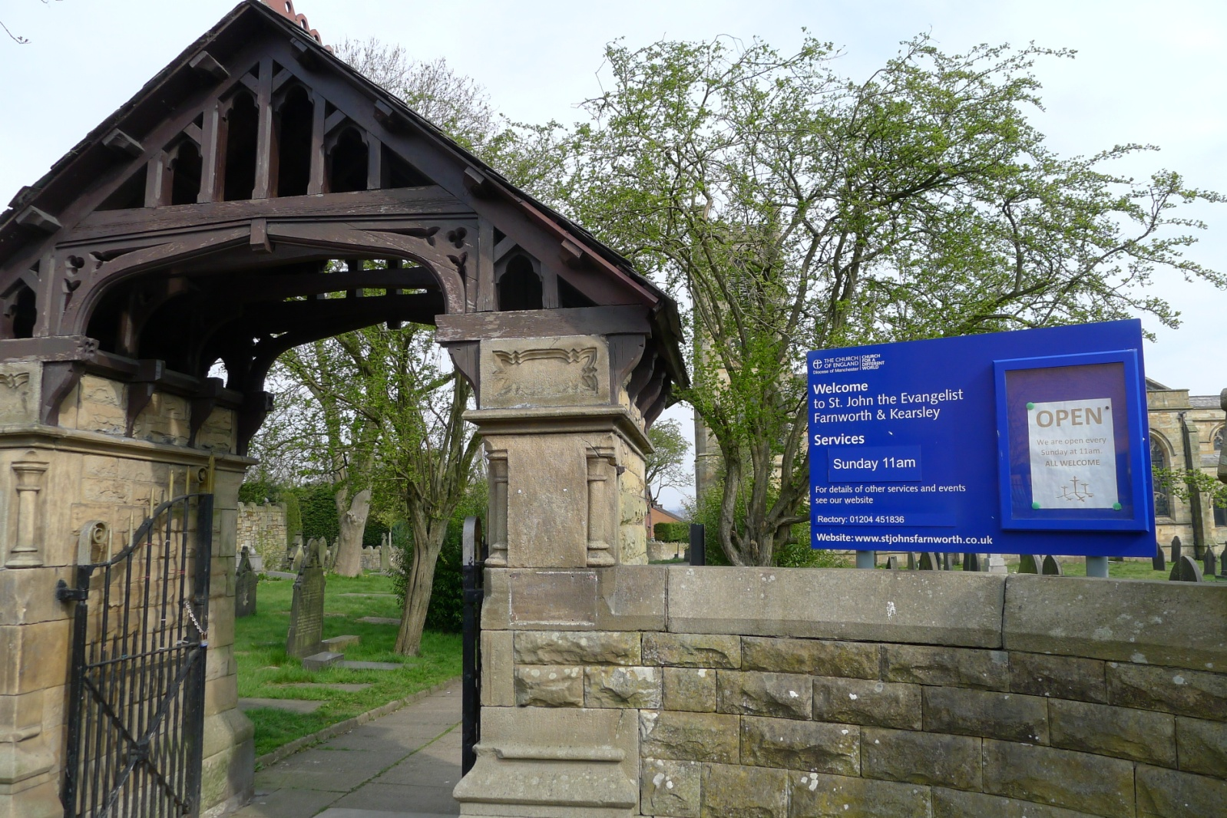
The New Service Times: – Sunday Morning Service at Stoneclough and St Stephen’s were to start at 9.30 am and at St John’s at 11.00 am, was ratified and would start in January 2021.
TRANSFORMING MANCHESTER DIOCESE:- The meeting was informed that the deanery boundaries where changing and that there would be a New Deanery. The Transforming Manchester Diocese Briefing Document on the Proposals for Mission Communities, October 2020, which had just been received, had been circulated to members prior to the meeting. The proposal was to split Seven Saints Parish in two and we had been asked to take on two more churches and one more school. More consultation would take place at Deanery Synod.
At the first meeting of the newly elected Parochial Council, the following officers were elected – Chair Revd Stephen Nolan, Lay Vice Chair Stephanie Buckley, Secretary Dorothy McGlynn, Treasurer Sandra Croston, Electoral Roll Officer Kim McIntyre. The Standing Committee, with powers to make emergency decisions, comprised of the Chair, Treasurer, the two Church Wardens and the Secretary.
NOVEMBER/DECEMBER
Little did we know when we arranged our next meeting at 7.00 pm Thursday 5th November in church, that restrictions would come into place on that day and the meeting would have to be cancelled at short notice. The meeting was re-scheduled for a virtual meeting on Thursday 3rd December.
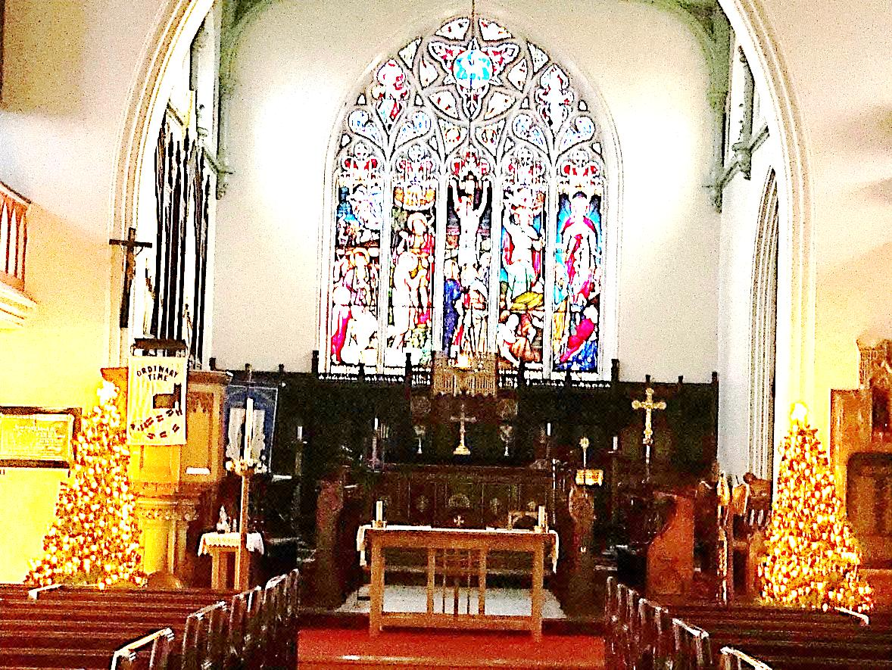
At the December meeting, thanks were expressed to Denise Entwistle for her gift of two matching Christmas Trees, which had been beautifully decorated by her family, and would be enjoyed by everyone at the first Mass of Christmas.
Dorothy McGlynn
PCC Secretary

Treasurer’s Report
The less said about 2020 the better so I'll keep this short.
I regained the treasury role half way through the year and hope to do the job to the best of my ability, I wouldn't be able to do it without the help of Betty, our wardens, Tony, Rev Stephen, Rob and Shaun.
If there is anyone who thinks they can steer me on a clearer path, please show yourselves.
During the 1st lockdown it was decided that we wouldn't be able to meet our quota payment.
Many things have affected our income.
Giving down £2500
Funeral fees down £1300
Weddings down £3500
Fairs and events down £2000
We did obviously save in 1 area
Energy saved £2100.
We ran on the whole at a small profit but this is mainly down to not meeting the quota payment.
Hopefully 2021 will see much more life within our church walls with regular services and lots of Weddings..... and God willing generosity.
Yours in fellowship
Sandra Croston
Treasurer
Planned Giving and Gift Aid Report
2020 was such an awful year, in so many respects; it is not surprising that our finances have also been affected.
In 2020 there were 39 contributors (giving either via an envelope or through a bank standing order) down from 52 in 2019.
However, 31 members had signed up to the Gift Aid Scheme, and the amount of tax reclaimed on their donations, with the addition of those who had signed One-Off Donation envelopes, amounted to £5,099.96 in 2020 which was just 0.74% down on 2019.
Due to HMRC’s Gift Aid Small Donations Scheme (or GASDS for short) which was introduced in April 2013, we are now able to claim ‘top-up’ payments on amounts of up to £8,000 on none Gift Aided cash donations of £30 or less. The income from this amounted to £1,258.55 in 2020 compared with £1,335.88 in 2019. This amounts to a decrease of 5.8% for the year.

Thank you to all who contribute through Planned Giving and the Gift Aid Scheme.
Tony Hemming
Churchwarden’s Report
This year has been dominated by the Covid-19 pandemic, which has resulted in two periods of closure of the church. Baptisms were suspended; weddings and funerals were severely restricted in terms of numbers of attendees allowed. When services were permitted, they were under strict Covid-19 rules. One-way systems were introduced, masks worn, track-and-trace was introduced, social distancing was strongly adhered to and after-service refreshments were stopped. Singing by the congregation and the choir was suspended, the congregation sat through all the service and the incumbent clergy delivered the communion wafer to each member of the congregation in their pew. Only the incumbent took the wine.
Sadly, in May, we lost one of our own congregation to the Covid-19 virus, Sandra Martin. Later in the year, three of our Clergy left us. Sister Dorothy Needham and Rev Phillip Castle both retired and Rev Dr Malcolm Wearing moved on to take on his own church.
None of our events were able to run this year, not just our fund-raising events but also our ‘Experience’ events for local primary schools and our Christingle workshop.
We still continue to struggle with financing. For the first time, we have had to reduce the amount of Parish Share we pay. It is up to all of us to try and find ways to raise funds once we are able. So please pray and think about how we can achieve this so our church can remain open.
The Archdeacon’s Visitation and the APC were postponed. Elected officials had their period of office extended. PCC meetings were held virtually via ZOOM. The Archdeacon’s Visitation was also held virtually via ZOOM. Jackie Powell did not seek re-election as Church Warden and her place was filled by Graham Martin. Thank you, Jackie, for all your hard work and willingness to continue throughout the extended period, and a special ‘Welcome back’ to Graham.
The church wardens and the deputy wardens would like to thank the Tuesday and Saturday gangs for all their hard work maintaining our church and churchyard not forgetting all those who help to make our church a clean and safe area to be in.
The warden team would like to give a special thank you to Malcolm for all the extra work he did in hosting and setting up the site to hold the virtual services, as well as filming and editing them.
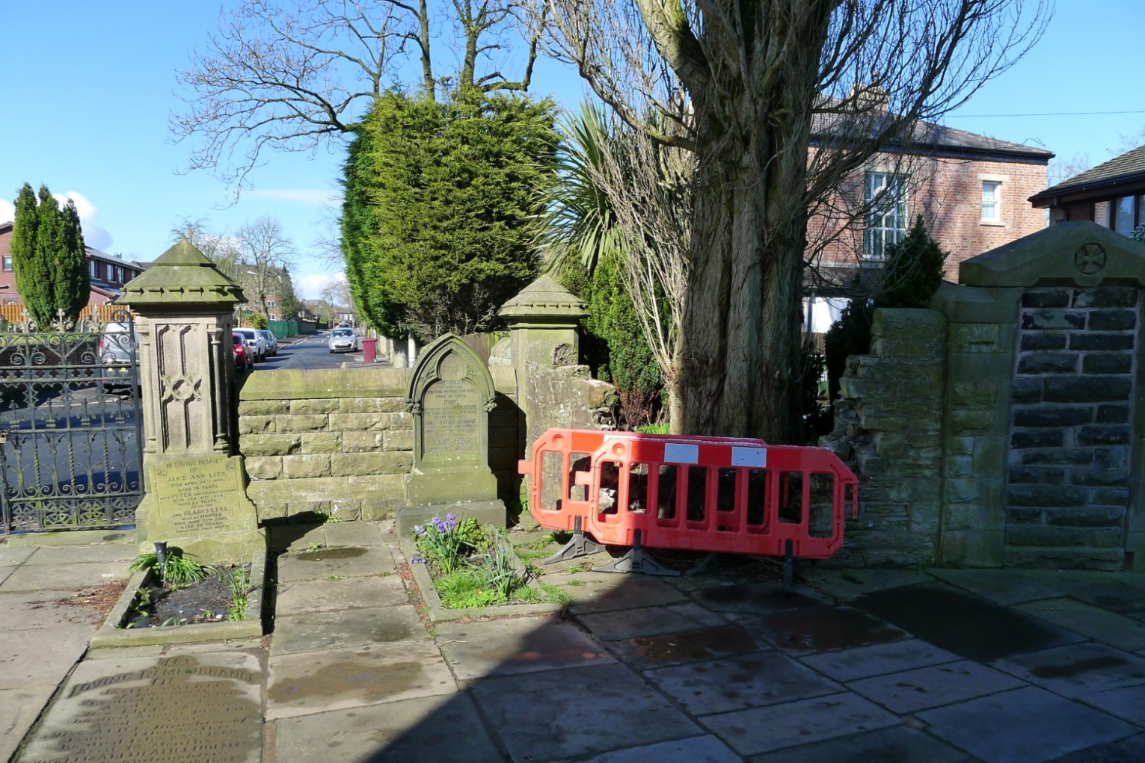
In terms of the fabric of the Church, the only notable event was the collapse of part of the wall on the left-hand side of the main entrance. This was due to disturbance by a tree in an adjacent garden. A specialist company was brought in to make the wall safe. They will need to rebuild it in 2021, finances permitting.
Steve Mann and Graham Martin
Churchwardens

Team Vicar’s Report
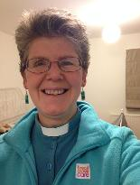
Revd Kim Lafferty
What a year this has been. I am sure none of us would ever have imagined how this year would work out! A pandemic hit our world and life as we knew changed for us all.
As a nation, we went into lockdown on March 23rd and because of this, our churches were closed and worship moved online. It was a huge learning curve for all of the ministry team but we were quickly able to post weekly YouTube services, with input from across the team and ably put together by Malcolm. I began live-streaming Midday and Evening Prayer, Monday to Friday, across 2 of our church Facebook pages. This continued until Holy Week when a new Team Facebook page became the venue for Evening Prayer, every Monday to Thursday.
Little did I think that this would continue for a full 12 months but a regular, faithful community gathered and worshipped together each evening. We have had people join us live from across the UK and some watching regularly either on catch-up or on the Parish of Stoneclough’s website. There were even some who joined us from the USA and Malaysia. We laughed together, cried together and prayed together. It was a source of connection for me personally, as living alone was hard during lockdown.
We started a weekly coffee & chat via Zoom on Sundays for the whole team and had some fun times, laughing and sharing together. This is continuing for the moment.
One of the most difficult parts of this year has been walking with those who have lost loved ones. The restrictions on numbers at services (at one point down to only 6 allowed in the church) made grieving so much more painful for people. It has been my immense privilege to share these journeys with families and hold them in my prayers both then and now.
254 videos later, we are beginning to see life open up, our churches are back and although we are still having to observe physical distance from one another, wear masks and not sing (a real hardship for many of us), it is good to be able to be in the building again and worship physically as well as virtually. The life-streaming is slowly fading out and as more of us receive our vaccines, life is returning to a ‘new normal’. We look forward to the day when we can join together fully, have a brew and good chat around the coffee tables across all of our churches. It will come; we just need to be patient.
We have been blessed to share so much together over this past year and although it has been difficult, I believe it has brought us closer to God and each other.
Kim E Lafferty

Authorised Lay Ministry
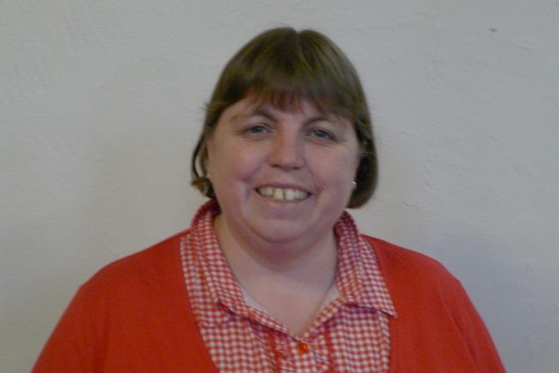
Alison Mole
As for many 2020 has been very challenging to say the least.
When the church doors were forced to close in order to protect us all, I asked myself how could I carry on with my church work which means so much to me.
I work with a fantastic team of nurses at Fairfield Hospital as part of the discharge team. One of their roles is to assess the most poorly of patients to try and place them either back home or into 24 hour care. Once Covid 19 started to affect our patients the nurses would not even have time to complete assessments for discharge before the patients had unfortunately passed away. This became the norm for quite some time and was psychologically hard to deal with as you can imagine.
I decided that I could make a difference even if only for 10 minutes day.
The crafts that I would have done in church and at brownies, I took to the work place instead.
Whilst colouring in and making things we would talk about things, sometimes about work but other things as well. It just gave us time out from the immense pressures of work. They really enjoyed the diversion and looked forward to it.
I led the two minutes silence at work when we remembered all those who had died, by saying a piece of reflection and a prayer. A couple of the lead nursed came over to join us in this.
So my ministry did not stop it just changed.
I continue to enjoy leading the service with the presiding minister and considerate it a great honour to do so.
I look forward to 2021, hoping that we can meet in church.
Alison Mole
Electoral Roll
I write this report, whilst we are the midst of a pandemic, due to the Covid-19 virus. Nothing is as normal and our Church has been closed for part of the year. We currently have 103 members on the roll. There has only been a little movement during the year. Unfortunately, 2 members have died.
I can only hope that we can enrol more members as the Church re-opens fully.
For existing members, the closure of the Church has shown the need for contact telephone and/or email addresses. Please could I ask everyone to check I have the correct up-to-date information.
Thanks
Kim McIntyre
Electoral Roll Officer

Child Protection
2020 was a strange year for everybody in more ways than one, the pandemic affected everybody’s lives in more ways than one but due to the lack of services and Sunday school etc. I have nothing to report.
Hopefully we will soon be back to hearing our children enjoying Sunday school at the back of church and causing mischief 😊
I will be asking the PCC to ask for all volunteers who want to continue working with children to contact me as I want to get all the correct forms filled and will start a complete fresh on DBS checks as most have expired or are due to. This way we start with a clean sheet and it will be easier to manage going forward.
We will always continue to offer our children a safe and caring environment to come and learn and play, and I would like to thank all in advance who want to continue working with children for their continuing work mentoring, teaching and protecting our parish’s young minds.
Please come and see me if you have any interest in working with our parish’s children and I will talk you through our process.
God bless
Shaun Croston
Child Protection Officer
Sunday School
At the beginning of 2020, we managed to hold our Sunday school, still only once a month.
Unfortunately with the Coronavirus pandemic, the restrictions and lockdowns. the last Sunday school was held in March.
There still have been families attending Church, when they can. So hopefully when restrictions are lifted Sunday school can commence once again.
We will welcome the children back with open arms to our Sunday school. And anyone who feels they would like to help out and take part with the Sunday school are also more than welcome to join us.
Michelle Winter and Jackie Powell

Church Website
Social Media Report
We are no longer able to access the website statistics, (without paying a fee), However, along with Facebook, Twitter, and YouTube, it has been an invaluable conduit in maintaining contact with our congregation, especially during the periods when St. John’s was closed due to the Covid-16 Lockdown rules.
Facebook followers have more than doubled to 334
Twitter followers are up almost 25%, from 198 to 239
YouTube has 71 subscribers. It has been invaluable for hosting virtual services, both for lockdown when all of the churches in our benefice were shut, and for those shielding or not able to attend our services.
Thank you to all that have contributed to the website, please keep up the good work.

Steve Mann

All Saints’ CE Primary School
Head teachers Report for the Parish
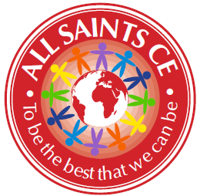

At All Saints, our mission continues to be to ensure that our children get the very best education, which gives them the very best opportunities in life. This has been more of a challenge than ever this year, but we are so proud of what our staff, governors and families have managed to achieve.

Covid-19 at All Saints

Being at the heart of our school community, we knew that we would need to provide home learning as soon as school shut. We provided a variety of work from March to June, including home learning text books, work set on class dojo, links to websites such as TT rockstars and Read Write Inc. We also sent home exercise books, stationery packs and Amazon fire tablets for families without devices. All families were phoned fortnightly, with more vulnerable children phoned weekly. Mrs Hague did home visits to families who we couldn’t get hold of at all. Food parcels and then vouchers were also provided. All of this meant that we were as sure as we could be that our school community had everything they needed. School remained open for the children of key workers and those who were vulnerable.

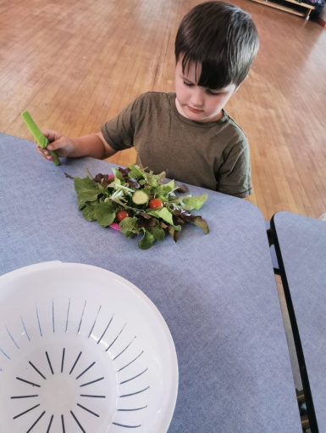 | 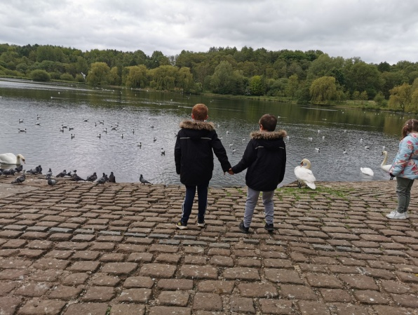 | 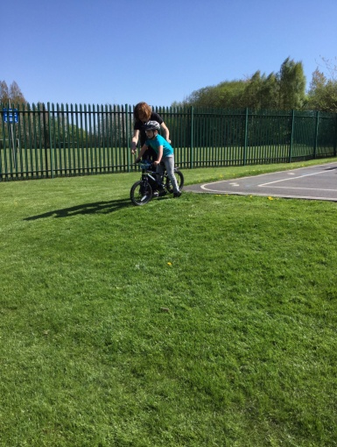
One of our key worker children looking forward to eating the salad that they had grown during lockdown!! | 2 of our key workers who are brothers, enjoying a walk to Moses Gate. | One of our key worker children learning how to ride a bike during lockdown.

We assessed the children in Autumn term and then implemented a curriculum which supported the children back into school and began to address the gaps caused by absence. We also started doing live weekly homework on zoom so that we would be better prepared for any future lockdown. This has stood us in very good stead during this lockdown, as staff and families were already familiar with the technology. Every class has had at least 3 live zoom lessons a day, with additional work being set through pre-recorded videos or worksheets. All lessons have been saved to our school Youtube channel so that families could access them at a time that suited them if they missed the live time slot. Engagement has been at around 90%.

Of course our biggest challenge was the loss of our lovely Sandra Martin. Our whole community was devastated by her death. Sandra was at the heart of our school for over 20 years and is still missed every day. I write this on her birthday, when we had hoped to open her memorial in the school grounds. Sadly, that will have to wait until we can meet up in higher numbers. We have built an outdoor seating area in her name, which I can just picture her sitting on and watching the children play. We were able to use it as the stable in our nativity at Christmas! Sandra would have loved it.

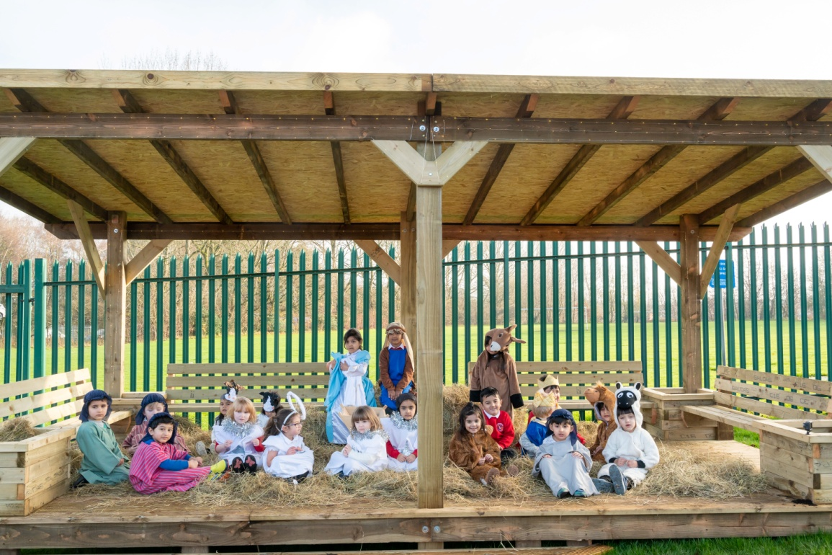

Our ‘normal’ school life has continued as well as possible. We raised around £1000 in Autumn term for the foodbank, Children in Need, and Bolton Hospice. We were able to hold a Harvest service, a Nativity service and a carol service. These were all filmed and shared with parents on our Youtube channel.

Despite the challenges that the year brought us, I am the proudest I have ever been. Our staff have pulled together amazingly well. Despite their own anxieties (and more than a few tears), they worked out how best to work with the children in school, supporting the return, and managing home learning during 2 lockdowns. Many of them were also juggling home schooling their own children and running their own households. Several of them have had covid themselves. Despite all of this, they have approached every day with good grace, with humour, and without (public) complaint! The team work has been truly outstanding. I am beyond thankful to every one of them for their support of me, of each other, and of our families. We are blessed. The support and guidance from our Governors has also been invaluable over the last year.

We are looking forward to a time when we can operate school normally, have visitors in and come back to church. And when the only bubbles in school will be of the soap variety!

We can’t always see where the road leads, but God promises there’s something better up ahead we just have to trust Him. – Psalm 56:3
Katie Hague
Head teacher

St John’s CE Primary School
Head teacher’s Report for the Parish
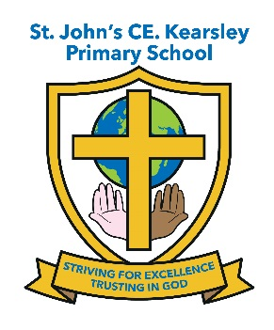
(January 2020 - December 2020)
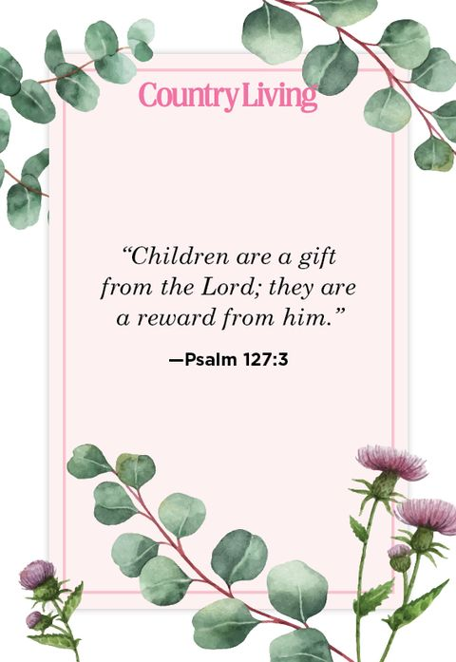
This year’s report follows what can only be described as one of the most challenging times our children and families have ever faced. Without the strength and support of my whole school community and the other Head teachers within this Parish I know the task of keeping the school going on an even keel would have been much harder. I feel truly blessed to be the Head teacher of St John’s CE Kearsley at what was such a worrying and testing time for all of the school and church community

Spring term 2020

All children continued to attend church on Thursday mornings until we were unable to do so when school closed to all but essential worker and vulnerable children on Friday 20th March.
This term’s whole school themes for HEARTSMART were ‘Don’t Rub it in Rub it Out’ and ‘Fake is a mistake’ as well as covering our school values of Forgiveness, Respect, Equality, Kindness and Encouragement. Worship was led by the staff, with Father Stephen following on from the weekly focus introduced each Monday in Worship by the Head teacher. It was great to begin to see a regular worship structure in church as the children became used to following the openings and closing rituals that Father Stephen introduced and they really enjoyed learning some new worship songs a long with the actions to accompany them.
Unfortunately just as the Spring term was getting going and we were looking forward to creating new spiritual memories with Father Stephen at the helm of St John’s the COVID pandemic hit and so all of our usual events and activities held within the spring term had to be cancelled. Experience Easter at St John’s Church, our annual Easter Services at St John’s church for both the Infant and the Junior Units
As part of our Easter Celebrations all children would normally take part in the decorating an egg competition. Again all this had to stop
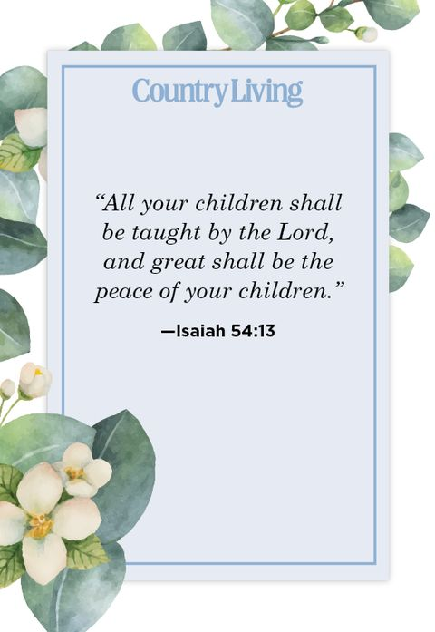
Summer term 2020
Unfortunately school remained closed to all but Key worker families and vulnerable children for the whole of the Summer term. The school did its best to provide suitable learning opportunities to all children at home during this time and ensured appropriate support for families at the point of need through our Pastoral Officer and Behaviour and Engagement Mentor making welfare calls to families and sign posting them to agencies and Charites throughout the height of the pandemic.

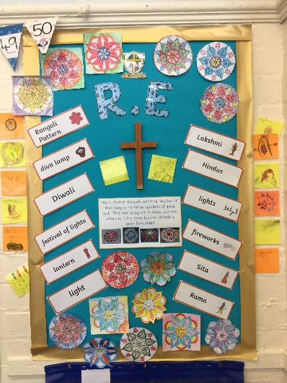

St John’s just wasn’t the same without the children and for many it was their ultimate faith that God had a plan for us all that got us through such a mentally and emotionally challenging time for all concerned.
Autumn term 2020
Unfortunately we have not been able to attend church since September due to COVID restrictions which has been a real shame for the children as it’s an integral part of what being a member of St John’s school. Father Stephen has sent across some content for us to use within Collective Worship on a monthly basis to supplement what school has been using up to Christmas. The Diocese have provided high quality weekly Collective Worship resources and videos which school has been using alongside their own to supplement collective worship especially during the 3rd lockdown and has formed part of the school’s weekly RE provision for home learning.
Reception were able to hold 3 ‘Wiggle Worship’ within the Autumn term led by Steph from Changing Places Team – this event was held separately for each bubble and the children loved it but unfortunately we could not include parents this time.
The school collected donations for the Harvest which once quarantined was dropped off at Farnworth Foodbank and each Unit had a Harvest Service within school with reading and prayers created by the children.
Robins really enjoyed learning about Diwali and tasting celebratory Indian food and making their Puja lamps, the children really enjoyed listening to Mrs Waland explain her family traditions and how they all celebrate this important Hindu festival.
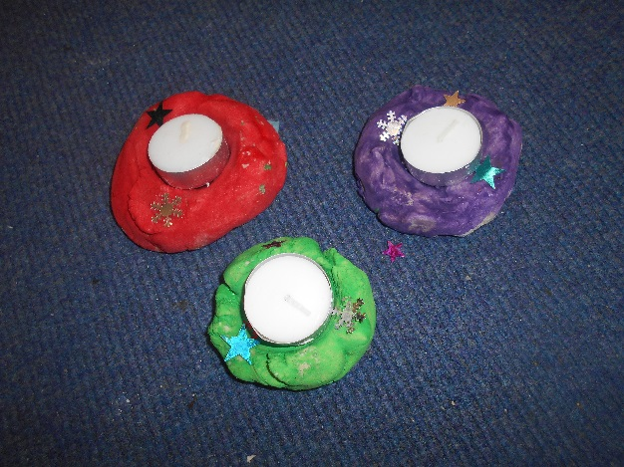
School managed to ensure we held a Christingle Service at St John’s as normal with all classes making Christingles and learning about their significance. This was recorded and uploaded to Twitter and the school’s FB account for parents to share in.
The annual ‘Tree Dressing Ceremony took place on 30th November with each class teacher leading a reading, poem or prayer. This was again recorded and uploaded to social media for families to enjoy. However Experience Christmas at St John’s Church had to be cancelled due to COVID restrictions again another disappointment for the children as this is highlight in their celebrations.
School worked really hard to ensure the magic of Christmas continued despite the pandemic and the Infants performed of ‘Off to Bethlehem’ on 14th December again this was recorded and uploaded for families to share and enjoy. The Juniors held a Carol Service in school separately within their bubbles on 17th December which was videoed and uploaded alongside the other festivities to enjoy. School finished for the Christmas holidays feeling extremely proud of the way the whole school community had pulled together to try to keep things as normal as possible for the children of St John’s

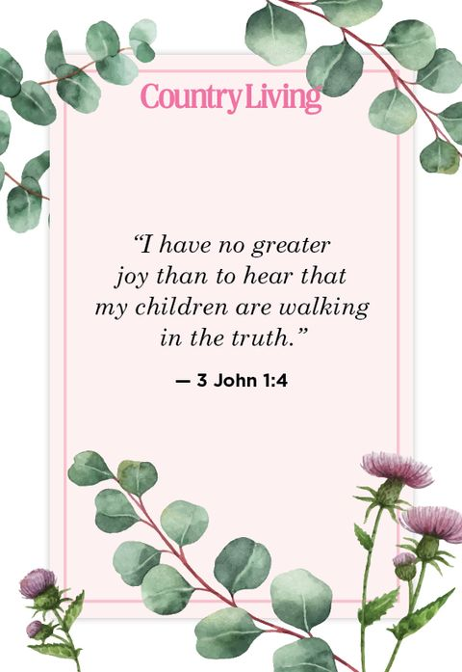

Finally I would like to thank all of my staff and Governors for all their hard work and continued support through what has been a very challenging time for the family of St John’s.
Suzanne Howard
Head teacher

St.Peter’s C.E.Primary School

Head teachers Report for the Parish
“ Learn, Sparkle & Shine…”
2020 was an exceptionally challenging year for all, including the St. Peter’s community, however, despite the COVID situation the school continued to promote its ethos and there are many positive achievements to report on.

What is our vision?
As teachers we are often charged with the task of preparing our children for their future. At St. Peter’s we think a little differently, and rather than prepare our children for a future that is imposed upon them, we aim to give them the skills necessary to create the future that they perceive for themselves. Today is the tomorrow of yesterday. By controlling today, we are creating the future of tomorrow. Our vision is to develop our children to enable them to create the future they aspire for themselves.
“Our children will contribute to and prosper in society.”

How will our vision be achieved?
We believe our vision will be achieved if we provide our children with an environment, underpinned by British and Christian values, in which they can “ Learn, Sparkle & Shine…”

Learn = develop wisdom, knowledge and skills.

Sparkle = develop individual character; hope, aspiration and courageous advocacy.

Shine = develop community spirit and learn to live well together.
- We believe inherited traits are only one part of the story of where we may end up. The environment created in our classrooms, the culture of hard work and determination that we encourage, the recognition that we are all able to increase our knowledge through learning, we believe, has an equally valid impact on our future success. (Learn)
- We believe that engaging in a rich and varied curriculum will provide our children with an opportunity to develop a positive attitude to learning and an environment in which they can flourish and thrive. (Sparkle)
- We believe that by using Christian Values to underpin our work, children will be able to spread positive attitudes and shine as a beacon in society. (Shine)
Our daily work is dedicated to achieving these aims.

In June we were re-assessed against the criteria for the Inclusion Quality Mark excellence status and are delighted to say we once again met the standard. We were thrilled with the report below, written by the assessor.

“St Peter’s CE Primary is a larger than average two form entry school with 424 pupils on roll, where the majority of pupils are of White British heritage. It is a vibrant, impressively inclusive school that serves its pupils and community exceptionally well with a strong ambition, heart and soul that marks out this truly inclusive school. This is a school where pupils and staff are encouraged to achieve their full potential, to develop as individual learners and to contribute to the school, their community and society. The staff at the school recognise that the challenges facing their pupils are not just academic and that there is a need to, educate the whole child and often their families as well. This is aptly demonstrated by their vision, ‘rather than prepare our children for a future that is imposed upon them, we aim to give them the skills necessary to create the future that they perceive for themselves. Our vision is to develop our children to enable them to create the future they aspire for themselves. Our children will contribute to and prosper in society. This superbly inclusive vision will be achieved by providing the children with an environment, underpinned by values, in which they can, ‘Learn, Sparkle & Shine’. Where pupils come to school to ‘learn’, so that they can all achieve and that there are the highest expectations for all; to ‘sparkle’, recognising and celebrating the achievements of all pupils and ‘shine’ by representing the school in the wider community and by working towards the school’s Christian values for personal development and becoming good citizens of the future. A fantastic vision and inclusive ethos that is ingrained in the very fabric of the school, its staff and its pupils. These are facts I can attest to from previous reviews and from the evidence of this online review.
This is a school that continues to know its pupils, its families and community well and is determined to help everyone that is involved to the best of its ability. Everyone involved with the school, works hard on a daily basis to make a difference to its pupils and their families. Mutual respect is evident in every area of the school. All adults who work here, led by the extremely aspirational and inspirational Head-teacher and her senior team, have a clear vision for the school and their pupils with a relentless drive for all to succeed, but they also support their colleagues and work together extremely well.”

The school was also shortlisted for three prestigious awards in November 2020.

The TES Primary school of the year award and Educate Awards SEND provider of the year and most inspirational primary school.

Children missed over a term of school in the Spring and Summer of 2020. Whilst school remained open over lockdown for vulnerable children and those of key workers, for the vast majority of children school provided home learning from the beginning of March 2020.
At the time this included setting online learning via tapestry and class blogs, and sending paper copies of work packs home. Purple mash, TT rock stars and LBQ were platforms that the children were already subscribed to and were used widely to support home learning. Reading books were also sent home. The detailed curriculum knowledge organisers were placed on the website for pupils to access, alongside the measures facts and spelling lists that children are expected to learn in the year group.
This provision was enhanced by the use of Microsoft teams, which was introduced in June 2020 for the purpose of offering emotional support and ‘virtually’ seeing children.
The school you tube channel was used to post on line tutorials and weekly challenge tasks for Ks1 children.
One of our staff reinvented herself as Professor Brain and created a vast array of phonics videos which the children (and their parents) loved. These videos can all be found on our school website here. Phonics with Professor Brain
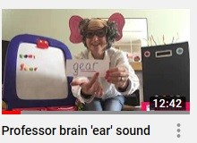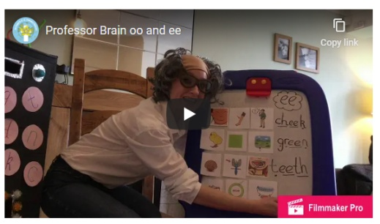
CPOMS was introduced for logging phone calls between staff and parents, particularly vulnerable pupils and all safeguarding issues were logged and followed up.
Food parcels were provided by Magic Breakfast and were hand delivered in the community. This service continued throughout the summer holidays using amazon delivery service.
At the time 145 children were eligible for FSM (now 153). These families were provided with vouchers through the Government scheme. This required a lot of administration time, setting up and managing each week, but ensured the families were able to purchase the food they needed.
Communication with the community remained strong and a daily newsletter was posted on the school website, school APP and twitter.
School reopened on 8th June to pupils in YR, Y1 and Y6. Once all the places had been allocated the additional capacity was offered to Y5 pupils. Over 140 out of the 420 children in total returned.
Transition of pupils in to the reception class of St Peter’s looked very different, however the introduction of ‘tapestry’ for the pre induction pupils proved to be very successful. Over 90% of parents logged on and engaged with the transition programme, including sharing videos of their children. Staff felt they got to know the children very well prior to them starting and the transition was smooth. All children had a home visit from a member of school staff and were presented with a goody bag containing information about the class and a story book. The reception class blog was set up prior to September and messages to parents were posted this way.
Year 6 leavers were given a leavers goody bag, which was presented to them in a 1;1 appointment with their class teacher, with their family.
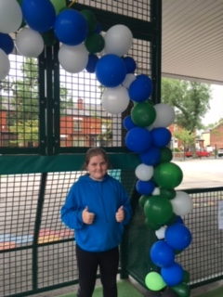
The autumn term was challenging due to the high level of COVID transmission in the community, but school remained a stable and positive environment. School was able to operate safely within the guidance of the full and thorough risk assessment. The staff and children adapted well and quickly became used to the ‘new normal.’
During the Autumn term our outward facing community work was able to continue and we raised over £1000 for community causes including Children in Need and Macmillan nurses.

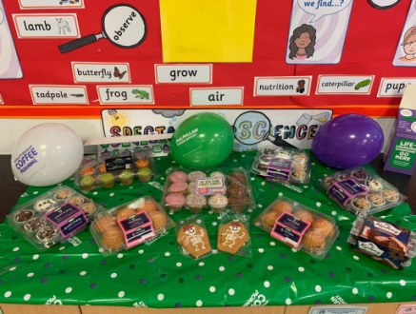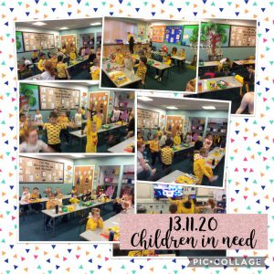

We were able to hold our usual harvest, Remembrance and Christmas services, albeit virtually. These are available to view on our school You Tube Channel, by clicking on the links below.

Harvest

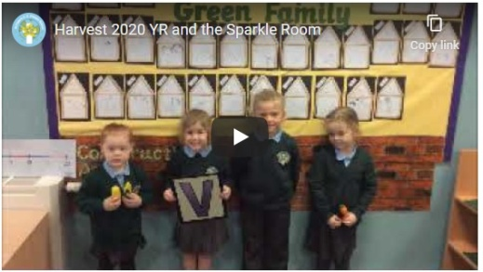 | 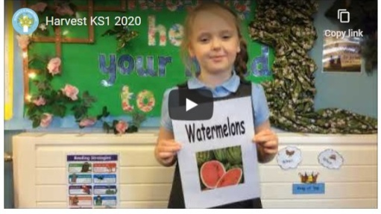 | 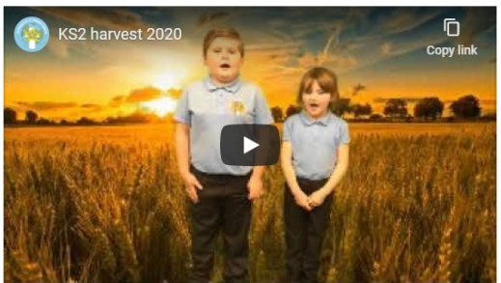

Remembrance

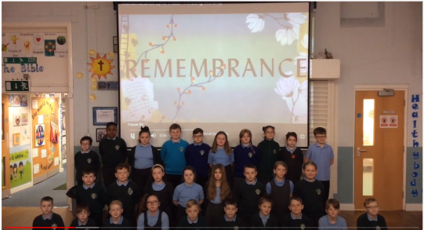

Christmas

 | 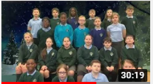 | 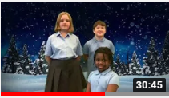

The Children Changing Places project has been very beneficial to the pupils and Wiggle Worship is a hit with EYFS and KS1. Thanks go the entire team.

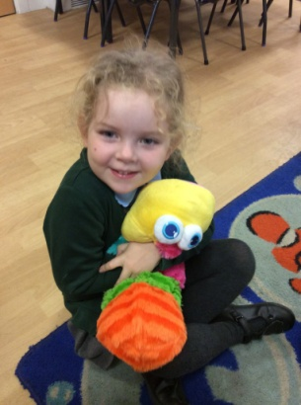

Farnworth continues to be a wonderful community to be a part of. It is a pleasure to serve a community with such supportive parents and Governors and such wonderful children. With God’s help we trust this community can continue to build and develop, so that our children will benefit from a vibrant and aspirant community ethos.

Thank you
L. M. Williams
Head teacher

3rd Farnworth St John's Brownies
The Brownies celebrated Shrove Tuesday by cooking Pancakes over a candle, an activity which they really enjoyed.
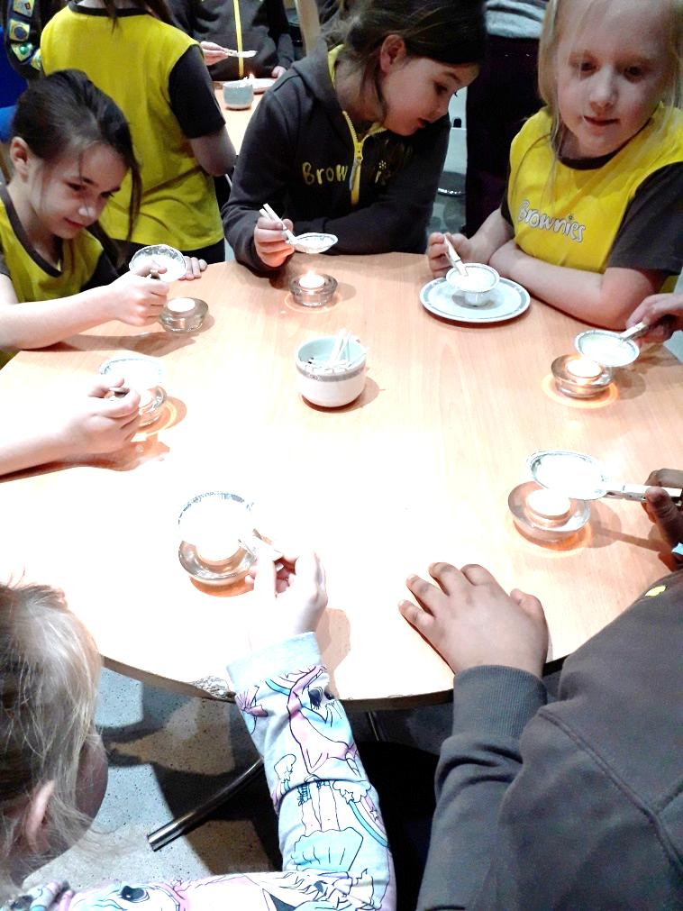
At our final meeting of the year, in March, we made Button Heart pictures in a box frame for Mothering Sunday gifts. We did not know at the time how relevant the wording would be “Mothers are like Buttons, they hold everything together”.
The following week, unfortunately, due to Covid 19, St Johns Brownies had to stop meeting when the Country went into Lockdown.
It was with great sadness in May that we said goodbye to our Sister in Guiding, Sandra Martin, St Johns Rainbow Leader after she contracted Covid 19. Sandra will be missed by so many friends as she was involved in so many aspects of Church and wider Community life.
We kept in contact with the Brownies during Lockdown by posting out Jig-Saw pieces for them to decorate and return a lovely idea from Alison. We have welcomed Heather Birchall as Assistant Leader.
Even though we have not met since March and have not taken subscriptions from the girls, we still have had to pay an Annual Subscription to Girlguiding UK.
Susan Stevens
3rd Farnworth St John's Rainbows
The Rainbows were only able to meet on 4 occasions from January to lockdown on 23rd March 2020, due to the half-term break and illness. This didn’t give a lot of time to carry out much of the rainbow programme of work with the girls.
Sadly, we lost our Rainbow Leader, Sandra Martin, who passed on 3rd May 2020.
She will be solely missed by us all.
Yours in guiding,
Heather Birchall

Statement of Accounts 2020
2020 | Farnworth and Kearsley Parish Accounts
Balance
 |  |  |  | Bank Total | Barclays Current | Barclays Savings
Opening Balance |  | 33307.37 |  | 37252.46 | 6769.3 | 26538.07
Total Income |  | £51,926.85
Total Outgoings |  | £47,432.42
Prec. Year cheques paid |  | £0.00
Unpaid cheques |  | £0.00 |  | Bank Total | Barclays Current | Barclays Savings
Current Balance |  | £37,801.80 |  | 37801.80 | 23224.73 | 14577.07
 |  | £0.00 | This cell should always equal zero
Monthly reporting items
 |  | Balance | opening | Income | Outgoings
Parish General |  | £13,992 | -£2,501 | £51,964.13 | £35,471.42 | -£16,492.71
Coffee Fund |  | £2,675 | £2,675.00 | £0.00 | £0.00 | £0.00
Minor Projects |  | £1,477 | £1,514.00 | -£37.28 | £0.00 | £37.28
St Johns reserve |  | £24,711 | £36,672.00 | £0.00 | £11,961.00 | £11,961.00
Youth Worker fund |  | -£5,053 | -£5,053.00 | £0.00 | £0.00 | £0.00
HST (In HST A/C) |  | £5,656 | £5,864.00 | £0.00 | £207.48 | £207.67
Quota Paid |  | 19,850
Notes | donation of £1000 received in January

MINUTES OF THE ANNUAL PARISH CHURCH MEETING & THE ANNUAL PAROCHIAL CHURCH MEETING – 11 October 2020.
The Annual Meetings were held after the Communion Service with 23 people present.
ANNUAL PARISH MEETING
Apologies for absence: Tania Kitchen and Barry McGlynn

Minutes of the Annual Vestry Meeting: Held on 14th April 2019, having been available for all present, were taken as read and agreed by all members present that they be approved and signed as a correct record.
Revd Stephen Nolan informed members of the change of title of the meeting from Annual Vestry Meeting to Annual Parish Meeting.
Election of Churchwardens: Steven Mann and Graham Martin having been proposed and seconded, and with no further nominations, were unanimously elected to serve as Churchwardens for 2020/2021. Revd Stephen expressed a huge thank you to Jackie Powell, who was stepping down after serving as a warden for the last two years.

ANNUAL PAROCHIAL CHURCH MEETING
Apologies for absence: Tania Kitchen, Barry McGlynn
Minutes of the Annual Parochial Church Meeting: Held on the 14th April 2019, having been available for all present were taken as read and agreed by all members present that they be approved and signed as a correct record.
Reports:
- Church Electoral Roll: Revd Stephen Nolan reported that we had 102 members on the Electoral Roll.
- Parochial Church Council: - Included in the Annual Report.
Revd Stephen Nolan said well done, we were in a good place that we were a thriving church with lots of potential for growth. He said that when church first re-opened following the Covid Lockdown 41 people had attended and that had grown to 79 over that last 6 weeks that we were only in the 70’s pre-pandemic. Revd Stephen Nolan informed the meeting about a ‘Portrait Completion’ which was to be held, when all the children, from our schools would be asked to draw a picture of a bible character on the subject of ‘Hope’ and the pictures would be displayed later in the year in Bolton Parish Church. Wiggle Worship was being introduced to our very young children and a new Messy Church was due to commence at St Peter’s School.
- Financial Statements. The accounts for 2019 were available in the previously electronically circulated Annual Report. We had also maintained the level of giving for the year at £21,701 compared to £22,359 in 2018. We have however continued to spend more than we generate in income with an overall reduction in balances of £4,245 which was lower than if otherwise would have been due to no parochial fees being paid since February.
At 31st December 2019 we had balances of £33,307. Collectively we need to consider how we can increase our income or reduce our expenditure by £260 per week, this equates to £2.70 per person per week on the new electoral roll.
Thanks were expressed for the help and support received from Sandra Croston and the weekly money counters.
The financial report was approved by 14 members
Revd Stephen Nolan commented that the figures were roughly in line with the previous year, but he would need 3 months of uninterrupted figures to look at finance.
Revd Stephen Nolan expressed thanks to Rob McIntyre who was stepping down as Treasurer after serving for five years. He said that Sandra Croston would be taking over the role and she would be assisted by Shaun Croston.
- Fabric and Church Property: - Revd Stephen Nolan reported that the crack in the church wall, between the old vicarage and the churchyard, had widened significantly and was in danger of collapsing. The damage had been caused by the poplar tree, in the grounds of the house next to the church, which has a preservation order on it. He said that the other poplar tree which was situated in the new church yard was also damaging the adjacent wall and that the diocese was dealing with the matter.
- Deanery Synod: - Included in the Annual Report. Revd Stephen told the meeting that the deanery boundaries were changing and that there would be a ‘New Deanery.’ He said that the Seven Saints Parish was being split and that we had been asked to take on two more churches and one more school. He said that this was good news and would enable Farnworth to be looked at as a whole.
A member commented that this would be a positive step with one voice over Farnworth.
- Child Protection & Vulnerable Persons Policy Statement & Report: - Revd Stephen Nolan told members that Shaun Croston would continue in the role and that The Child Protection & Vulnerable Persons Policy Statement would be signed next week and displayed in church.
It was reported, by Shaun Croston, that 2019 came and went without any incidents for which he and the church is very grateful. He had agreed to carry on with this very important job and would hope and pray that our children would feel confident in approaching him with any concerns rather than suffering in silence.
There are new volunteer forms to fill in for any wishing to carry on with their roles for which we are all again grateful for and DBS checks for those whose certificates have run out. He will do the background work and apply for the checks once a sense of normality is on the horizon.
We continue to offer our children a safe and caring environment to come and learn and play. Thanks were expressed to all who currently work with children for their continuing work mentoring and protecting our parish’s young minds.
- Admitting Children to Holy Communion Policy Report: - It was agreed to continue to Admit Children to Holy Communion. Revd Stephen Nolan said we have a policy of admitting Year 3 children and above who attend church regularly to Holy Communion. St John’s Church was one of the first churches in the Diocese to adopt this policy.
- Other Reports included in Annual Report: - Thanks were expressed to all those who had contributed to the reports.
- Election of Officers:
- Deputy Wardens: Shaun Croston and Nigel McFarlane having been proposed and seconded and with no further nominations, were elected to serve for 2020/2021.
- Deanery Synod Representatives: The number of Deanery Synod Representatives is governed by the number of members on the Electoral Roll. We currently have 102 members on the Electoral Roll at St John’s and are entitled to 4 representatives. Alison Mole and Jackie Powell were appointed as Deanery Synod Representatives.
- PCC Representatives: Comprises of 10 representatives. The following 6 people having been proposed and seconded were elected to serve for 2020/2021. – Judith Birchall, Stephanie Buckley, Denise Entwistle, Sharon Goodwin, Susan Stevens and Dorothy McGlynn.
- Sides People: The following 8 people, having been proposed and seconded, were elected to serve for 2020/2021 – Keith Morgan, Carol Morgan, June Eatock, Stan Eatock, Judith Birchall, Victoria Billington, Abdul Akhunzada and Sajj Heidan.
- Ex-Officio Members: - The following are also ex-officio members of the PCC - Revd Stephen Nolan (Chair), Revd Dr Malcolm Wearing (Ordained Local Minister) Dr Steven Mann (Church Warden), Graham Martin (Church Warden) & Deanery Synod Reps. - Alison Mole and Jackie Powell.
- Appointment of Auditor to the Council: - It was reported that an Auditor had been appointed.
Any other business: Kim McIntyre raised the questions whether we would still be able to drop poppies from the balcony at our Remembrance Service this year and have a Christmas tree due to Covid Restrictions. Father Stephen said that we could but the people dressing the tree must be in the same ‘bubble’ and wear masks.
Notice of the next meeting for the newly elected PCC: Thursday 5th November 2020 at 7.00pm.
Archdeacon's Visitation: Date of a ‘virtual meeting’ to be announced in due course.
Church Wardens, Deputy Wardens & Sides People must attend and PCC members are strongly encouraged to attend.
Signed …………………………………………………..
Date …………………………………………………..

